

ISBN: 978-0-642-60539-9

© Australian Capital Territory, Canberra 2010

This work is copyright. Apart from any use as permitted under the Copyright Act 1968, no part may be reproduced by any process without written permission from the Territory Records Office, Governance, Corporate Support, Department of Territory and Municipal Services, ACT Government, GPO Box 158, Canberra City ACT 2601.

Published for the:

ACT Chief Minister’s Department
Governance Division

Enquiries about this publication should be directed to:

Public Sector Management Group
Governance Division
Chief Minister’s Department
GPO Box 158
CANBERRA CITY ACT 2601

http://www.cmd.act.gov.au/governance/commissioner

Telephone: (02) 6205 0358

For Further information contact:

Senior Manager, Strategic HR, Chief Minister’s Department, ph (02) 6207 6502

Cover Design: Publishing Services, Shared Services, Department of Territory and Municipal Services

Foreword

I am pleased to be able to present this supplementary report to the annual ACT Public Service (ACTPS) Workforce Profile which provides an analysis of gender across the ACTPS.

This report provides a more in-depth gender analysis of the ACTPS as at the last pay date in the 2009 financial year (24 June 2009) and should be read in conjunction with the ACTPS Workforce Profile 2008-09 (the Workforce Profile). This report expands on the Workforce Profile by providing an analysis of the following areas:
- employment type by generation and gender;
- age profile by classification group and gender;
- length of service by classification group and gender; and
- remuneration by gender (including a new gender pay gap analysis by classification group and agency).

It is recognised that there is much work being undertaken across the nation in the area of gender equality, particularly the recent publication of the Gender Equality Blueprint 2010 by the Sex Discrimination Commissioner of the Australian Human Rights Commission. More locally there is the work of the ACT Women’s Plan 2010-2015 which outlines the ACT Government’s vision for working with the ACT community in this area.

One of the key factors in addressing gender equality is the development of a stronger understanding of why gender inequality still exists, despite the many years of legislation and policy action on equal opportunity.

It is relatively positive news in the ACTPS when reviewing gender pay equity however more can be done, such as sustained and enhanced reporting of this nature in future editions of the Workforce Profile.

Catherine Hudson
COMMISSIONER FOR PUBLIC ADMINISTRATION

Table of Contents

Foreword 4
Table of Contents 5
Introduction 6
Employment Type 8
Table 1: Number of employees against employment type by gender and as a percentage 8
Table 2: Number of employees against employment mode by gender 8
Figure 1: Female employment type by generation 9
Figure 2: Male employment type by generation 9
Age Profile 11
Figure 3: Female employment as a percentage of each generation 11
Figure 4: Male employment as a percentage of each generation 11
Table 3: Average age in years by classification group and gender 12
Length of Service 13
Table 4: Average length of service in years by classification group 13
Table 5: Average length of service in years by generation 14
Remuneration by Gender 15
Table 6: ACTPS Gender Pay Gap and relevant workforce comparisons 15
Table 7: Observations of key gender pay gap results by Agency 17
Table 8: Gender Pay Gap by Classification Group 18
Table 9: Observations of key gender pay gap results by classification group 19
Figure 5: Gender Pay Gap by Age Cohort 20
Figure 6: Annual salary by Gender Profile (excluding casuals) as a percentage of each gender 21
Abbreviations 22
Attachment 1 23
Gender Pay Gap by Agency 23
Attachment 2 - Classifications 24
Gender breakdown of classification groupings by agency at June 2009 as a percentage of total agency workforce 24

Introduction

About the 2008-09 ACT Public Service Workforce Profile Supplementary Gender Analysis

This supplementary report to the 2008-09 ACTPS Workforce Profile provides an analysis of gender across the ACTPS. This report should be read in conjunction with the 2008-09 ACTPS Workforce Profile (http://www.cmd.act.gov.au/governance/commissioner).

This Supplementary Gender Analysis provides a snapshot of the ACTPS as at the last pay date in the 2008/09 financial year (referred to throughout the report as ‘June 2009’).

Data in this report is provided for all departments and agencies (entities and enterprises) against a number of employee and human resource related measures.

For the purpose of this report, generational boundaries reflect the following:

Generation | Year span
Pre-Baby Boomers | Born prior to 1946
Baby Boomers | Born 1946 to 1964 inclusive
Generation X | Born 1965 to 1979 inclusive
Generation Y | Born from 1980 and onwards

About the 2008-09 Data

Data in this supplementary report has been derived from the Chris21 Human Resource Management System which encompasses 88.5 per cent of the ACTPS. Information was also gathered from agencies using separate human resource/payroll systems (2,318 employees or 11.5 per cent of employees) including:
- Calvary Public Hospital;
- CIT Solutions;
- Cultural Facilities Corporation;
- Exhibition Park in Canberra;
- Legal Aid Commission (ACT) - an independent statutory corporation
- Legislative Assembly Secretariat; and
- TAMS ACTION Buses.

Unless otherwise indicated, the figures presented in this report reflect ‘paid headcount’ - defined as the number of employees that have received payment at a given point in time (24 June 2009).

Information referencing other jurisdictions or based on the greater ACT population, has been annotated in the footnotes throughout the document.

Due to machinery of government changes, comparison of some agencies between 2005-06, 2006-07 and 2008-09 may not give an accurate representation of actual fluctuations within each agency. There were no machinery of government changes between agencies in 2007-08.

The calculation used to determine the gender pay gap is based on the methodology used by the Western Australian Government’s Department of Commerce.

Limitations of the Data

Data within this report may be affected by:
- invalid data (e.g. nil response received for diversity information status);
- data definitions (work continues to develop consistent data definitions, but with a number of different payroll systems involved in the analysis, some minor variations may exist);
- omissions; and
- progression (where possible comparisons might have been drawn with previous Workforce Profiles or State of the Service Reports, however due to updates in data, definitions and methods of extraction, some comparison has not been possible).

Caution should be exercised in interpreting the results where the numbers in a particular agency or classification group are small.

Variations may exist between data in the Workforce Profile and that published by individual agencies due to differences in data sources, data definitions, and/or retrospective updating of an individual record.

Employment Type

Employment type refers to how a staff member is employed in the ACTPS (on a permanent, temporary or casual basis). Permanent and temporary employees can also be employed on a full-time or part-time basis.

Table 1 provides the number of staff employed by employment type, as well as the percentage of each gender across the whole workforce at June 2009.

Table 1: Number of employees against employment type by gender and as a percentage

Employment Type | Female | Male | TOTAL | % of Female | % of Male
Permanent Full-time | 6,892 | 4,774 | 11,666 | 59% | 41%
Permanent Part-time | 3,154 | 500 | 3,654 | 86% | 14%
Temporary Full-time | 1,141 | 839 | 1,980 | 58% | 42%
Temporary Part-time | 545 | 152 | 697 | 78% | 22%
Casual | 1,480 | 634 | 2,114 | 70% | 30%
TOTAL | 13,212 | 6,899 | 20,111 | 66% | 34%

Table 2 indicates the number of staff by employment mode, as well as by gender. Employment mode involves reviewing employment only by full-time, part-time and casual status.

Table 2: Number of employees against employment mode by gender

Employment Mode | Female | Male | TOTAL
Full-time | 8,033 | 5,613 | 13,646
Part-time | 3,699 | 652 | 4,351
Casual | 1,480 | 634 | 2,114

Overall, at June 2009, the ACTPS workforce consisted of 15,320 permanent (up 1,077 from 2007-08), 2,677 temporary (up 95 from 2007-08) and 2,114 casual (up 44 from 2007-08) employees.

Female employees represent approximately 66 per cent of the workforce while male employees represent 34 per cent. This composition has been relatively consistent with only minor fluctuations over the last thirteen years.

Figures 1 and 2 outline the percentage of the employees against each employment type by generation and gender at June 2009.

Figure 1: Female employment type by generation
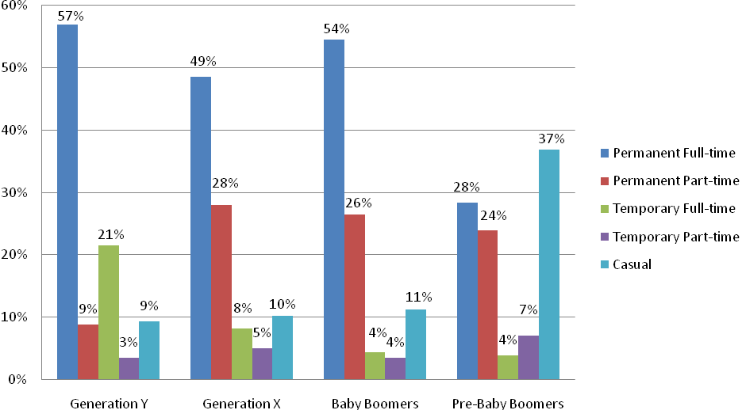
Figures in this graph are rounded to the nearest percentage.

Figure 2: Male employment type by generation
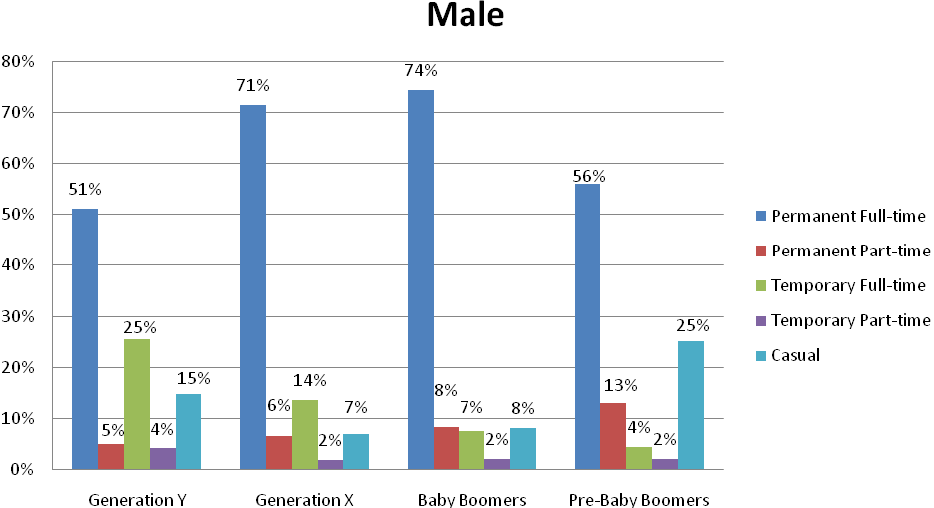Figures in this graph are rounded to the nearest percentage.

Full-time employment
In most generational groups there is a higher percentage of male employees in full-time employment (permanent and temporary) compared to female employees across the generations. There is however a higher percentage of female permanent full-time employees in Generation Y (at 57 per cent) compared to their male counterparts (at 51 per cent).

Part-time employment
Conversely, when it comes to permanent part-time employment this form of employment is much more common amongst women irrespective of generational groups.

Casual employment
For casual employees, the highest percentages in both genders were
Pre-Baby Boomers, arguably reflecting a preference for a more flexible employment arrangement amongst mature-aged employees.

The key observation when comparing Figure 1 with Figure 2 is the contrasting pattern of employment between female and male employees, particularly in permanent full-time employment.

Age Profile

The age profile of the workforce is an important element of workforce planning.

Figures 3 and 4 display employment across the generational groups as a percentage of the whole ACTPS.

Figure 3: Female employment as a percentage of each generation
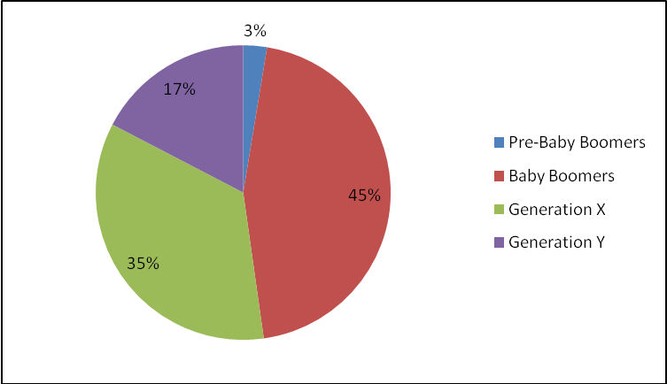

Figure 4: Male employment as a percentage of each generation
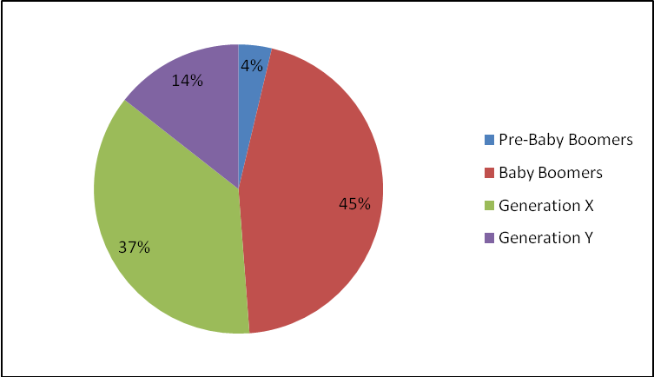

The key observations from Figures 3 and 4 are that Baby Boomers have the highest representation of male and female employees at 45 per cent (3,110 and 5,970 respectively), with Generation X close behind accounting for 37 per cent of male employees and 35 per cent of female employees (2,538 and 4,607 respectively).

Table 3 presents the total average age by classification group and gender at
June 2009.

Table 3: Average age in years by classification group and gender
Classification Group | Female | Male | Total  Average
Administrative Officers | 42.2 | 39.5 | 41.6
Ambulance Officers | 37.3 | 41.7 | 40.1
Bus Operators | 43.7 | 48.9 | 48.4
Correctional Officers | 41.4 | 40.1 | 40.4
Dentists/Dental Officers | 36.5 | 51.1 | 38.6
Disability Officers | 44.2 | 43.6 | 43.9
Chief Executives/Executives | 49.6 | 50.3 | 50.0
Fire Brigade Officers | 38.4 | 42.8 | 42.7
General Service Officers & Equivalent | 44.4 | 45.6 | 45.3
Graduate Administrative Officers | 30.1 | 27.7 | 29.3
Health Professional Officers | 40.2 | 41.8 | 40.5
Information Technology Officers | 36.1 | 35.7 | 35.8
Legal Officers | 36.0 | 44.1 | 39.3
Medical Officers | 37.1 | 41.3 | 39.4
Nursing Staff | 44.1 | 42.4 | 43.9
Linen Production & Maintenance | 49.6 | 43.0 | 46.7
Professional Officers | 43.3 | 42.3 | 43.0
Rangers | 34.6 | 43.3 | 41.0
School Leaders | 46.8 | 44.9 | 46.3
Senior Officers | 44.4 | 46.8 | 45.6
Technical Officers | 41.2 | 45.5 | 43.4
Trainees & Apprentices | 23.1 | 20.8 | 21.3
Teachers | 43.7 | 44.3 | 43.9
Service-wide Average | 43.0 | 43.6 | 43.2

Male employees in classification groups that had an average age higher than the male average age (43.6 years) were dentists/dental officers, chief executives/executives, bus operators, senior officers, general service officers and equivalent, technical officers, school leaders, teachers and legal officers.

Whereas for female employees (43.0 years), it was chief executives/executives, linen and production maintenance officers, school leaders, senior officers, general service officers and equivalent, disability officers, nursing staff, bus operators, teachers and professional officers.

Typically, the age for trainees and apprentices is lowest in both genders at an average of 23.1 years for females and 20.8 years for males.

Classification groups which had the highest average age gap between genders were dentists/dental officers (14.6 years), rangers (8.7 years), legal officers (8.1 years) and bus operators (5.2 years).

Female graduates are older, on average, than their male counterparts, with the average age for females at 30.1 years compared with 27.7 years for males.

Length of Service

Length of service (also known as tenure) can provide valuable information in ascertaining the extent of retention within an agency and across the ACTPS workforce.

Table 4 shows the average length of service of staff across the ACTPS by classification group and gender at June 2009.

Table 4: Average length of service in years by classification group
Classification Group | Female | Male | Total Average
Administrative Officers | 5.9 | 5.8 | 5.9
Ambulance Officers | 7.2 | 8.3 | 7.9
Bus Operators | 5.5 | 10.1 | 9.7
Correctional Officers | 5.4 | 4.3 | 4.5
Dentists/Dental Officers | 7.4 | 5.6 | 7.1
Disability Officers | 6.4 | 6.2 | 6.3
Chief Executives/Executives | 10.9 | 11.7 | 11.4
Fire Brigade Officers | 9.9 | 14.9 | 14.8
General Service Officers & Equivalent | 7.7 | 8.8 | 8.6
Graduate Administrative Officers | 0.5 | 0.4 | 0.5
Health Professional Officers | 6.3 | 6.7 | 6.4
Information Technology Officers | 6.0 | 5.2 | 5.3
Legal Officers | 5.6 | 7.5 | 6.4
Medical Officers | 3.4 | 4.4 | 4.0
Nursing Staff | 7.9 | 5.4 | 7.7
Linen Production & Maintenance | 9.8 | 8.1 | 9.1
Professional Officers | 7.0 | 7.4 | 7.1
Rangers | 4.2 | 9.9 | 8.4
School Leaders | 15.2 | 15.2 | 15.2
Senior Officers | 9.4 | 9.9 | 9.6
Technical Officers | 6.1 | 11.1 | 8.7
Trainees & Apprentices | 1.1 | 1.2 | 1.2
Teachers | 7.7 | 7.1 | 7.5
Service-wide average | 7.3 | 8.1 | 7.6

The average length of service across the ACTPS was 7.3 years for female employees while for male employees it was 8.1 years.

There appears to be little difference between male and female employees when looking at the average length of service. School leaders, chief executives/executives and fire brigade officers have the highest tenure in both genders. For both school leaders and fire brigade officers it could be expected that they would have a higher tenure given the career structure of these occupations. Similarly, chief executives and executives can be expected to have a longer tenure given their average age and the time it may take to get to these levels.

In some classification groups that are traditionally undertaken by males, there is a higher length of service for male employees than female employees (fire brigade officers, bus operators and rangers).

As would be expected, both graduate administrative officers and trainees and apprentices have the lowest average tenures across both genders. The average length of service for male graduates is slightly lower at 0.4 years compared to female graduates at 0.5 years as a result of some female graduates starting prior to the graduate program commencing.

It should be noted that the ACTPS is a relatively new service which originally brought together people from a number of different backgrounds and, as such, limitations exist for employee data prior to 1994. This calculation of tenure also does not take into consideration periods of leave with or without pay which is a significant consideration in looking at male and female career progression. The reported length of service data also reflects the full length of service of ACTPS employees - an employee’s service may include periods where they have worked in classification groups other than that in which they have been reported.

Average length of service by agency is an estimate based on the best historical information available on employee commencements in the ACTPS.

Table 5 shows the average length of service of staff across the ACTPS by generation and gender at June 2009.

Table 5: Average length of service in years by generation
Generation | Female | Male | Total Average
Pre-baby Boomers | 10.9 | 12.2 | 11.5
Baby Boomers | 10.5 | 11.8 | 10.9
Generation X | 5.6 | 5.6 | 5.6
Generation Y | 2.1 | 2.1 | 2.1

The key observation from Table 3 is that there is a diminishing gap between the length of service of female and male employees across the generations. There is a gap of 1.3 years between female and male Pre-baby Boomers and Baby Boomers. This could relate to changing work expectations of the female workforce. By contrast, there is no gap for female and male Generation X and Generation Y employees.

Remuneration by Gender
Reviewing remuneration by gender is a useful indicator for determining the level of remuneration equity within the workforce. Gender pay equity involves reviewing the difference in average earnings of male and female employees to determine whether a gap exists. The number of male and female employees and their average earnings will effect the calculation of the gender pay gap.
This section reviews the gender pay gap service-wide and by agency, classification group and age cohort.

The calculation used to determine the gender pay gap is:

1 minus (female weekly ordinary time earnings / male weekly ordinary time earnings) x 100

A positive gender pay gap means that the average earnings of female employees is less than the average earnings of male employees. Conversely a negative gender pay gap means that the average earnings of female employees is more than the average earnings of male employees.

The gender pay gap calculation in this section is based on the methodology used by the Western Australian Government’s Department of Commerce.

The calculation of the gender pay gap in the ACTPS uses the anticipated annual salary (excluding allowances and other pay components) which is the best data available. In the majority of cases, it represents the salary increment point within the classification that the employee is employed against. Accordingly caution should be exercised when comparing ACTPS results to other jurisdictions.

ACT Public Service Gender Pay Gap
As at June 2009, the gender pay gap for the ACTPS workforce was 5.5 per cent which means that on average for every dollar earned by male employees in the ACTPS, females earned 94.5 cents. In the majority of cases there are positive gender pay gaps in professions which are traditionally male dominated or where male employees have a higher length of service than female employees.

Table 6 shows the ACTPS Gender Pay Gap compared with ACT and Australia’s workforce.

Table 6: ACTPS Gender Pay Gap and relevant workforce comparisons
Workforce | Gender Pay Gap %
ACTPS Gender Pay Gap | 5.5
ACT Gender Pay Gap | 11.0
Australia’s Gender Pay Gap | 16.9

While caution should be exercised in comparing results based on marginally different methodologies, the gender pay gap for the ACTPS workforce is lower than the national and broader ACT gender pay gap. The national pay gap was 16.9 per cent at May 2009 and 17.2 per cent at August 2009, while the ACT gender pay gap was 11.0 per cent and 11.4 per cent at May 2009 and
August 2009 respectively (ABS 6302 Average weekly earnings trend estimates). These gender pay gap figures are based on full-time adult ordinary time earnings figures compiled by the ABS.

Gender Pay Gap by Agency
At June 2009, the ACTPS agencies with the highest positive gender pay gap were the Land Development Agency (27.9 per cent), the Department of Treasury (22.2 per cent) and the Legal Aid Commission (21.9 per cent). This means that on average for every dollar earned by male employees in these agencies, females earned 72.1 cents, 77.8 cents and 78.1 cents respectively.

As each of the above agencies are considered to have a small workforce, it should be noted that any variation in the percentage of female and male employees within small agencies will impact significantly on the gender pay gap calculations.

At June 2009, the agencies that had the most significant negative differences between the salaries of female and male employees were the
Auditor-General’s Office (-5.8 per cent), the Department of Disability, Housing and Community Services (-3.4 per cent) and the Department of Justice and Community Safety (-2.1 per cent). This means that the average earnings of female employees were more than the average earnings of male employees.

A breakdown of the gender pay gap by agency is included in Attachment 1.

To assist with analysing the gender pay gap by agency, Table 7 provides some observations of the key gender pay gap results.

Table 7: Observations of key gender pay gap results by Agency
Agency | Agency Observations
Land Development Agency  (27.9%) | This is a small agency which has a positive gender pay gap within administrative and senior officers. Within administrative officers, there is a high proportion of female employees however male employees have a longer length of service. The senior officer cohort are employees from the engineering, planning, design and development professions which are traditionally male dominated. Within senior officers, there are a higher proportion of male employees compared to female employees. The family friendly practices within this agency are reflected in the number of part-time female employees  (14 per cent).  To further assist in the employment of women, this agency offers scholarships for women undertaking the Building and Construction Management Degree at the University of Canberra. The aim of the scholarship is to encourage female students to build a career in this agency by offering financial assistance and the opportunity to participate in work experience.
Department of Treasury  (22.2%) | This is a small agency which has a positive gender pay gap within administrative officers and senior officers. Within administrative officers there is a high proportion of female employees (who work within the Revenue Office) however male employees have a slightly longer length of service. It should be noted that at June 2010, there was a negative pay gap in executives which means that female executives earn on average higher than male executives.
Legal Aid Commission  (21.9%) | This is a small agency which has a positive gender pay gap within senior officers, as male employees occupy the majority of senior roles. While there is a relatively even proportion of male and female lawyers, there is a high proportion of female administrative officers compared to male employees with a negative gender pay gap (on average females are paid more than male employees).
ACT Planning and Land Authority  (19.5%) | This is a small agency which has a positive gender pay gap within administrative officers, senior officers and to a lesser extent, technical officers. This reflects the traditional male dominated professions (such as engineers and surveyors) within this agency who also have a longer length of service.
Chief Minister’s Department  (16.3%) | This is a small agency which has a positive gender pay gap only within administrative officers. There is a high proportion of female employees however male employees have a longer length of service.
Gambling and Racing  Commission  (16.3%) | This is one of the smallest agencies and has a positive gender pay gap only within senior officers. There is a slightly higher proportion of male senior officers involved with regulatory work in the gaming and racing industries which are traditionally male dominated.
Health  (15.9%) | This is a large agency which has a positive gender pay gap within traditionally male dominated occupations (medical officers, technical officers and general service officers) and female dominated occupations (nursing staff). There is a high turnover in the first two to four years of employment in female dominated occupations (especially nursing) where employees resign to undertake family obligations or to accompany spouses on transfers. This leave of absence from the workplace (without pay) is a contributing factor to female employees not earning as much as male employees due to career progression being delayed.

Gender Pay Gap by Classification Group
Table 8 below shows the gender pay gap by classification group.

For example, administrative officers have a positive gender pay gap of 7.4 per cent. This means that on average for every dollar earned by a full-time male employee, full-time female employees earn $0.93. The negative gender pay gap of -15.6 per cent for rangers, means that on average for every dollar earned by a full-time male employee, full-time female employees earn $1.16. Again, however, caution should be exercised in interpreting these results where the numbers in a particular classification group are small.

The ACT Government supports the principles of pay equity across the ACTPS through the establishment of common terms and conditions (including standardised salaries across classifications) in collective and enterprise agreements. These workplace arrangements are unlike other public sector counterparts who have different enterprise agreements between their agencies.

Given the small sample size of some classification groups, some variation between reporting periods is expected.

Table 8: Gender Pay Gap by Classification Group
Classification Group | Gender Pay Gap | Average amount earned by female employees
Administrative Officers | 7.4% | $0.93
Ambulance Officers | -1.2% | $1.01
Bus Operators | -0.2% | $1.00
Correctional Officers | -1.4% | $1.01
Dentists/Dental Officers | 47.2% | $0.53
Disability Officers | 0.1% | $1.00
Chief Executives/Executives | 3.7% | $0.96
Fire Brigade Officers | 1.5% | $0.99
General Service Officers & Equiv | 14.8% | $0.85
Graduate Administrative Officers | -0.2% | $1.00
Health Professional Officers | 0.8% | $0.99
Information Technology Officers | 0.3% | $1.00
Legal Officers | 9.7% | $0.90
Medical Officers | 14.2% | $0.86
Nursing Staff | 7.8% | $0.92
Linen Production & Maintenance | 9.0% | $0.91
Professional Officers | 4.4% | $0.96
Rangers | -15.6% | $1.16
School Leaders | 2.3% | $0.98
Senior Officers | 1.7% | $0.98
Technical Officers | 18.7% | $0.81
Trainees & Apprentices | -8.8% | $1.09
Teachers | 1.0% | $0.99
Based on Table 8, classification groups that have the highest positive gender pay gap were dentists/dental officers (47.2 per cent), technical officers (18.7 per cent) and general service officers and equivalent (14.8 per cent).
Classification groups which have the most significant negative difference between the salaries of female and male employees were rangers
(-15.6 per cent) and trainees and apprentices (-8.8 per cent).

When analysing the gender pay gap by classification group, it is useful to compare the gender pay gap with Table 20 and Table 21 (Gender by agency and Classification groups by gender) from the ACTPS 2008-09 Workforce Profile. A gender breakdown of the classification groups by agency is included at the back of this supplementary analysis in Attachment 2.

To assist with analysing the gender pay gap by classification, Table 9 provides some observations of the key gender pay gap results.

Table 9: Observations of key gender pay gap results by classification group
Classification Group | Observation
Dentists/Dental Officers (47.2%) | There is a high percentage of female employees in this cohort who earn on average less than the small percentage of male employees. This appears to be due to the higher number of female dental assistants.
Technical Officers (18.7%) | There is a slightly higher percentage of male employees in this cohort who earn on average more than the female employees in this cohort.
General Service Officers & Equiv (14.8%) | There is a high percentage of male employees in this cohort who earn on average more than the female employees in this cohort.
Medical Officers (14.2%) | There is a slightly higher percentage of male employees in this cohort who earn on average more than the female employees in this cohort.
Legal Officers (9.7%) | There is a slightly higher percentage of female employees in this cohort who earn on average less than the male employees in this cohort.
Administrative Officers (7.4%) | There is a high percentage of female employees in this cohort who earn on average less than the male employees in this cohort. This appears to be due to the large percentage of female employees at the ASO2, ASO3 and ASO4 levels in ACT Health, as well as the large percentage of female employees at the School Assistant and ASO4 levels within the Department of Education and Training compared to the low percentage of male employees.
Rangers (-15.6%) | There is a high percentage of male employees in this cohort who earn on average less than the female employees in this cohort. The total cohort of rangers is a relatively small cohort.
Trainees & Apprentices (-8.8%) | There is a high percentage of male employees in this cohort who earn on average less than the female employees in this cohort.

In summary, it appears that female employees earn less than male employees in the ACTPS as they are currently at lower salary increment points within a classification group.

Gender Pay Gap by Age Cohort

Figure 5 outlines the gender pay gap by age cohort.

Figure 5: Gender Pay Gap by Age Cohort
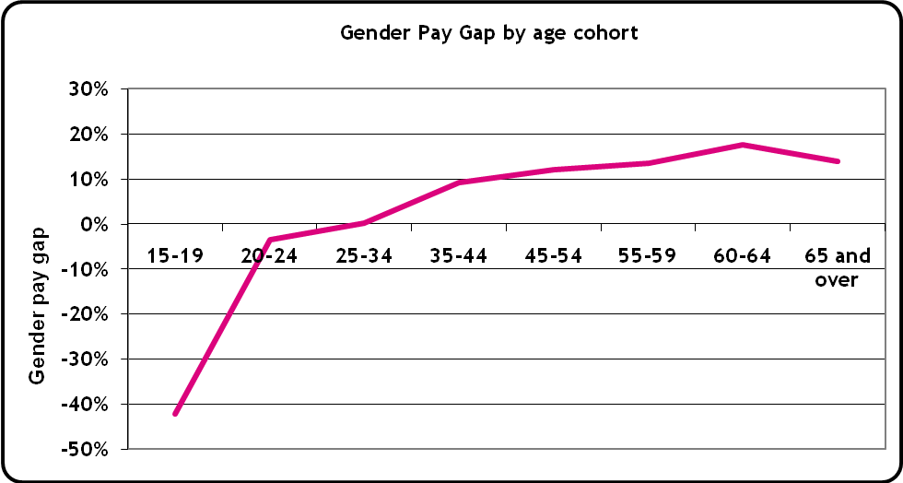

The key observation from Figure 5 is that while the gap is negative up to the 20 – 24 age group, the positive gender pay gap increases with age with a slight drop for employees aged 65 and over.

Figure 6 outlines annual salary across the Service in $10,000 increments by gender. This annual salary profile excludes casual employees.

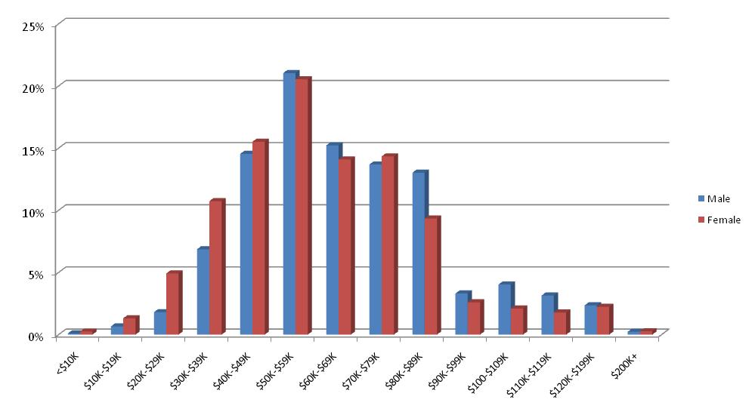
Figure 6: Annual salary by Gender Profile (excluding casuals) as a percentage of each gender
% of employees
Annual Salary

Figure 6 outlines that there is a relatively consistent proportion of female to male employees by the increments across the ACTPS, although there is clearly some imbalance in the proportion of male and female employees in the $30,000-$39,999 and $80,000-$89,999 brackets.

Amongst female employees, 11 per cent (or 1,277 employees) receive on average an annual salary of $30,000-$39,999, while amongst male employees, seven per cent (or 419 employees) receive on average an annual salary of $30,000-$39,999.

Amongst male employees, 13 per cent (or 795 employees) receive on average an annual salary of $80,000-$89,999, while amongst female employees, nine per cent (or 1,110 employees) receive on average an annual salary of $80,000-$89,999.

Abbreviations

ACT | Australian Capital Territory
ACTPS | Australian Capital Territory Public Service
ACTPLA | ACT Planning and Land Authority
AG | Auditor-General’s Office
APS | Australian Public Service
ASO | Administrative Services Officer
CFC | Cultural Facilities Corporation
CIT | Canberra Institute of Technology
CIT Sol | CIT Solutions
CMD | Chief Minister’s Department
CPH | Calvary Public Hospital
DET | Department of Education and Training
DECCEW | Department of the Environment, Climate Change, Energy and Water
DHCS | Department of Disability, Housing and Community Services
DT | Department of Treasury
EPIC | Exhibition Park in Canberra
FTE | Full-time Equivalent
G&RC | Gambling and Racing Commission
HR | Human Resources
InTACT | Information Technology ACT
IT | Information Technology
JACS | Department of Justice and Community Safety
LAC | Legal Aid Commission (ACT) – an independent statutory corporation
LAS | Legislative Assembly Secretariat
LDA | Land Development Agency
LSLB | Long Service Leave Board (Construction and Cleaning Industries)
TAMS | Department of Territory and Municipal Services
TAMS - ACTION | ACTION Buses within the Department of Territory and Municipal Services

Attachment 1

Gender Pay Gap by Agency

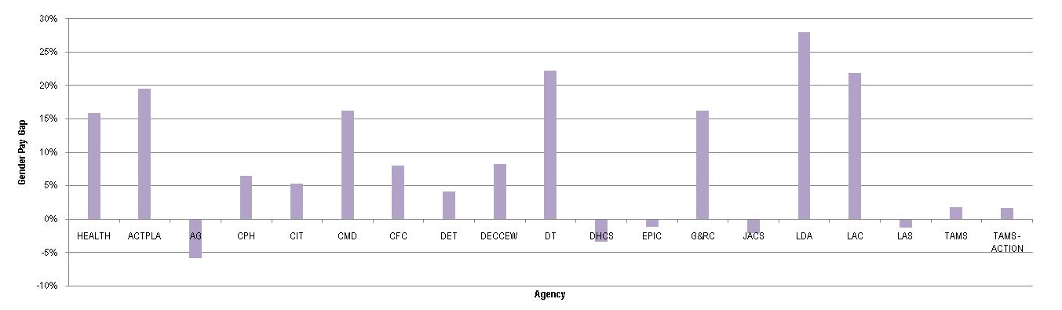

The Chief Minister’s Department’s gender pay gap includes 12 members of the Long Service Leave Board.

Attachment 2 - Classifications

Gender breakdown of classification groupings by agency at June 2009 as a percentage of total agency workforce

Classification Group | Health | ACTPLA | AG | CPH | CIT | CMD | CIT SOL | CFC | DET | DECCEW | DT | DHCS | EPIC | G&RC | JACS | LDA | LAC | LAS | TAMS | TAMS -ACTION | Total
Administrative Officers | ⁸⁵ / ₁₅ | ⁶⁸ / ₃₂ | ¹⁰⁰ / ₀ | ⁹⁰ / ₁₀ | ⁸⁴ / ₁₆ | ⁸⁵ / ₁₅ | ⁸⁴ / ₁₆ | ⁵⁷ / ₄₃ | ⁸⁹ / ₁₁ | ⁷⁷ / ₂₃ | ⁷⁴ / ₂₆ | ⁶⁶ / ₃₄ | ⁵⁰ / ₅₀ | ⁶³ / ₃₇ | ⁶² / ₃₈ | ⁷⁸ / ₂₂ | ⁸² / ₁₈ | ⁵⁷ / ₄₃ | ⁶⁴ / ₃₆ | ⁵² / ₄₈ | ⁷⁷ / ₂₃
Ambulance Officers | ⁻ | ⁻ | ⁻ | ⁻ | ⁻ | ⁻ | ⁻ | ⁻ | ⁻ | ⁻ | ⁻ | ⁻ | ⁻ | ⁻ | ³⁵ / ₆₅ | ⁻ | ⁻ | ⁻ | ⁻ | ⁻ | ³⁵ / ₆₅
Bus Operators | ⁻ | ⁻ | ⁻ | ⁻ | ⁻ | ⁻ | ⁻ | ⁻ | ⁻ | ⁻ | ⁻ | ⁻ | ⁻ | ⁻ | ⁻ | ⁻ | ⁻ | ⁻ | ⁻ | ⁹ / ₉₁ | ⁹ / ₉₁
Correctional Officers | ⁻ | ⁻ | ⁻ | ⁻ | ⁻ | ⁻ | ⁻ | ⁻ | ⁻ | ⁻ | ⁻ | ⁻ | ⁻ | ⁻ | ²³ / ₇₇ | ⁻ | ⁻ | ⁻ | ⁻ | ⁻ | ²³ / ₇₇
Dental | ⁸⁶ / ₁₄ | ⁻ | ⁻ | ⁻ | ⁻ | ⁻ | ⁻ | ⁻ | ⁻ | ⁻ | ⁻ | ⁻ | ⁻ | ⁻ | ⁻ | ⁻ | ⁻ | ⁻ | ⁻ | ⁻ | ⁸⁶ / ₁₄
Disability Officers | ⁻ | ⁻ | ⁻ | ⁻ | ⁻ | ⁻ | ⁻ | ⁻ | ¹⁰⁰ / ₀ | ⁻ | ⁻ | ⁵⁶ / ₄₄ | ⁻ | ⁻ | ⁻ | ⁻ | ⁻ | ⁻ | ⁻ | ⁻ | ⁵⁶ / ₄₄
Chief Executives/Executives | ⁵⁸ / ₄₂ | ⁰ / ₁₀₀ | ³³ / ₆₇ | ⁻ | ⁵⁰ / ₅₀ | ³⁷ / ₆₃ | ⁰ / ₁₀₀ | ¹⁰⁰ / ₀ | ⁵⁹ / ₄₁ | ³⁸ / ₆₃ | ³¹ / ₆₉ | ⁵⁰ / ₅₀ | ⁰ / ₁₀₀ | ⁰ / ₁₀₀ | ⁴⁰ / ₆₀ | ⁰ / ₁₀₀ | ⁰ / ₁₀₀ | ⁰ / ₁₀₀ | ³³ / ₆₇ | ⁰ / ₁₀₀ | ³⁹ / ₆₁
Fire Brigade Officers | ⁻ | ⁻ | ⁻ | ⁻ | ⁻ | ⁻ | ⁻ | ⁻ | ⁻ | ⁻ | ⁻ | ⁻ | ⁻ | ⁻ | ² / ₉₈ | ⁻ | ⁻ | ⁻ | ⁻ | ⁻ | ² / ₉₈
General Service Officers & Equiv | ⁴³ / ₅₇ | ⁰ / ₁₀₀ | ⁻ | ²⁵ / ₅ | ³³ / ₆₇ | ⁻ | ⁻ | ²⁵ / ₇₅ | ⁵ / ₉₅ | ⁻ | ⁻ | ²⁵ / ₇₅ | ¹⁷ / ₈₃ | ⁻ | ⁰ / ₁₀₀ | ⁻ | ⁻ | ⁻ | ⁸ / ₉₂ | ¹² / ₈₈ | ²³ / ₇₇
Graduate Administrative Officers | ¹⁰⁰ / ₀ | ⁻ | ⁻ | ⁻ | ¹⁰⁰ / ₀ | ⁰ / ₁₀₀ | ⁻ | ⁻ | ¹⁰⁰ / ₉ | ⁰ / ₁₀₀ | ⁻ | ⁷⁵ / ₂₅ | ⁻ | ⁻ | ⁸⁰ / ₂₀ | ⁵⁰ / ₅₀ | ⁻ | ⁻ | ¹⁰⁰ / ₀ | ⁻ | ⁶⁸ / ₃₂
Health Professional Officers | ⁷⁸ / ₂₂ | ⁻ | ⁻ | ⁸¹ / ₁₉ | ⁻ | ⁻ | ⁻ | ⁻ | ⁹³ / ₇ | ⁻ | ⁻ | ⁸⁹ / ₁₁ | ⁻ | ⁻ | ⁹¹ / ₉ | ⁻ | ⁻ | ⁻ | ⁻ | ⁻ | ⁸¹ / ₁₉
Information Technology Officers | ⁰ / ₁₀₀ | ⁰ / ₁₀₀ | ⁻ | ⁰ / ₁₀₀ | ⁻ | ⁻ | ⁻ | ⁻ | ¹⁰ / ₉₀ | ⁻ | ⁻ | ⁻ | ⁻ | ⁻ | ⁻ | ⁻ | ⁰ / ₁₀₀ | ⁰ / ₁₀₀ | ¹³ / ₈₇ | ⁻ | ¹² / ₈₈
Judicial Officers | ⁻ | ⁻ | ⁻ | ⁻ | ⁻ | ⁻ | ⁻ | ⁻ | ⁻ | ⁻ | ⁻ | ⁻ | ⁻ | ⁻ | ³⁸ / ₆₃ | ⁻ | ⁻ | ⁻ | ⁻ | ⁻ | ³⁸ / ₆₃
Legal Officers | ⁻ | ⁻ | ⁻ | ⁻ | ⁻ | ⁻ | ⁻ | ⁻ | ⁻ | ⁻ | ⁻ | ¹⁰⁰ / ₀ | ⁻ | ⁻ | ⁶⁰ / ₄₀ | ⁻ | ⁵² / ₄₈ | ⁻ | ⁻ | ⁻ | ⁵⁹ / ₄₁
Medical Officers | ⁴³ / ₅₇ | ⁻ | ⁻ | ⁴⁶ / ₅₄ | ⁻ | ⁻ | ⁻ | ⁻ | ⁻ | ⁻ | ⁻ | ⁻ | ⁻ | ⁻ | ⁻ | ⁻ | ⁻ | ⁻ | ⁻ | ⁻ | ⁴⁴ / ₅₆
Nursing Staff | ⁹¹ / ₉ | ⁻ | ⁻ | ⁹⁰ / ₁₀ | ⁻ | ⁻ | ⁻ | ⁻ | ⁻ | ⁻ | ⁻ | ⁻ | ⁻ | ⁻ | ⁻ | ⁻ | ⁻ | ⁻ | ⁻ | ⁻ | ⁹¹ / ₉
Linen Production & Maintenance | ⁻ | ⁻ | ⁻ | ⁻ | ⁻ | ⁻ | ⁻ | ⁻ | ⁻ | ⁻ | ⁻ | ⁻ | ⁻ | ⁻ | ⁻ | ⁻ | ⁻ | ⁻ | ⁵⁷ / ₄₃ | ⁻ | ⁵⁷ / ₄₃
Professional Officers | ⁶⁰ / ₄₀ | ⁷⁵ / ₂₅ | ³⁷ / ₆₃ | ¹⁰⁰ / ₀ | ⁸⁵ / ₁₅ | ⁻ | ⁻ | ⁸⁹ / ₁₁ | ¹⁰⁰ / ₀ | ²⁰ / ₈₀ | ⁻ | ¹⁰⁰ / ₀ | ⁻ | ⁻ | ⁶⁷ / ₃₃ | ⁻ | ⁻ | ⁻ | ⁶³ / ₃₇ | ⁻ | ⁷⁰ / ₃₀
Rangers | ⁻ | ⁻ | ⁻ | ⁻ | ⁻ | ⁻ | ⁻ | ⁻ | ⁻ | ⁻ | ⁻ | ⁻ | ⁻ | ⁻ | ⁻ | ⁻ | ⁻ | ⁻ | ²⁷ / ₇₃ | ⁻ | ²⁷ / ₇₃
School Leaders | ⁻ | ⁻ | ⁻ | ⁻ | ⁻ | ⁻ | ⁻ | ⁻ | ⁷¹ / ₂₉ | ⁻ | ⁻ | ⁻ | ⁻ | ⁻ | ⁻ | ⁻ | ⁻ | ⁻ | ⁻ | ⁻ | ⁷¹ / ₂₉
Senior Officers | ⁶⁹ / ₃₁ | ⁴⁰ / ₆₀ | ⁻ | ⁵⁶ / ₄₄ | ⁵⁵ / ₄₅ | ⁵³ / ₄₇ | ³⁵ / ₆₅ | ²² / ₇₈ | ⁶⁴ / ₃₆ | ⁵² / ₄₈ | ⁴³ / ₅₈ | ⁶² / ₃₈ | ¹⁰⁰ / ₀ | ³⁶ / ₆₄ | ⁵⁴ / ₄₆ | ⁴² / ₅₈ | ³³ / ₆₇ | ⁷⁶ / ₂₄ | ³⁹ / ₆₁ | ²⁷ / ₇₃ | ⁵¹ / ₄₉
Teachers | ¹⁰⁰ / ₀ | ⁻ | ⁻ | ⁻ | ⁵⁶ / ₄₄ | ⁻ | ⁷³ / ₂₇ | ⁻ | ⁷⁸ / ₂₂ | ⁻ | ⁻ | ⁻ | ⁻ | ⁻ | ⁻ | ⁻ | ⁻ | ⁻ | ⁻ | ⁻ | ⁷⁴ / ₂₆
Technical Officers | ⁷¹ / ₂₉ | ³⁶ / ₆₄ | ⁻ | ⁷⁶ / ₂₄ | ³⁶ / ₆₄ | ⁻ | ⁻ | ⁻ | ⁻ | ⁵⁰ / ₅₀ | ⁻ | ⁵⁰ / ₅₀ | ⁻ | ⁻ | ⁻ | ⁻ | ⁻ | ⁰ / ₁₀₀ | ²² / ₇₈ | ⁷ / ₉₃ | ⁴⁹ / ₅₁
Trainees & Apprentices | ⁵⁰ / ₅₀ | ⁻ | ⁻ | ⁻ | ⁰ / ₁₀₀ | ⁻ | ⁻ | ⁻ | ⁻ | ⁻ | ⁻ | ⁻ | ⁻ | ⁻ | ⁰ / ₁₀₀ | ⁻ | ⁻ | ⁻ | ²⁰ / ₈₀ | ²⁵ / ₇₅ | ²¹ / ₇₉
Total | ⁷⁷ / ₂₃ | ⁵¹ / ₄₉ | ⁴⁰ / ₆₀ | ⁸¹ / ₁₉ | ⁶¹ / ₃₉ | ⁶³ / ₃₇ | ⁷⁰ / ₃₀ | ⁵⁶ / ₄₄ | ⁷⁸ / ₂₂ | ⁵⁶ / ₄₄ | ⁵⁹ / ₄₁ | ⁶⁸ / ₃₂ | ³⁶ / ₆₄ | ⁵² / ₄₈ | ⁴¹ / ₅₉ | ⁵¹ / ₄₉ | ⁶² / ₃₈ | ⁶⁰ / ₄₀ | ⁴⁴ / ₅₆ | ¹¹ / ₈₉ | ⁶⁶ / ₃₄
Figures in this table are percentages rounded to the nearest decimal place (Female / Male). The Chief Minister’s Department’s figures included 12 members of the Long Service Leave Board.

For continuity purposes, General Government Sector (Departments); Other Entities; and Public Trading Enterprises, are referred to generically as ‘agencies’ throughout this report.
The calculation of average age includes casual employees across the ACTPS and may impact those classifications which have a high number of casual employees such as teachers and nursing staff.
The calculation of length of service includes casual employees across the ACTPS and may impact those classifications which have a high number of casual employees such as teachers and nursing staff.
Department of Commerce, Western Australia Government, Pay Equity – Factsheets - The gender pay gap in the WA public sector
Department of Commerce, Western Australia Government, Pay Equity – About the Statistics http://www.commerce.wa.gov.au/LabourRelations/Content/Work%20Life%20Balance/Pay%20Equity/About_PE_statistics.html
In this section, the calculation of the gender pay gap uses the anticipated annual salary instead of what is actually paid to the employee. It does not include allowances and other pay components. In the majority of cases, it represents the salary assigned to the classification of the employee. Casual employee records are excluded in the calculation as it is difficult to estimate an annual salary for these employees as a result of their fluctuating work patterns. Some employee records were excluded from the gender pay equity calculation as these employees did not work during the reporting pay period (ie only a separation or termination payment was made). Of these exclusions, 66 per cent were female employee and 34 per cent were male employees.
Australian Bureau of Statistics, Commonwealth Government, Average Weekly Earnings - States & Territories: Trend (6302.0)
The Chief Minister’s Department’s gender pay gap includes 12 members of the Long Service Leave Board.
Average amount earned by female employees for every dollar earned by male employees.
The Chief Executive/Executives category includes statutory office holders.

