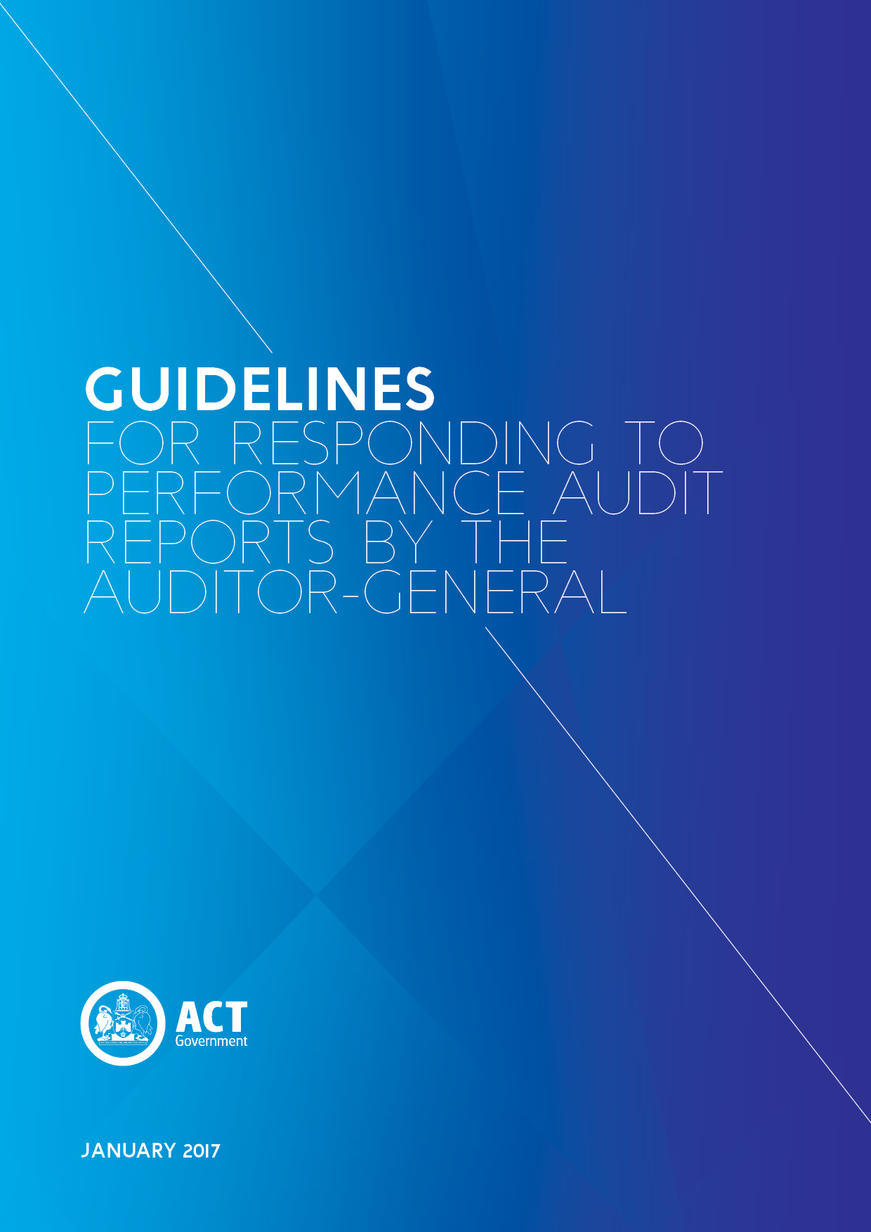

Process for Responding to Performance Audit Reports
Auditor-General formally commences audit. Arrangements are put in place for communicating with auditee/s and for obtaining information and data.
(Lead Directorate nominates a senior point of contact to lead coordinated engagement.)

Auditor-General provides relevant directorates with draft proposed report, which may contain recommendations.

Directorates provide a response to the Auditor-General on the draft proposed report.
(Directorate responses should be focused on correcting factual inaccuracies, providing additional information where necessary and clarifying any misinterpretations)

Auditor-General provides relevant directorates with final proposed report, which may contain recommendations.

Directorates provide a management response to the Auditor-General on the final proposed report. Directorates have the opportunity to provide comments for inclusion in the final report.
(Directorate responses should bring attention to any further issues they wish to raise, or otherwise advise that there are no further issues.)

Auditor-General’s report presented to the Speaker
All reports are automatically referred to the Standing Committee on Public Accounts (PAC) for consideration and report.

Government prepares a response to the Auditor-General’s report. Government Response is tabled within four months, or provided to the Speaker within four months and tabled on the next day of sitting.

PAC advises nil further inquiry OR PAC tables a report on the audit report
Government response to the PAC recommendations is tabled within four months OR provided to the Speaker within four months and tabled on the next day of sitting.

Government implements its response to the Auditor-General’s report and any subsequent PAC report.

The Government is committed to timely and thorough consideration of, and response to, recommendations made by the Auditor-General and Assembly Committees.
Table of Contents
Auditor-General Performance Audit 4
Conduct of Audit 4
Preparation and Finalisation of Report 4
Tabling of the Auditor-General’s report 4
Government Response to the Auditor-General’s Report 5
Preparation of Response 5
Cabinet Approval 5
Timeframe for Response 5
Public Accounts Committee Inquiry 6
Consideration of Auditor-General report 6
Nil further inquiry into the audit report 6
Further inquiry and report on the audit report 6
Government Response to the PAC’s Report 6
Preparation of Response 6
Cabinet Approval 7
Timeframe for Response 7
Implementation and Follow Up 7
Implementation Plans 7
Implementation 7
Review of reports by internal audit committees 8
Contact for Further Information 8
Appendix A: Responding to Recommendations 9
Appendix B: Format for the Government Response 10
Appendix C: Development of a Whole of Government Action Plan 12
Appendix D: Implementation and Monitoring of Agreed Recommendations 13

Auditor-General Performance Audit
A typical performance audit may involve various stages, and take an average of six to nine months for the Auditor-General’s Office to complete, depending on the complexity and scope of the audit. More information on performance audits can be found on the Auditor-General’s website including the annual performance audit program. The functions and powers of the Auditor-General are outlined in the Auditor-General Act 1996.

Conduct of Audit
- Once the Auditor-General formally commences an audit, the Audit Office makes arrangements for communicating with relevant directorates, and for obtaining information and data.
- Each directorate should nominate a senior point of contact to lead a coordinated engagement for a given audit. This ensures consistency of approach and eliminates the prospect of duplication where more than one area is working to obtain or produce the same or similar information.

Preparation and Finalisation of Report
- Before presenting a report to the Speaker, the Auditor-General consults with relevant directorate/s on a proposed report in two stages:
  - Firstly, the Auditor-General provides a draft proposed report, which may contain recommendations. Directorate responses to the draft proposed report should be focused on correcting factual inaccuracies, providing additional information where necessary and clarifying misinterpretations.
  - Secondly, the Auditor-General provides a final proposed report, which may contain recommendations. Management responses may include comments for inclusion in the final report. Any further issues for the Auditor-General’s consideration should be raised at this stage.
- Before providing responses at either stage, directorates must brief the relevant minister/s on the content of the audit report, including any recommendations, and propose a response to the Auditor-General. On no account should a directorate response, at either stage, commit the government to a course of action.

Tabling of the Auditor-General’s report
- Once an audit report is finalised, including any comments received from directorates, the Auditor-General forwards the report to the Speaker of the Legislative Assembly. An audit report is deemed to have been presented to the Assembly upon provision to the Speaker, under the Auditor-General Act 1996, but is also tabled by the Speaker at the next sitting.
- An audit report is immediately referred to the Standing Committee on Public Accounts (PAC), for inquiry and report, upon presentation to the Speaker.

Government Response to the Auditor-General’s Report

Preparation of Response
- These Guidelines are intended to facilitate timely and thorough consideration of, and response to, recommendations made by the Auditor-General.
- The Government’s response should clearly articulate the government’s position in relation to each recommendation/finding. Detailed guidance for assessing individual recommendations/findings is provided at Appendix A. An example format for the Government response is provided at Appendix B.

Cabinet Approval
- A Cabinet submission proposing and seeking approval to a Government Response to an Auditor-General’s report must be prepared and circulated in accordance with the Cabinet Handbook and Cabinet Paper Drafting Guide.
- The Cabinet Submission should summarise the main recommendations and findings of the Auditor-General’s report. While the Cabinet Submission should not replicate detailed information from the Government Response, it should include sufficient detail to support proposed positions. Particular attention should be paid to any recommendations/findings that are not proposed to be supported.
- The Cabinet Submission must include a Whole of Government Action Plan (Appendix C), setting out the process for implementing the recommendations/findings that are accepted by the government – Note: this implementation Plan is for Cabinet consideration only and is NOT to be tabled in the Legislative Assembly with the Government Response.
- Directorates must ensure that all papers are provided within agreed timeframes and must keep the Cabinet Office informed about the progress of the Government response with respect to forecast dates for Cabinet consideration.

Timeframe for Response
- A government response to the audit report must be prepared for tabling in the Assembly, and for provision to the PAC to assist in deciding if it will conduct a further inquiry.
- The timeframe for preparation and tabling of a response to an audit report is four months. If the Assembly is not sitting when the government response is due, the responsible minister may present the response to the Speaker for out of session circulation, with the response to be tabled in the Assembly on the next day of sitting.
- During years in which an ACT General Election is to be held, wherever possible, the Government should present its response to the performance audit reports prior to the commencement of the Caretaker period.

Public Accounts Committee Inquiry

Consideration of Auditor-General report
- The Government response to an audit report is a key document to assist the PAC in its examination of the report. In its examination of an audit report, the PAC may invite public submissions on the report and/or the Government response.
- In the event that public servants are asked to appear before a Committee inquiry into an audit report, they should follow the processes outlined in the Handbook for ACT Government Officials on Participation in Assembly and Other Inquiries.
- There is no fixed period in which PAC is required to bring down its report, or advise the Assembly of its resolution to not inquire further.
- After considering the Auditor-General’s report, and any other information and evidence it considers relevant, including the Government Response to the Auditor-General’s Report, the PAC may proceed on one of two ways:

Nil further inquiry into the audit report
- If PAC resolves not to inquire into an Auditor-General report, the Government need not make any further response, provided that a response to the audit report has been tabled.
- Should the Government wish to add to or amend its earlier response, there is no set timeframe for preparation and tabling of such a response.
- It is important to ensure implementation and appropriate follow up occurs regardless of whether the PAC resolves to not inquire further into an Auditor-General report.

Further inquiry and report on the audit report
- Further inquiries by the PAC may include further public consultation and/or further requests for information from the Government.
- Once the PAC has finalised its report, it will table the report in the Assembly in the same way as for other Committee reports.

Government Response to the PAC’s Report

Preparation of Response
- A government response to the PAC report must be prepared for tabling in the Assembly, and for provision to the PAC. A Cabinet submission proposing a government response should include any required revision of the Whole of Government Action plan.
  - If the PAC report raises no additional issues and makes no further recommendations beyond the issues and recommendations set out in the audit report, the Government’s response may simply reference its response to the audit report.
  - If the PAC raises additional issues, or makes further recommendations, or if the Government otherwise wishes to revise its earlier response, a full Government response should be prepared.
- The Government’s response should be prepared and clearly articulate the government’s position in relation to each recommendation/finding. Before a government position can be determined, each of the recommendations/findings needs to be assessed (Appendix A). An example format for the Government response is provided at Appendix B.

Cabinet Approval
- A Cabinet submission proposing and seeking approval to a Government Response must be prepared and circulated in accordance with the Cabinet Handbook and Cabinet Paper Drafting Guide.
- The Cabinet Submission should summarise the main recommendations and findings of the PAC’s report. While the Cabinet Submission should not replicate detailed information from the Government Response, it should include sufficient detail to support proposed positions. Particular attention should be paid to any recommendations/findings that are not proposed to be supported.
- The Whole of Government Action Plan (Appendix C) must be revised as necessary, reflecting the PAC recommendations/findings that are accepted by the government, and attached to the Cabinet submission – Note: this implementation Plan is for Cabinet consideration only and is NOT to be tabled in the Legislative Assembly with the Government Response.

Timeframe for Response
- The timeframe for preparation and tabling of a response to PAC report on an audit report is four months. If the Assembly is not sitting when the government response is due, the responsible minister may present the response to the Speaker for out of session circulation, with the response to be tabled in the Assembly on the next day of sitting.

Implementation and Follow Up

Implementation Plans
- All affected directorates should prepare individual internal implementation plans for implementing supported recommendations within their directorate. These plans should be based on, and consistent with, the government’s position in respect to the report recommendations and the Whole of Government Action plan. Directorates not directly affected by a report recommendation should consider whether there is a need to adjust their own operations, and if so, prepare individual action plans.

Implementation
- Implementation on a given audit report commences, as applicable, once agreed by Cabinet and subject to any revision required by the Government’s response to the PAC report.
- Each Directorate must have in place a satisfactory process for implementing and monitoring accepted report recommendations, including the following key responsibilities:
  - Maintaining a register of audit recommendations that monitors implementation and ensures that appropriate action takes place within a reasonable timeframe;
  - Actively monitor implementation activity, through to completion; and
  - Internally report progress to Directorate management, particularly where progress appears deficient.
- It is important to ensure implementation and appropriate follow up occurs regardless of whether the PAC inquires further into an Auditor-General report.
- A summary of the minimum Directorate actions for implementing and following up supported report recommendations is at Appendix D.
- Under the annual report directions, directorates are required to provide information about relevant Auditor-General reports issued in the reporting year, including summary details of the recommendations and the government’s response.
- Special attention will be required whenever Government/Directorate restructuring occurs to ensure that implementation is not overlooked.

Review of reports by internal audit committees
- The government has agreed Auditor-General reports will be reviewed by every directorate’s internal audit committee, whether or not the directorate was involved in the audit, with an internal action plan to be prepared as applicable.

Contact for Further Information
Manager
Government Business Coordination
Chief Minister, Treasury and Economic Development Directorate
Ph: 620 50543

APPENDIX A

Appendix A: Responding to Recommendations
- Before a Government response can be determined, each of the recommendations needs to be assessed:
  - Identification and consideration of policy issues. The government’s policy position will be guided by existing polices relevant to the issues raised by the report. On certain matters it may be necessary/appropriate to seek the initial views of the relevant minister/s on particular policy matters.
  - Identification of budgetary implications. This involves consultation with Treasury to cost the financial and human resources necessary to implement the recommendations, and assessing the availability of necessary skills and knowledge within the ACT Public Service.
  - Consideration of whole of government issues. It is necessary to consider issues from a whole of government perspective and to identify issues that may require coordination between agencies. The lead agency should contact relevant agencies as soon as possible to ensure that any necessary input is developed and provided in a timely manner.
  - Review of previous related matters. It may be useful to give consideration to previous Government responses to similar or related matters.
- The Government position should be clearly articulated and defensible, particularly where it is proposed not to support a particular issue. Responses against a given recommendation generally fall within one of four categories:
  - Agreed – relevant details of the proposed implementation strategy should be included with the response.
  - Agreed-in-principle – this may be appropriate where the government generally supports a finding or policy approach, but does not necessarily agree with particular specifications in the report.
  - Not agreed – a detailed explanation should be included whenever a position of not agreed is proposed. It may be appropriate to offer alternative solutions/approaches.
  - Noted – this may be appropriate where the government considers no specific action or response is necessary.

APPENDIX B

Appendix B: Format for the Government Response

[year]

THE LEGISLATIVE ASSEMBLY FOR
THE AUSTRALIAN CAPITAL TERRITORY

GOVERNMENT RESPONSE TO

Auditor General’s Report
or
Public Accounts committee’s Report
[delete whichever does not apply]

No … [Report Subject]

Presented by
[Minister's name]
[Minister's portfolio]

Government Response [title]

Introduction/Background

<Usually not more than one page.>

Government Position on Recommendations/Findings

Recommendation 1
[full text of recommendation]

Government Position
[Summary response, eg 'agreed', 'not agreed']
[detailed explanation of Government position. Particular attention should be paid to recommendations that are not proposed to be supported]

[Apply the above format for subsequent recommendations, and for any findings which warrant a specific response]

APPENDIX C

Appendix C: Development of a Whole of Government Action Plan
A whole of government action plan needs to be developed to set out the process for implementing the recommendations/findings that are accepted by the Government. The action plan does not form part of the Government Response, but the details provided in the action plan may be reflected within the individual responses to agreed recommendations.
There is no specific requirement as to the form in which an action plan is to be presented, however it should include the following:
- Subject: Auditor-General’s Report No.[X] – [Title]
- Revision: [If revision is necessary, show the relevant PAC report and/or other factor requiring revision]
- Outcome: [Identify the overall desired outcome of the action plan – the outcome may address the Auditor-General’s summary or key findings]
- Detail against each finding or recommendation:
  - Description of finding/recommendation
  - Action/Implementation strategy, including communications strategy
  - Desired outcome
  - Performance measures
  - Date of effect/completion date
  - Monitoring/review process.

APPENDIX D

Appendix D: Implementation and Monitoring of Agreed Recommendations
An appropriate process needs to be established by each agency for implementing and monitoring supported Auditor-General report recommendations and any subsequent revisions required by the Government response to a PAC inquiry.
Actions to be taken by Directorates should include:
- assign responsibility for the implementation of accepted recommendations to a single person or business unit;
- develop an internal action plan that includes a timetable for implementation and clearly outlines roles and responsibilities for the implementation of each recommendation accepted;
- include in the plan mechanisms to monitor and report on results against key indicators where they have been identified in the Auditor-General’s report or PAC report;
- allocate sufficient resources to implement the plan and set realistic and achievable timeframes and targets;
- have the plan endorsed by the Director-General and where appropriate, the Strategic Board and/or the relevant portfolio Minister;
- nominate or establish a committee (if not the internal audit committee) to monitor and report on progress;
- provide regular reports on the progress of implementation of the accepted recommendations to the Director-General and where appropriate, the Strategic Board and/or the relevant portfolio Minister;
- raise staff awareness of the outcomes of the performance audit and invite feedback on how best to implement the recommendations;
- regularly review and monitor the internal action plan and make amendments, where necessary, to maintain relevance and appropriateness; and
- report progress and action taken to address accepted recommendations for significant matters/issues in accordance with annual report directions and, where relevant and applicable, to the Minister and the Legislative Assembly (reporting progress each year until implementation for significant matters/issues is complete).

