
Achieving Results for the Community:
An ACT Government Strategic Service Planning Framework
June 2012

© Australian Capital Territory, Canberra, June 2012

This work is copyright. Apart from any use permitted under the Copyright Act 1968, no part may be reproduced by any process without written permission from the Territory Records Office, Shared Services, Treasury Directorate, ACT Government. GPO Box 158, Canberra City, ACT, 2601

Produced by: Policy and Cabinet Division, ACT Chief Minister and Cabinet Directorate

Contact: Director
Economic, Regional and Planning
Policy and Cabinet Division
Chief Minister and Cabinet Directorate
ACT Government
GPO Box 158
Canberra City ACT 2601
phone: 13 22 81

This publication has been prepared by officers of the Chief Minister and Cabinet Directorate, ACT Government. It is believed that the information is correct and reliable, but neither the authors nor the Directorate give warranty in relation hereto and no liability is accepted by the authors or the Directorate, or any other person who assisted in the preparation of the publication, for errors and omissions, loss or damage suffered as a result of any person acting in reliance thereon.

Last updated: 12 June 2012

Contents
Introduction 1
This document 2
1. What is strategic service planning? 3
Objectives 3
2. Where does strategic service planning fit in the ACT? 5
The ACT Government Strategic Service Planning Framework 5
3. How do we conduct strategic service planning? 7
Principles for strategic service planning 7
Strategic service planning 8
Where we are now – information component 8
Where we want to be – information and decision component 8
How we can get there – options component 9
Who is going to do what and when – assessment and decision component 9
How we will know if we are there – information component 10
Outputs of strategic service planning 10
4. Who should do strategic service planning? 11
Implementation and application 11
Leadership 11
Roles and responsibilities 11
5. How will we improve? 13
References 14
Appendix I – Guidelines for strategic service planning I

List of figures and tables
Figure 1: Strategic service planning — top down/bottom up line of sight 1
Figure 2: Components of strategic service planning 4
Figure 3: ACT Government Strategic Planning Framework 5
Figure 4: Principles for strategic service planning 7
Table 1: Proposed roles for key decision-making bodies 12
Table 2: Accountability arrangements 12

Introduction
The ACT Government is committed to delivering high quality public services to the Canberra community. In order to achieve the best results for the community, the Government must effectively and efficiently plan for the future.
The ACT Government has a long-term vision. The Government works hard to deliver on this vision for the community in an increasingly complex public policy environment.
However, in the process of refreshing the ACT Government performance and accountability framework, opportunities to strengthen medium-term planning were identified. Strengthened medium-term planning processes will better align annual planning processes and resource allocation with the long-term vision of Government.
Specifically, through strengthened planning processes, a clearer line of sight will emerge between:
- the overarching strategic direction of Government as set out in the Canberra Plan: Towards our Second Century;
- Directorate strategic direction;
- the services Directorates deliver; and
- the resource requirements of services (as reflected in the Budget papers).
Figure 1: Strategic service planning — top down/bottom up line of sight
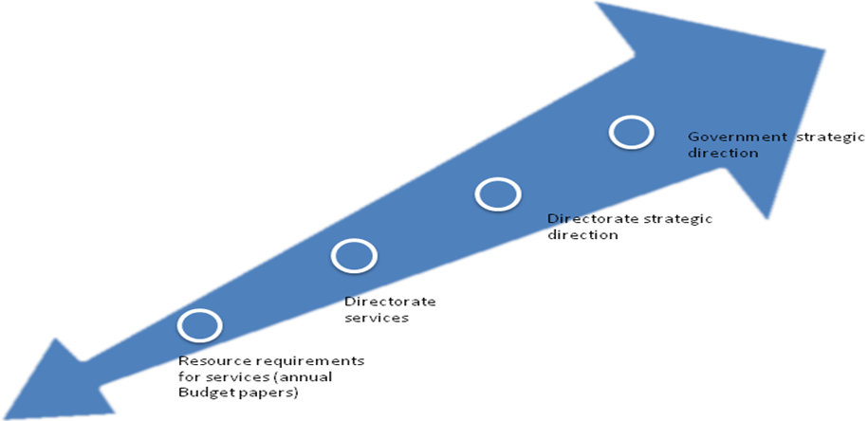
Source: Chief Minister and Cabinet Directorate (2012).
Strengthening Performance and Accountability: A Framework for the ACT Government (the ACT Government Performance and Accountability Framework) includes a range of actions to enhance government service delivery and ensure transparent, accountable decision-making and resource allocation, premised on continuous improvement. This document, Achieving Results for the Community: An ACT Government Strategic Service Planning Framework, will outline a plan of improvement for medium-term planning in the ACT Government.

This document
This document will assist, guide and further build the strategic planning capacity of ACT Government Directorates. It will be implemented across Government under the ACT Government Performance and Accountability Framework.
This document comprises five sections, as follows:
- Definition and objectives – what is strategic service planning?
- Relevance in the ACT – where does strategic service planning fit in the ACT?
- Process and principles – how do we conduct strategic service planning?
- Implementation – who should do strategic service planning?
- Review – how will we improve?

1. What is strategic service planning?
Services are the outputs of the ACT Government Directorates. All ACT Government Directorates deliver services; to either the community, other Directorates, and/or the Government.
Strategic service planning is a medium-term planning process. It ensures a robust planning process to improve organisational performance and accountability to deliver more appropriate, efficient and effective public services.
Strategic service planning is informed by operational service planning while also being enriched by other processes, including collaboration and communication across Directorates, and the Government’s strategic priority setting process.

Objectives
The overarching objective of strengthening medium-term planning processes is to achieve better results for the community. This will be done by:
- providing consistency between Directorate planning processes across Government;
- enhancing transparency of planning processes and resource allocation;
- ensuring the most effective and efficient delivery of services by Directorates;
- informing decision makers; and
- improving the coordination and distribution of services in the community.
Like all strategic planning processes, strategic service planning will encompass generic steps, including determining:
- where we are now;
- where we want to be;
- how we can get there;
- who is going to do what and when; and
- how we will know if we are there.
Strategic service planning, as distinct from more generic strategic planning, is made up of the components represented in figure 2.
Figure 2: Components of strategic service planning
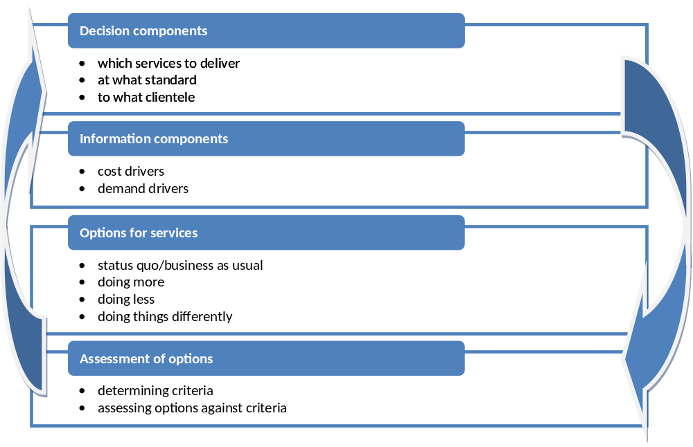
Source: Adapted from Centre for International Economics (2011).

2. Where does strategic service planning fit in the ACT?
Figure 3 outlines the ACT Government Strategic Planning Framework, highlighting where strategic service planning is located within the Framework. It shows the relationship between the Government’s long-term vision, Government strategic priority setting, strategic service planning and the Budget papers.
The central location of this process will ensure that key decision-making processes are better integrated in the ACT.
Figure 3: ACT Government Strategic Planning Framework
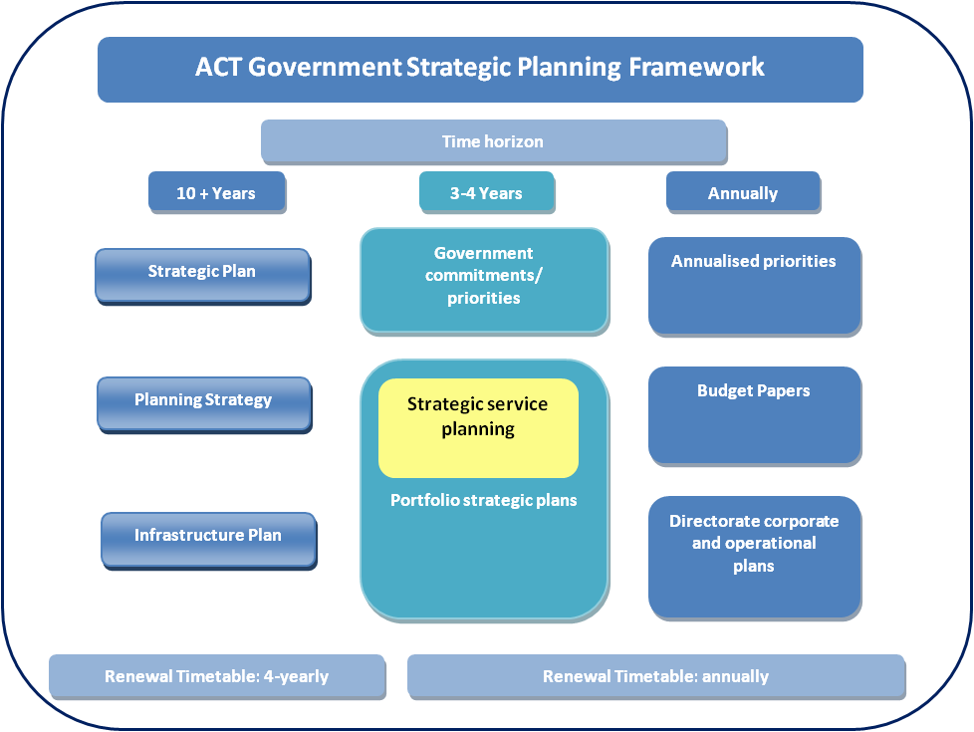
Source: Chief Minister and Cabinet Directorate (2012).

The ACT Government Strategic Service Planning Framework
Chief Minister and Cabinet Directorate (CMCD) have led the development of the ACT Government Strategic Service Planning Framework under the ACT Government Performance and Accountability Framework. CMCD have relied heavily on the input and expertise of all ACT Government Directorates. CMCD also engaged the Centre for International Economics (CIE) to review best practice service planning in the ACT and other jurisdictions.
This Strategic Service Planning Framework has been developed as a fit-for-purpose framework for the ACT Government to allow for the diverse range of Government activity undertaken in the Territory. It is designed to support and strengthen a flexible and dynamic process of planning rather than be a prescriptive, static requirement for Directorates.
The Strategic Service Planning Framework will build on and refine existing planning process to strengthen clear direction setting for Directorates. It will also encourage innovative options for the way we get there to be developed, discussed and decided.
The principles of strategic service planning set a high standard for a process that will achieve real results and improvement for the community and the Government.

3. How do we conduct strategic service planning?

Principles for strategic service planning
The principles identified in figure 4 should guide the strategic planning process. These principles form the basis of the more detailed guidelines in Appendix I.
Figure 4: Principles for strategic service planning
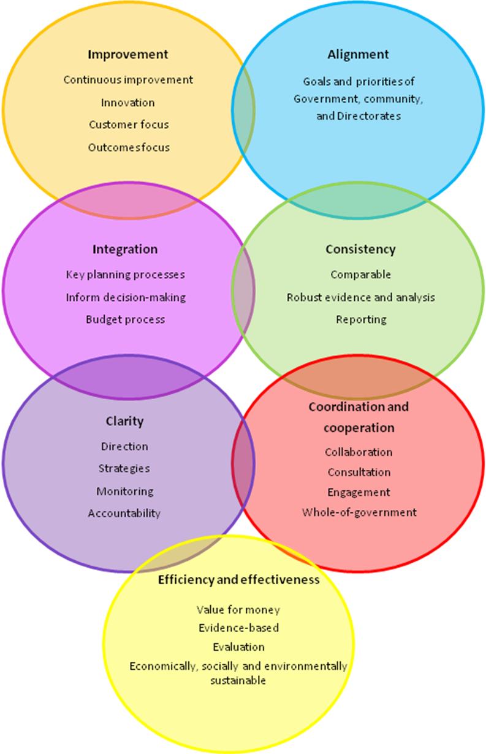
Source: Chief Minister and Cabinet Directorate (2011).

Strategic service planning
As outlined in section 1. What is Strategic Service Planning, strategic service planning encompasses the following steps:
- where we are now;
- where we want to be;
- how we can get there;
- who will do what and when; and
- how we will know if we are there.
These steps, and their relationship to the components of strategic service planning, are outlined below.

Where we are now – information component
In order to know ‘where we are going’, we need to know ‘where we are now’. This will require a situation analysis.
A situation analysis entails:
- a review of Directorate history and achievements to understand any relevant change already undertaken by the Directorate;
- an assessment of current performance to identify areas where the Directorate is achieving real results, as well as areas for improvement; and
- identification of the current influences on this performance, as well as other environmental factors, to identify changes that may affect performance into the future.
This step will inform decisions about the potential need to change, cease or continue service delivery to achieve results for the community.

Where we want to be – information and decision component
To improve we need to have a clear direction of where we want to be. To determine where we want to be, Directorates should identify:
- objectives (aligned with Government priorities);
- priority areas for action under these goals; and
- appropriate performance indicators for these objectives.

How we can get there – options component
To get ‘where we want to be’ from ‘where we are now’ we need to know what the difference between these states is, and how to address this difference. This is best achieved through:
- a gap analysis;
- identifying options for improvement or change including:
- status quo/business as usual – provision of existing services;
- doing more;
- doing less; and
- doing things differently; and
- identifying and considering risks which could impact on achieving Directorate or Government objectives.
This step will see the preparation of options for achieving results. These options will be consulted on and presented to appropriate decision makers for consideration.

Who is going to do what and when – assessment and decision component
Once a suite of options has been prepared to achieve Directorate objectives, it will be necessary to make decisions about which services should be provided, where they should be provided and to whom they should be provided.
The results of the ‘how we can get there’ step should be communicated to a decision-making body by presenting:
- options for services, improvements and innovations;
- the evidence for the service need and demand;
- options for collaboration across Government;
- financial implications; and
- the rationale and evidence supporting each option.
Presentation of this information will allow decision makers to:
- ensure the most effective and efficient delivery of services by Directorates;
- determine which Directorates should deliver which services or portions of services; and
- decide an appropriate mix of services that:
- contribute to Directorate strategic objectives and, through them, the overarching direction of Government;
- most effectively achieves desired results; and
- reflect the best investment.
The strategic service planning decision-making process will need to be integrated with other key decision-making processes in the ACT, including the annual Government priority setting process and the Budget process. Strategic service planning should be involved in a ‘top down/bottom up’ relationship with all Government strategic planning processes.
The timing of strategic service planning should reflect this relationship, with Directorates beginning the strategic service planning cycle early in the financial year so that decisions about service type, quality and mix can inform business case development and, through this, the Budget papers.
‘Who is going to what and when’ reflects both the assessment and decision-making components of service planning.

How we will know if we are there – information component
It is important to measure the impact of government services to know if we achieved what we set out to do. Reviewing performance through well planned evaluation activity, and measuring progress against appropriate indicators, will provide this information.
Strategic service planning will be an annual process to allow the Government the flexibility to adapt and modify services as well as respond to emerging needs.

Outputs of strategic service planning
The robust strategic service planning process, as outlined above, will ensure there is a ‘line of sight’ between the vision and goals of Government and the resources allocated to achieve this (as reflected in the Budget papers).
In light of this, the primary output of strategic service planning is the process. However, the decisions and outcomes of this process will be publicly reflected in refined versions of existing Directorate strategic or corporate plans.

4. Who should do strategic service planning?
All ACT Government Directorates undertake strategic service planning.

Implementation and application
The application of strategic service planning as outlined under The ACT Government Performance and Accountability Framework should be at the Directorate strategic planning level. Directorate strategic planning already occurs within ACT Government Directorates. This Strategic Service Planning Framework should not replace those processes; rather, it should strengthen them. This Strategic Service Planning Framework will provide an opportunity to streamline processes and achieve consistency in medium-term planning to ensure the most effective and efficient delivery of services by Directorates.
Implementation and application will be an iterative process, which will continue to improve over time. Implementation reflects current and developing Directorate capability and capacity for these planning processes. The implementation of this Framework will develop strategic service planning maturity for these planning processes over time.

Leadership
Good planning needs to be embraced by all levels of management in the ACT Public Service. Leaders advocating for the processes identified in this Framework will embed improved strategic service planning processes across Government.
The Strategic Board, in its collaborative role, will be central to the uptake of this Framework across Government. In this way, ACT Government Directors-General will develop our strategic service planning maturity to return real benefits for the community.
It is also essential for Directorates to support building the strategic planning capacity of the ACT Government.

Roles and responsibilities
In order to implement the strategic service planning process, engagement is required at all levels of Government operation. Table 1 outlines proposed roles for each key decision-making body in relation to strategic service planning.
Table 1: Proposed roles for key decision-making bodies
Proposed roles | Decision-making body
Proposed roles | Government | Strategic Board | Directorates
Proposed roles | Communicate a vision for Canberra | Assemble a set of clearly stated goals from existing plans | Develop a statement of current objectives describing how existing programs deliver these (business as usual)
Proposed roles | Agree on annual Statement of Intent/priorities | Translate stated Government priorities into relevant outcomes for Directorates | Identify any divergence between Government priorities and business-as-usual paths
Proposed roles | Ensure the most effective and efficient delivery of services by Directorates
Proposed roles | Agree broad roles for individual Directorates in contributing to cross cutting goals. |  | Identify demand and cost drivers behind all options
Source: Chief Minister and Cabinet Directorate (2011).

Strategic service planning process
As outlined in ‘who is going to what and when’, Directorates are responsible for the process of developing options for services, improvements and innovations, as well as the evidence base supporting each option.
Both Cabinet and the Strategic Board have key decision-making roles throughout this process.

Strategic service plans
Strategic plans (or equivalent), as an articulation of agreed and funded services, have a clear line of accountability. This is represented in the accountability arrangements in table 2.
Table 2: Accountability arrangements
Accountable entity | Accountability arrangements
The Legislative Assembly | Elections
The Government and Ministers | Published plans and reports  Estimates hearings  Independent review by the Auditor-General
Directors-General | Performance agreement with Minister  Strategic plans  Annual reports
Directorate Senior Executives and Managers | Performance agreement with Director-General
Directorate Officers | Performance agreement with manager
Source: Chief Minister and Cabinet Directorate (2011).

5. How will we improve?
To facilitate and support ongoing implementation, the utility and relevance of strategic plans (or equivalent) needs to be evident to Directorates, Government and the community. Directorates should monitor and report on their strategic plans (or equivalent) – this will include effective performance reporting to measure how well the services are achieving their objectives, and whether or not an element of the service needs to be changed (or the strategic plan itself needs to be amended).
The time horizon of a strategic plan should be three to five years. However, they should be flexible and dynamic documents that allow for a shift in focus as Government priorities change to reflect emerging risk or opportunity, as well as reflecting evaluation and review processes.
This Strategic Service Planning Framework will also need to undergo review and evaluation to determine if it achieved its objectives of assisting, guiding and further building the strategic planning capacity of ACT Government Directorates.

References
Centre for International Economics (CIE) 2011, Strategic Service Planning for the ACT Government, Chief Minister & Cabinet Directorate, Canberra.
Chief Minister & Cabinet Directorate 2010, ACT Government Evaluation Policy and Guidelines. http://www.cmd.act.gov.au/__data/assets/pdf_file/0004/175432/ACT-Evaluation-Policy-Guidelines.pdf, ACT Government.
—— 2011, Strengthening Performance and Accountability: A Framework for the ACT Government, ACT Government.
Department of Premier and Cabinet 2009, Agency Planning Requirements: Requirements for the 2012 Planning Period, Queensland Government, http://www.premiers.qld.gov.au/
publications/categories/plans/planning-requirements.aspx.
Department of Ageing, Disability and Home Care 2007, Strategic Service Planning Framework, NSW Government.
Local Government Improvement and Development UK 2005, Performance management, measurement and information – service planning guidance, http://www.idea.gov.uk/idk/
aio/973256.

Appendix I – Guidelines for strategic service planning
The following guidelines are strategic in nature, built around the principles for strategic service planning to provide more detail around the strategic service planning process. The guidelines are designed to be flexible to allow for the breadth of activity undertaken by ACT Government Directorates.

Improvement
Continuous improvement and innovation
Central to the updated ACT Government Performance and Accountability Framework is continuous improvement. Improvement is something to strive for, and within all Government activity there is always room for improvement.
Strategic service planning should identify options for improving and innovating service delivery. This may be in the delivery of new services or working towards new priorities.
Improvement
Continuous improvement
Innovation
Customer focus
Outcomes focus
When undertaking strategic service planning Directorates should:
- identify areas for improvement and innovation;
- identify options for improvement and innovation; and
- communicate this to inform resource allocation.
It is important to note that improvement may mean a cessation of delivery of services.
Customer and outcomes focus
In order to continue to improve planning processes, including strategic service planning, it is essential to maintain a customer and outcomes focus. The ACT Government serves our community. We must continue to see the ‘big picture’ and ensure that all our planning processes are completed with this focus.

Alignment
Goals and priorities of Government, community and Directorates
Directorate services should contribute to the high-level goals of Government, as outlined in the Canberra Plan: Towards Our Second Century.
Alignment
Goals and priorities of Government, community,
and Directorates
Strategic service plans will provide the line of sight between Directorate services and high-level goals of Government. This will be done by:
- outlining which high-level goal or priority the services contribute to;
- testing for the line of sight between: goals and priorities of the community → the service → Directorate strategic objectives → Government priorities → and Government high-level goals; and
- determining an appropriate measure of performance (ensuring they are linked to the overarching indicator set).
Testing for the line of sight should include an analysis of the current services and any additional services that Directorates think might be necessary to meet these objectives. Through this process information may also be provided on whether or not objectives need to be altered.

Integration
Key planning processes, informed decision-making and the Budget process
Strategic service plans should be integrated with key planning processes, meaning they should inform and be informed by these processes.
Key planning processes in the ACT Government include:
Integration
Key planning processes
Inform decision-making
Budget process
- decision-making;
- setting annual Government priorities; and
- the Budget process.
The Budget process is central to a robust strategic service planning process and the Budget should reflect decisions made based on strategic service planning documentation.
In order to successfully integrate with these processes, strategic service planning should be:
- routinely undertaken (including being reviewed, but not necessarily updated, annually); and
- timed to coincide with decision-making processes.

Consistency
Comparable robust evidence, analysis and reporting
In order to effectively inform decision-making, strategic service plans need to have consistency across Directorates. This will present options to Government that have been based on the same or similar assumptions. Essentially, where appropriate or relevant, it will allow Government to compare ‘like with like’.
Consistency
Comparable
Robust evidence and analysis
Reporting

This can be achieved by:
- providing input to, and using, a common information base and agreed sources;
- using official ACT population projections, including suburb level projections;
- assessing consistency with existing policy and legislation;
- using common methodologies for forecasting demand and costs where appropriate; and
- using consistent reporting.

Coordination and cooperation
The complexity of problems facing Government mean that overlap, or even conflict, between objectives may sometimes arise. Through the strategic service planning process, clarifying Directorate objectives and their role in the overarching strategic direction of Government will allow clearer and easier identification of duplication or conflict.
Coordination and cooperation
Collaboration
Consultation
Engagement
Whole-of-government
Steps for coordination and collaboration include:
- identifying what other Directorates and non-government bodies are doing in this area;
- identifying influential stakeholders, including other Directorates, the private sector, etc., with the potential to impact materially on targeted outcomes;
- providing strategic service plans to the Strategic Board early in the planning process to identify areas of conflict or overlap;
- providing options for decision makers on trade-offs between Directorates; and
- clarifying roles and responsibilities of Directorates to ensure that duplication is minimised.

Clarity
Direction and strategies
Strategic service planning should clearly state the overall direction of the Government and Directorate, but they should also clearly state the strategies that the Directorates will undertake to achieve these.
Directorates should:
Clarity
Direction
Strategies
Monitoring
Accountability
- clearly state Directorate objectives;
- clearly articulate the service standards and objectives; and
- assess and summarise current service need and levels.
Scope for action
ACT Government Directorates work in a unique environment. It is important to be open and transparent about the context in which we work and the limitations that this context has on the scope of our activity.
Strategic service planning should:
- outline any COAG or other intergovernmental agreements in place; and
- outline regulatory or legislated limitations.
Accountability and monitoring
Good governance will be essential to ensuring that strategies are carried out and actions are undertaken. This involves establishing clear lines of accountability and performance monitoring arrangements to ensure that we can determine if we got where we were going.
Accountability and monitoring will need to be determined in a consistent and meaningful way across Government. However, strategic service planning should not introduce another layer of reporting or accountability where existing structures are sufficient.
Directorates should:
- assess current accountability and performance monitoring arrangements; and
- determine if these will allow us to accurately determine if we got where we were going.

Efficiency and effectiveness
Planning for the future requires Governments to determine a service mix and quality that meets needs, is sustainable and is cost-effective – we need to do more for less. Strategic service planning should, therefore, be premised on efficiency and effectiveness.
Efficiency and effectiveness
Value for money
Evidence-based
Evaluation
Economically, socially and environmentally sustainable
Value
When investing in services and dedicating resources the Government needs to be sure it is providing a service that is of value to the community and that it is investing the right amount at the right time.
Evidence base and evaluation
Policy and programs should be developed on sound evidence. As outlined above, they should also be based on consistent data. When undertaking strategic service planning there should be demonstrable evidence supporting:
- the need for a service;
- the drivers of demand for that service; and
- the efficacy of the options.
To know that services and service plans are effective, it is necessary to evaluate policies, programs and planning processes. Strategic service planning should further embed a culture of evaluation as laid out in the ACT Government Evaluation Policy and Guidelines.
Economically, socially and environmentally sustainable
The ACT Government is committed to developing services that are economically, socially and environmentally sustainable. In all planning processes, it is necessary to undertake a full triple bottom line assessment of services and service options.

See also Local Government Improvement and Development UK (2005).
Centre for International Economics (2011), p. 5.
See also Department of Ageing, Disability and Home Care (2007).
Department of Premier and Cabinet (2009).
As outlined in figure 2.
Department of Premier and Cabinet (2009).
CIE (2011).
See also ACT Government (2010). ACT Government Evaluation Policy and Guidelines. http://www.cmd.act.gov.au/__data/assets/pdf_file/0004/175432/ACT-Evaluation-Policy-Guidelines.pdf

