08
Fall



2012-2013 ACT Public Service

State of the Service Report

Transmittal Certificate
Ms Katy Gallagher MLA
Chief Minister
ACT Legislative Assembly
London Circuit
CANBERRA ACT 2601

Dear Chief Minister

I am pleased to submit the annual report of the Commissioner for Public Administration (which is incorporated into the State of the Service Report 2013). The report provides an account of the management of the ACT public sector during the reporting period 1 July 2012 to 30 June 2013, and focuses on the exercise of the Commissioner’s statutory powers and functions under the Public Sector Management Act 1994.

This report has been prepared in accordance with section 7 of the Annual Reports (Government Agencies) Act 2004 and the requirements prescribed in the Chief Minister’s 2012–2013 Annual Report Directions. It has also been prepared in conformity with other relevant legislation.

I certify that the report is an honest and accurate account of the operations of the Office of Commissioner for Public Administration during the reporting period 1 July 2012 to 30 June 2013, that all relevant material information is included, and that it complies with the Directions. I also certify that fraud prevention has been managed in accordance with the Public Sector Management Standards 2006, Chapter 2,
Division 2.1.3.

Section 13 of the Annual Reports (Government Agencies) Act 2004 requires that you present the report to the Legislative Assembly within 3 months of the end of the reporting period.

Yours sincerely

Andrew Kefford
Commissioner for Public Administration

19 September 2013

Contents
Introduction 5
Commissioner for Public Administration Annual Report 2013 6
1.1 Performance and Financial Management Reporting 6
The Office of the Commissioner for Public Administration 6
The Commissioner for Public Administration 6
Overview and the Management of the ACTPS 6
1.2 Highlights 13
Annual Priorities 13
ACT Public Service Values and Signature Behaviours 13
ACT Public Service Awards for Excellence 15
1.3 Complaints 17
1.4 Outlook 18
1.5 Consultation and scrutiny reporting 18
Internal and External Scrutiny 18
Legislative Assembly Committee Inquiries and Reports 19
1.6 Legislative and Policy Based Reporting 19
Public Interest Disclosure 19
Aboriginal and Torres Strait Islander Reporting 19
Freedom of Information 20
Human Rights Act 2004 20
1.7 Non-Applicable Reporting Requirements 21
Agency Survey 22
2.1 Introduction and Methodology 22
2.2 Values and Behaviour 23
Delivery Methods for Learning and Development 23
Delivery Methods for Learning and Development – Tracking 24
2.3 Attraction and Retention 25
Formal Performance Management/Development Framework 25
Performance Management System Elements 25
Performance Management System Elements – Tracking 26
Workforce Planning Activity 27
Workforce Planning Activity – Tracking 27
Workforce Planning Challenges 28
Workforce Planning Challenges – Tracking 29
High Performers Identification Strategy 30
High Performers Identification Strategy – Tracking 30
Most Utilised Benefits 31
Targeted Initiatives to Retain Specific Groups 32
Breach Investigations 34
Time Taken to Complete Investigations 34
Number of Alleged Breaches of s9 of PSMA 35
Total Number of Sanctions Applied for Completed Investigations 36
Measures to Ensure Consistency 37
Measures to Ensure Consistency – Tracking 38
Measures to Ensure Sanctions are Imposed 39
Measures to Ensure Sanctions are Imposed – Tracking 39
Preventing Bullying and Harassment 40
Systems for Employees to Report Bullying and Harassment 40
Employee Assistance Provider 41
Bullying and Harassment Reports 41
2.4 Managing Underperformance 42
Underperformance Investigations 42
Procedures for Managing Underperformance 43
ACTPS Administrative Review and Investigations Panel Engagement 43
2.5 Respect, Equity and Diversity Framework 44
RED Framework Measure 44
Strategy 44
Tools to Promote RED Framework 45
Tools to Promote RED Framework – Tracking 45
Access to RED Folder and Other Resources 46
Method of Providing Staff Access to RED Resources 46
Diversity Census Process 47
Review of Recruitment Process, HR Process and Forms 47
2.6 People with a Disability 48
Actions to Assist People with Disability 48
Actions to Assist People with Disability – Tracking 48
Recruitment Strategies for People with Disability 49
Recruitment Strategies for People with Disability – Tracking 50
Retention Strategies for People with Disability 51
Retention Strategies for People with Disability – Tracking 51
Reasonable Adjustment 51
Applications to Employment Assistance Fund (EAF) 52
Accessibility Audits (Timeline) 52
Accessibility Audits (Timeline) – Reported in 2011/2012 53
Disability Employment Network 54
2.7 Aboriginal and Torres Strait Islander People 55
Strategies to attract Aboriginal and Torres Strait Islander People 55
Strategies to attract Aboriginal and Torres Strait Islander People – Tracking 55
Strategies to Retain Aboriginal and Torres Strait Islander People 56
Strategies to Retain Aboriginal and Torres Strait Islander People – Tracking 57
Further Strategies for Aboriginal and Torres Strait Islander Employees 58
Further Strategies for Aboriginal and Torres Strait Islander Employees – Tracking 58
Number of Aboriginal and Torres Strait Islander Liaison Officers 59
Aboriginal and Torres Strait Islander Recruitment Package 59
Aboriginal and Torres Strait Islander Recruitment Package – Tracking 59
2.8 Fraud and Risk 61
Formal Risk Assessment of Agency 61
Plans to Review the Risk Assessment 61
Fraud and Corruption Prevention Plan 62
Plans to review the Fraud and Corruption Plan 62
Risk Category 62
Risk Category – Tracking 63
Occurrence of Risk Incidents 63
Workforce Profile 2012-13 64
3.1 ACT public sector – ACT Public Service and other ACT public sector Agencies 64
Table 1: ACT public sector - ACT Public Service and other ACT public sector agencies 65
3.2 ACT public sector – Workforce Summary 66
Table 2: ACT public sector – Workforce Summary (2011-12 and 2012-13) 67
3.3 ACT Public Service – Workforce Summary 68
Table 2a: ACTPS employee numbers (2008-09 to 2012-13) 69
Table 2b: ACTPS workforce characteristics (2008-09 to 2012-13) 70
Table 2c: ACTPS diversity (2008-09 to 2012-13) 71
Table 3: ACTPS FTE and headcount by employment modes (June 2013) 72
Figure 1: FTE by employment mode (June 2013) 72
Table 4: ACTPS FTE and headcount by classification group (June 2012 and June 2013) 73
Table 5: FTE by agency (June 2012 and June 2013) 74
Table 6: FTE by agency and employment mode (June 2013) 75
Figure 2: FTE by agency and employment mode (June 2013) 75
Table 7: Headcount by agency and employment mode (June 2013) 76
Table 8: Headcount by classification group and agency (June 2013) 77
Table 9: FTE and headcount by agency and division (June 2013) 78
3.4 Remuneration 83
Figure 3: Headcount by superannuation scheme (June 2013) 83
Figure 4: Salary profile by gender (June 2013) 84
Table 10: Full-time employee salaries by generation and gender (June 2013) 84
Table 11: Full-time employee salaries by length of service and gender (June 2013) 85
Table 12: Part-time employee salaries by generation and gender (June 2013) 85
Table 13: Part-time employee salaries by length of service and gender (June 2013) 86
Table 14: Gender pay gap in the ACTPS, ACT and Australia (June 2013) 87
Figure 5: Gender pay gap by age cohort (June 2013) 87
Table 15: Gender pay gap by classification group (June 2013) 88
3.5 Time-to-hire and separation rates 89
Table 16: Time-to-hire (2012-13) 89
Table 17: Separation rates by classification group (2012-13) 90
Table 18: Separation rates by agency (2012-13) 91
Table 19: Separation rates by generation (2012-13) 91
3.6 Age and Length of Service 92
Table 20: Definition of generations 92
Table 21: Headcount by generation and gender (June 2013) 92
Figure 6: Generation and gender as a proportion of headcount (June 2013) 93
Table 22: Age and length of service by agency and gender (June 2013) 93
Figure 7: Age distribution by gender (June 2013) 94
Table 23: Age and length of service by classification group and gender (June 2013) 95
3.7 Leave 96
Table 24: Annual leave usage by classification group and gender (2012-13) 96
Table 25: Annual leave usage by agency and gender (2012-13) 97
Table 26: Personal leave usage and absence rate by classification group (2012-13) 98
Table 27: Personal leave usage and absence rate by agency (2012-13) 99
3.8 Diversity 100
Table 28: Diversity in the ACTPS (June 2013) 100
Table 28: Diversity in the ACTPS (June 2013) (cont’d) 101
Table 29: Diversity by classification group (June 2013) 102
Table 30: Diversity by agency (June 2013) 103
Table 31: Cultural Facilities Corporation (June 2013) 104
3.9 Summary of ACT public sector Agencies external to the ACT Public Service 105
Table 32: Summary of ACT public sector agencies external to the ACT Public Service (June 2013) 105
Table 33: Divisions of ACT public sector agencies external to the ACT Public Service (June 2013) 106
3.10 Statutory Officer Holders 107
Appendix 1 - Abbreviations Used in This Report 108
Appendix 2 - Definitions 110

Introduction

Through the course of 2012-13, the ACT Public Service (‘ACTPS’) has continued to provide crucial and valued infrastructure and services to the people of the Australian Capital Territory (‘ACT’) and the surrounding region. The year has been punctuated by a general election for the Legislative Assembly for the ACT (including the attendant caretaker period) and highlighted by an extensive program of events associated with the Centenary of Canberra.
The year has been one of consolidation for the ACTPS, during which there has been a continuing focus on embedding and fostering the values and signature behaviours articulated in the ACTPS Code of Conduct 2012, (‘the Code of Conduct’) promulgated in October 2012. Significant effort has been directed to an ongoing conversation about expectations of behaviour within the Service. Practical manifestations of that Code of Conduct have been developed and implemented including a new ACTPS Performance Framework, and in relation to employment and performance management for executives.
Important reform has been implemented in relation to public interest disclosure legislation, reflecting a continuing focus of effort in pursuit of the government’s integrity framework and agenda. The Public Interest Disclosure Act 2012 (‘PID Act’) came into effect on 1 February 2013, providing a new framework for the making of disclosures and establishing greater protections for disclosers. The PID Act provides for a range of opportunities for protected disclosures to be made, including directly to the media or a Member of the Legislative Assembly in limited circumstances.
During the year, the ACTPS has continued to strive for greater efficiency and effectiveness in service delivery in pursuit of the Government’s agenda and priorities. In part this has reflected the realities of the fiscal climate in Australia, and globally, which continue to challenge all public services around the country. Reflecting the ACTPS values of collaboration and innovation in particular, there are a number of pilot programs being run across the Service, for example in relation to supporting vulnerable families. These are beginning to show promising results in improving service delivery outcomes with a coordinated and cohesive approach adopted across directorates and with other providers of valued services.
The coming year will see a continuation of individual and collective effort across the Service to further embed the ACTPS values and signature behaviours and to foster positive workplace cultures across the Service. It will also see a continuation of reform to the Public Sector Management Act 1994, and efforts to streamline the administrative processes that support the efficient functioning of the ACTPS.
I have published as a companion to this report a separate volume reporting on my review of complaints of bullying, harassment and other misconduct at the Canberra Institute of Technology. The systemic learnings contained in that report are applicable across the ACTPS. It is my hope that the focus in that report on enhancing management skills and capabilities, early and local resolution of workplace issues, and dealing with colleagues fairly, decently and respectfully will be evident in all ACTPS workplaces in the coming year.

Andrew Kefford

Commissioner for Public Administration Annual Report 2013

Performance and Financial Management Reporting

The Office of the Commissioner for Public Administration
Under section 18 of the Public Sector Management Act 1994 (‘PSM Act’), the Chief Minister may appoint a person as Commissioner for Public Administration (‘the Commissioner’). During the reporting period the Commissioner held powers and responsibilities under the PSM Act and the Public Sector Management Standards 2006 (‘the Standards’) in relation to the management of the ACTPS including to:
- advise the Chief Minister on the management of the Service as a whole;
- make or amend Public Sector Management Standards;
- with the approval of the Chief Minister, authorise management reviews in relation to the Service or functions of the Service, in whole or in part;
- conduct inspections of, make inquiries or undertake investigations into the operations of government agencies;
- exercise any other functions given to the Commissioner by law; and
- redeploy an officer from the Service in certain circumstances.
In addition to powers prescribed in the PSM Act and Standards, the Commissioner holds powers and/or obligations under the:
- Public Interest Disclosure Act 2012;
- Safety, Rehabilitation and Compensation Act 1988 (Cwlth);
- Commissioner for the Environment Act 1993;
- ACTPS Enterprise Bargaining Agreements;
- Freedom of Information Act 1989; and
- Legal Aid Act 1977.

The Commissioner for Public Administration
The Commissioner is a part-time role. The incumbent, Mr Andrew Kefford, also serves as the Deputy Director-General Workforce Capability and Governance Division in the Chief Minister and Treasury Directorate (‘CMTD’). Mr Kefford held the Office of Commissioner during the whole reporting period.
For the purposes of management efficiency, the Commissioner makes use of the staff resources of the Workforce Capability and Governance Division within CMTD. Information on the Division can be found in the CMTD Annual Report which is available on the CMTD website (www.cmd.act.gov.au).

Overview and the Management of the ACTPS
The Commissioner plays a key role in promoting a positive workplace culture and standards of professional conduct across the ACT public sector. The ACTPS Code of Conduct and Public Interest Disclosure legislation are key examples of this work. The Commissioner champions strategic investment in capability and capacity building, including talent recruitment and leadership development programs at whole of government level.
The Commissioner also has investigative powers under the PSM Act and can provide information and recommendations to the Head of Service, Directors-General and agency heads. As a result of examining individual grievances, the Commissioner is able to distil systemic learnings for application across the ACT public sector.
Strategic Board
The Commissioner is a member of the ACTPS Strategic Board, which provides direction on whole of government issues, including in relation to the management and development of the ACTPS workforce.
Delegation of Powers
Under section 36 of the PSM Act, the Commissioner has the power to make delegations.
The Commissioner delegated the powers of the office on two occasions during the reporting period (during which he was either on leave or reassigned to other duties) to:
- the Director and Acting Director, Public Sector Management in CMTD (Ms Liesl Centenera and Mr Greg Haustead respectively) at different times encompassing the period 15 December 2012 to
28 January 2013 inclusive; and
- the Director, Workers Compensation and Continuous Improvement in CMTD (Ms Meg Brighton) for the period 6 May 2013 to 17 June 2013.
Work Safety, Rehabilitation and Workers’ Compensation
By notice under the Safety, Rehabilitation and Compensation Act 1988 (Cwlth) (‘SRC Act’), the Commissioner is identified as the principal officer of the Territory for the purposes of that Act and in that capacity has overall responsibility for workers’ compensation for the ACT public sector (excluding ACTEW Corporation Limited). During the reporting period, ACTEW exited the Comcare scheme.
The ACTPS Workers’ Compensation and Work Safety Improvement Plan (‘the Improvement Plan’) was instigated by the Government in the 2011-12 Budget having been endorsed by the Strategic Board in September 2011.
The Improvement Plan consists of a series of aligned and mutually reinforcing elements designed to significantly improve the ACTPS’s management of workers’ compensation and work health and safety issues. The elements include:
- a sector-wide case management model;
- strengthening the capability of case managers;
- building stronger people management skills in managers of staff;
- implementing enhancements to the existing ACTPS redeployment framework;
- a strengthened partnership agreement and working relationship with Comcare;
- enhanced performance monitoring and reporting;
- establishment of a workers’ compensation review and disputes committee to assist the
ACT Government to fulfil its governance obligations;
- implementation of the Work Health and Safety Act 2011 (‘WHS Act’) in the ACTPS ; and
- development and implementation of a new accident and incident ICT system.
Throughout 2012-13 considerable progress was made on the improvement plan:
- CMTD has continued to co-ordinate a meeting of work health and safety professionals from across the Service to identify, develop and execute a range of strategies to assist with the implementation of the Work Health and Safety Act 2011 (‘the WHS Act’).
- Elements of the new case management model have been implemented, including:
- better screening and triage of injured workers;
- application of new policy, processes and procedures to support injured workers to return to work;
- regular and systematic review of progress in returning injured workers to work; and
- a case manager capability development and strengthening program.
- Enhanced approaches to building people management capabilities for managers and supervisors across the ACTPS continued to be implemented with the piloting and implementation of:
- HR master class training for experienced supervisors and managers;
- training for supervisors and managers on managing workers with an injury; and
- additional specific training on managing workers with a psychological injury provided by an organisational and clinical psychologist.
- A new ‘fee for milestone and outcome’ based performance management and accountability model for the engagement and management of rehabilitation provider services has been developed. Following an evaluation of the initial pilot, the model has been enhanced with a new methodology for varying the amount a workplace rehabilitation provider will be remunerated for achieving return to work outcomes in more complex cases. A revised model is currently being piloted. This continues a strong evidence-based approach to development and implementation of initiatives under the Improvement Plan.
- Significant progress has been made on the development of an on-line accident and incident reporting system. This will allow faster reporting and improved support services to maintain an injured worker while at work or in returning them to work.
- A quality assurance framework was developed to articulate the standards against which case management of injured workers will be measured. The framework provides for a quarterly internal audit against the standards to identify areas of strength and opportunities to improve performance.
- New guidelines which detail requirements on how the ACT Government must execute its rehabilitation functions under the SRC Act commenced in July 2013. An independent assessment of the ACT Government’s rehabilitation management systems against the requirements of the guidelines was conducted and a work plan developed to ensure conformance.
- A whole of government health and wellbeing policy and network has been established to encourage staff to lead a healthy lifestyle.
The Improvement Plan has been successful in improving performance by ACT public sector directorates and agencies in managing health and safety risks, providing support to injured workers, and supporting rehabilitation and return to work programs for individuals. In determining the outcome of the Commissioner’s appeal of the 2012-13 premium, Comcare recognised sustained improved performance in reducing the ACT public sector premium by $2.3 million. The ACT public sector total premium bill would have been $7 million higher in 2012-13 had it not been for the Improvement Plan.
Sustained effort will be required to continue the necessary improvements in the ACT public sector’s workers’ compensation performance. This will remain a significant area of focus for the Commissioner in 2013-14, as it will for all directorates and agencies.
Review of the Public Sector Management Act 1994
Work has commenced on a comprehensive review of the PSM Act, to which the Commissioner has contributed, and will continue to do so. This process was recommended by Dr Allan Hawke AC in his review of the structure and capacity of the ACT public sector, which was published in February 2011, but the path adopted has evolved over time. Amendments were made to the PSM Act from 1 July 2011 giving effect to the single enterprise structure of the ACTPS under the Head of Service. Following those structural changes, a process of dialogue and consultation with staff was undertaken, the end product of which was the ACTPS values and signature behaviours announced by the Head of Service in May 2012, and enshrined in the ACTPS Code of Conduct made by the Commissioner in October 2012.
A commitment has been given to release a discussion paper in late 2013 addressing a number of areas of possible reform and modernisation. The intention is that such reforms will be founded on the values and signature behaviours. A significant area for discussion in that context will be the employment framework.
The current ACTPS employment framework has enterprise agreements as the primary source of entitlements for non-executive staff, and this will continue given the status of those agreements under the Fair Work Act 2009 (Cwlth) (‘the Fair Work Act’). The PSM Act and Standards specify the values and principles underlying the ACTPS (including merit), create legal authority for actions in relation to staff and provides the main source of entitlements for executives. However, the PSM Act and Standards also include additional rights, protections, obligations and entitlements for non-executive staff. Supporting the agreements, PSM Act and Standards is a combination of whole of government and/or agency-based policies and guidelines that have grown out of the need to supplement and explain how the agreements and legislation operate alongside each other.
The result is a complex employment framework with sometimes overlapping and/or inconsistent obligations, which are susceptible to being interpreted differently within directorates. The lack of clarity and certainty has often resulted in staff misunderstanding their entitlements, which in turn has led to unnecessary confusion.
To simplify and modernise the employment framework, there will need to be an holistic approach to reforming all of its elements. This level of change will require consistent effort during the life of the next series of enterprise agreements (which are under negotiation at the time of writing) including in relation to necessary and detailed consultation with staff and their representatives.
With this in mind, a staged approach to the review of the PSM Act is envisaged, with Stage 1 encompassing:
- public sector values and standards (including sanctions for their breach);
- the organisation of government (structural issues, machinery of government); and
- executive arrangements.
A further significant element of this stage will be consideration and clarification of the role of the Commissioner. This recognises the reallocation of powers from the Commissioner to the Head of Service in 2011, as well as the increasing role for the Commissioner in relation to setting and enforcing standards of conduct and behaviour.
A further issue for consideration will be whether or not it is necessary to formalise the powers assumed to rest with the Commissioner in relation to the conduct of investigations – short of a management review. Experiences in the conduct of the Commissioner’s review of allegations of bullying and other misconduct at the Canberra Institute of Technology will shape this aspect of the process.
Consequential Amendments to the Public Sector Management Act 1994
Consequential amendments to the PSM Act were contained in the Legislative Assembly (Office of the Legislative Assembly) Act 2012 (‘the OLA Act’), which came into effect on 1 July 2012. The OLA Act removed provisions in the PSM Act relating to the clerk and the Assembly Secretariat and created a new Office of the Legislative Assembly as an autonomous instrumentality. It also made changes to the role of the Commissioner.
The OLA Act provides for a process for the Commissioner to investigate the Office of the Legislative Assembly with the written approval of the Speaker. Once that approval is given, the Commissioner is not subject to the direction of the executive or the Speaker. This process parallels the management review process.
The OLA Act also repealed the provisions in the PSM Act relating to the appointment of the Clerk of the Legislative Assembly. Staff of the Office of the Legislative Assembly remain officials engaged under the PSM Act, but Head of Service powers are vested with the Clerk (appointed under the OLA Act) for matters relating to their employment. The OLA Act includes a provision to ensure the Office of the Legislative Assembly exists within an appropriate whole of government public sector management framework where good practice workplace environment programs and policies apply.
Amendments to the Public Sector Management Standards 2006
The Commissioner is empowered under section 251 of the PSM Act, with the approval of the
Chief Minister, to make and amend Standards for the purpose of the PSM Act. During the reporting period two sets of amendments to the Standards were made:
DI2012-238 (effective 1 July 2012)
This set of amendments substitutes a new Part 2 into the Standards.
Part 2.1 of the amended Standards requires the Commissioner to make a Code of Conduct that applies to all government agencies and employees engaged under the PSM Act. The ACTPS Code of Conduct supports the execution of public sector functions in accordance with the principles set out in the PSM Act sections 6 to 9. The new Code was launched by the Commissioner in October 2012.
The Standards allow the Commissioner to approve the creation of supplementary Codes of Conduct that enable the head of an agency to address aspects of conduct that are specific to a particular occupation, classification or workplace.
Part 2.2 of the amended standards introduces the employee values of respect, integrity, collaboration and innovation and requires them to be demonstrated by ACT public sector staff while performing their duties. The ACTPS Code of Conduct acknowledges the diversity of the workforce in the ACT public sector, and recognises the importance of being able to express the values in different ways depending on a person’s role and workplace. The values are used to inform and evaluate management practices, performance and the implementation of government policy.
Part 2.3 was renamed from ‘Integrity’ to ‘Fraud and Corruption’ in order to avoid confusion with the employee value of ‘integrity’.
Part 2.4 contains re-drafted provisions relating to ‘reasonable care and skill’, ‘conflict of interest’, ‘personal use of IT resources’ and ‘Commissioner’s functions and powers’ for improved clarity. The effect of the provisions has not changed.
DI2012-187 (effective 6 July 2013)
Although not commencing until after the reporting period, the Commissioner developed new standards in relation to the engagement and performance management of executives under the PSM Act. These amendments addressed obstacles in relation to the recruitment of executives, as well as a desire to streamline appointment processes. This work also reflected a deliberate intention, in consultation with the Head of Service, to extend the ACTPS values and signature behaviours to the Executive and embed expectations relating to conduct and performance in a performance management framework.
The new standard provides for a degree of flexibility to respond to issues surrounding the recruitment of executive employees by creating a power for the Head of Service to fix remuneration above the level set by the Standards and the ACT Remuneration Tribunal in limited circumstances.
It also imports to the Standards conditions of employment that have previously been included in standard form executive employee contracts, either directly, by reference or implication. The aim of these changes is to simplify the employment framework that applies to executive employees by placing the majority of their conditions of employment in one instrument. It also establishes a new performance management regime for executive employees, mirroring that announced by the Head of Service for non-executve employees. The provisions create requirements for a more rigorous and contemporary performance arrangement, with particulars to be determined by policy. The provisions also specify procedures and consequences relating to misconduct and underperformance.
2012 General Election Guidance on Caretaker Conventions
In anticipation of the Legislative Assembly (‘the Assembly’) general election in October 2012, in June 2012 the Commissioner and Head of Service reissued revised Guidance on Caretaker Conventions. The guidelines provided direction on what government business could be undertaken during the pre-election period; restrictions on the use of government premises and resources during that period; and guidance for publicly funded communications. It also offered guidance to public servants wishing to participate in election activities.
The guidelines were updated in September 2012 to reflect the passage by the Assembly of the Election Commitments Costing Act 2012.
The Commissioner, along with the Head of Service, played a key role in providing on the interpretation and application of the guidelines to particular circumstances through the pre-election period.
The Standing Committee on Public Accounts, in the report of its inquiry into Annual and Financial Reports 2011-12, recommended the Commissioner undertake a review of aspects of the Caretaker Guidelines. This will be undertaken prior to the 2016 Assembly election.
Agency Survey
The 2012-13 survey provided the Commissioner with a range of information in relation to broad management trends emerging across the ACTPS. To complement the ACTPS Workforce Profile, the Commissioner has sought more detailed information from agencies about people management practices across the ACTPS in the form of a short agency survey covering areas such as values, ethics and culture, workplace equity and diversity, workforce planning, attraction and retention, and human resource management.
The Agency Survey starts at page 22.
Workforce Profile
The ACTPS Workforce Profile is published by the Commissioner each financial year and provides a comprehensive, quantitative picture of the ACTPS. The ACTPS Workforce Profile captures aggregate workforce statistics and identifies trends that impact the ACTPS.
The ACTPS Workforce Profile starts at page 64.
ACTPS Development Programs
A number of whole of government professional development programs were offered across the ACTPS during the reporting period. In addition to strengthening the capabilities of participating staff, whole of government programs also offer the opportunity to build collaboration and strong networks across the ACTPS.
The Executive Leadership Development Program is designed to assist executives in forming a strategic mindset towards their roles and to identify and develop key capabilities required at the executive level. It was held over a number of sessions between October and December 2012 and had 13 participants.
The Future Leaders Development Program is designed to prepare managers for the challenges of operating effectively at the senior manager level. There were 25 participants for the course which ran from October 2012 to December 2012.
ACTPS Graduate Program
The ACTPS graduate program recruits talented graduates to the ACTPS. Participants undertake the Graduate Certificate in Public Administration within the Australian and New Zealand School of Government Institute for Governance (‘ANZSIG’) at the University of Canberra. This is a new initiative, introduced for the 2013 program, to offer an enhanced learning and development component that provides participants with a higher level qualification.
For the 2013 calendar year, 35 graduates are undertaking the ten-month work-based learning and development program. This has increased from the 28 Graduates who commenced the program in 2012.
Work Safety Council
The Work Safety Council is appointed by the Minister for Workplace Safety and Industrial Relations under the WHS Act. The Council is responsible for advising the Minister on matters relating to work safety and workers’ compensation. In 2012 -2013, the Work Safety Council gave advice on a range of proposals to improve the operation of the ACT private sector workers’ compensation scheme, including the development of an alternative regulatory funding model, asbestos disease compensation reform and insurer regulation and compliance auditing. The Commissioner is appointed to the Council as a representative of employers, and in that capacity represents the interests of the ACTPS on the Council.
Joint Council
The Commissioner chairs the ACTPS Joint Council established under the PSM Act. Joint Council is the peak union and management consultative committee for the ACTPS and provides a forum for the consideration and exchange of information on matters of strategic interest to ACT Government employees and staff organisations.
Matters of strategic interest to the ACTPS are not defined under the rules of the Joint Council, but instead are considered to be any significant issue that has, or might have, a multi-directorate impact upon the employment of ACT Government employees. These matters include:
- significant whole of government industrial relations issues;
- significant whole of government human resource issues; and
- significant administrative and communication issues.
Industrial Relations
Enterprise agreements made under the Fair Work Act grant the Commissioner certain powers. In limited circumstances, agreement provisions permit the Commissioner to carry out certain tasks related to employment in the Service. These powers were not exercised in the reporting period.

Highlights

Annual Priorities
The Commissioner’s annual priorities outline areas for specific focus within the responsibilities of the Commissioner and are endorsed by the Chief Minister. The Commissioner’s priorities for 2012-13 remained unchanged from the previous year and comprise:
- with the Head of Service, fostering a positive workplace culture and high standards of behaviour in the ACTPS;
- investigating individual employment related grievances with a view to distilling systemic learnings that might be applied across the ACTPS and assisting individuals to attain improved process outcomes; and
- promoting high standards of public administration in the ACTPS, including in relation to complaints handling, and provision of guidance on acceptable behaviours and standards of conduct for officials.
At the time of writing, it is anticipated that an additional priority will be added in 2013-14 in relation to opportunities to remove or reduce internal red tape which adds inefficiency to ACTPS administrative procedures.

ACT Public Service Values and Signature Behaviours
Following the development of the ACTPS Values and Signature Behaviours during 2011-12, further reforms have taken place to embed a positive workplace culture and behaviours into every everyday practice across the Service.
ACTPS Code of Conduct
In October 2012 the Code of Conduct was made by the Commissioner for Public Administration under the Public Sector Management Standards 2006. The Code of Conduct builds on the Values and Signature Behaviours and provides further guidance on what demonstration of them looks like in practice. Given the diversity of work undertaken across the ACTPS, the way that individuals and teams display the values and signature behaviours will vary depending on the type of work they do. The Code of Conduct is not intended to impose standardised behaviours on all staff, but provides guidance on the sorts of behaviours that are expected of all ACTPS employees. In so doing, it provides guidance on behaviours that are consistent with the requirements of Section 9 of the PSM Act.
Following the launch of the Code of Conduct a series of workshops was held for executives recognising the critical role they play in leading change and modelling desired standards of behaviour. All executive staff across the ACT public sector were required to attend. The workshops supported executives in engaging their teams on the Values and Signature Behaviours and leading by example.
ACTPS Performance Framework
The new ACTPS Performance Framework, which was launched by the Head of Service on 10 July 2013 further embeds Values and Signature Behaviours in work practice. The new framework explicitly defines staff work performance in terms of:
- services, projects, outputs and deliverables: the work that staff do, the Services delivered and the outputs produced;
- behaviour: how staff do their work and interact with people; and
- knowledge and skills: the knowledge, skills and capabilities that staff need in order to do their jobs well.
This is the first time that the ACTPS has had a single common approach to performance management across agencies, and the ACTPS values and signature behaviours are the cornerstone.
All staff survey
In late 2013 a survey of all ACT public sector staff will be conducted for the first time at a whole of service level. While a number of agencies currently undertake their own periodic staff surveys, a sector-wide survey will enable benchmarking and comparison across agencies. It will provide data on the first-hand experience of staff in relation to whether the values and signature behaviours are visible in their immediate workplaces. It will also provide data on the effectiveness of performance management arrangements.
It is intended that the survey be designed in a manner that will enable benchmarking of data and comparison of trends with other Australian public services. This has taken some time to establish and as a result the survey – originally foreshadowed to be included in this report - will be held later than planned and reported separately.
The 2013 survey findings will be published in a separate report. It remains the intention that the results of future surveys will be consolidated in the State of the Service.
Public Interest Disclosure
The Public Interest Disclosure Act 2012 (‘the PID Act 2012’) came into effect on 1 February 2013, repealing and replacing the former Public Interest Disclosure Act 1994. The new legislation provides stronger protection for whistle blowers and initiates more rigorous procedures for the making and investigation of public interest disclosures.
The PID Act 2012 creates significant new responsibilities and powers for the Commissioner. In effect, it establishes the Commissioner as one of a small number of disclosure officers with a remit covering the whole public sector. It establishes a general role for the Commissioner in setting guidelines on relevant processes and charges the Commissioner with overseeing the way that public sector organisations manage public interest disclosures. The PID Act 2012 requires that the Commissioner be kept informed of progress and any decisions made in relation to a disclosure.
The Commissioner is also able, in certain circumstances, to review and overturn decisions made by public sector organisations, and to direct organisations to take or not take particular actions in response to a disclosure. Recognising this power to intervene, and the general responsibility for the public interest disclosure regime, the Commissioner has no powers to investigate a disclosure at first instance, and must refer disclosures received in accordance with the procedures established in the PID Act.
The Commissioner has also been given an explicit power to report to the minister about a disclosure.
The Commissioner has developed the Public Interest Disclosure Guidelines 2013 to assist ACT public sector entities to meet their obligations under the PID Act. This serves as a foundation for all ACT public sector entities to develop their own internal procedures to deal with public interest disclosures.
The guidelines comprise two parts. Part one provides the overarching definition of what constitutes a public interest disclosure. Part two guides internal coordination and management of disclosures within the ACT public sector, and supports those with direct responsibility for managing public interest disclosures within their respective entity.
The guidelines have been developed in consultation with the Senior Executives Responsible for Business Integrity and Risk group, which comprises members from across the government, and will be reviewed periodically to ensure it meets the needs of users.
The guidelines were notified in June 2013 and relevant officers undertook training as provided jointly by the Commissioner and the Government Solicitor’s Office in July 2013.
In her article of 15 November 2012, The 5 Phases of Whistleblowing, Dr Suelette Dreyfus, Principal Researcher on the World Online Whistleblowing survey and Research Fellow at The University of Melbourne, notes: “the ACT’s law is presently the world’s best in a number of areas. It has garnered well-deserved praise from commentators and critics alike for raising the bar”.
A whole-of-government public interest disclosure management system is nearing completion and will provide a streamlined mechanism to permit the Commissioner to monitor and oversee the handling of public interest disclosures.
No disclosures were received by the Commissioner in the period July 2012 - February 2013. Five disclosures were received under the new legislation before 30 June 2013, all of which remained under investigation at that date.

ACT Public Service Awards for Excellence
The second ACTPS Awards for Excellence ceremony was held on Friday 31 May 2013 at which the Chief Minister, Ms Katy Gallagher MLA presented winners in all six categories: Respect, Integrity, Collaboration, Innovation, Leadership and Excellence.
There were 20 finalists from 110 nominations across the ACTPS including individuals and teams nominated for their outstanding commitment to serving the people of the Australian Capital Territory.
The first four categories centred on the ACTPS Values and Signature Behaviours (Respect, Integrity, Collaboration and Innovation) with the final two categories recognising Leadership and Excellence across the Service. The award winners are public servants who are acknowledged for their dedication and efforts in going ‘above and beyond’ in their day to day work.
The nominations included individuals, team level initiatives and larger projects from across the ACTPS.
Six award winners were selected from these nominations by a judging panel comprising
Mr Andrew Cappie-Wood, Head of Service, Ms Meg Brighton, Acting Commissioner for Public Administration, Ms Annwyn Godwin, Merit Protection Commissioner, Australian Public Service Commission, and Professor Mark Evans, Director of the Australian and New Zealand School of Government Institute for Governance at the University of Canberra.
Category 1 – Respect
Winner: Doug Gillespie, Justice and Community Safety Directorate:
Doug established GreaterGood, Canberra’s first and only public charitable foundation. The close of 2012 marked the tenth anniversary of Doug’s establishment of GreaterGood and to date the foundation has raised $11.5 million and supports 65 charitable accounts which will receive perpetual benefits. Doug works tirelessly to promote the work of the foundation.
Category 2 – Integrity
Winner: Lynette Marsh, Economic Development Directorate:
Lynette is the project manager of the Narrabundah Long Stay Project. She was recognised for her commitment and dedication to a complex and challenging project, and for the integrity she displayed in working with residents to find mutually satisfactory outcomes.
Category 3 – Collaboration
Winner: David Joyce, Chief Minister and Treasury Directorate:
David was recognised for his work as asbestos coordinator, establishing and enhancing linkages across many organisations to ensure that asbestos is dealt with safely and efficiently. David worked with Government and external agencies ensuring the coordination of effective communication and response strategies, allowing the ACT to respond quickly and effectively maintain public safety.
Category 4 – Innovation
Winner: Irene Lake, Health Directorate:
Irene was recognised for her work in the Research Centre for Nursing and Midwifery, specifically for her innovative management which reduced incidences of pressure injuries amongst hospital and aged care patients within the ACT. Irene educated and coordinated over 165 staff across ACT Health and Calvary Healthcare ACT, resulting in a sustained improved in patient outcomes and more cost effective clinical practices.
Category 5 – Leadership
Winner: Human Resources Team, Territory and Municipal Services Directorate:
Sue Dever, Pamela Best, Rebecca Davis, Melina Gannon, Phil Haarburger, Michael Ireland, Kim Ivens, Georgina James, Pauline Jenkins, Jacob Mimilidis , Dione Nair, Jill Reay-Smith, Andrew Staniforth, Glenda Stewart, Roslyn Vest, Steven Wright and Justin Wunsch.
The Human Resources Team was recognised for demonstrating leadership through focusing on building organisational capacity across their diverse Directorate. The team showed leadership in developing innovative programs that added value in the support of all staff, which has been instrumental in sustaining a positive workplace culture.
Category 6 – Excellence
Winner: After Hours Bail Support Service Team, Community Services Directorate:
The After Hours Bail Support Service was developed and implemented by a small team of dedicated youth justice workers and delivered an excellent service response which has contributed to a decrease in the numbers of young people in detention. Through the efforts of the team, the long term benefits of the program are starting to become visible, with both numbers of young people detained and average custody nights declining significantly.

Complaints
During the reporting period the Commissioner received 37 complaints from officials across the ACT public sector in relation to the conduct of their colleagues, as well as employment related processes (principally disciplinary) to which they were subject.
The level of activity continued to increase, and reflects in part at least, the impact of efforts made in embedding the RED Framework and Code of Conduct to create a common language, structure, and permission within the ACTPS for officials to speak out about alleged poor behaviour by their colleagues.
As was the case in 2011-12 complaints can be grouped under two broad headings:
- allegations of misconduct (including bullying and harassment) by colleagues; and
- perceived process shortcomings in employment-related disciplinary and recruitment processes, including most commonly in relation to provision of procedural fairness.
The Commissioner assisted in the resolution of 30 matters, with seven matters still in progress. In the reporting period the Commissioner received:
- three issues from the Environment and Sustainable Development Directorate which are all ongoing;
- one issue from the Economic Development Directorate which is closed;
- two issues from the Territory and Municipal Services Directorate which are both closed;
- eleven issues from ACT Health, of which one is ongoing and ten are closed;
- three issues from the Education and Training Directorate which are all closed;
- four issues from the Justice and Community Safety Directorate, of which one is ongoing and three are closed;
- six issues from the Community Services Directorate, of which one is ongoing and five are closed;
- two issues from the Commerce and Works Directorate, of which one is ongoing and one is closed;
- one issue from the Chief Minister and Treasury Directorate, which is closed;
- one issue from Independent Competition and Regulatory Commission, which is closed;
- two issues from the Canberra Institute of Technology, that were referred back to CIT in the first instance; and
- one issue regarding the Australian National University, which was referred to the Commonwealth Ombudsman Office.
Given the level of internal and external attention around conduct in the ACT public sector and the release of the Code of Conduct, an increase in reports of alleged misconduct is not unexpected. During the reporting period there was an increase in complaints received by the Commissioner and it will become a matter of concern if there is not a levelling out and subsequent decline in such reports as efforts to foster positive workplace cultures begin to take effect. The whole of government survey will provide another stream of data in relation to conduct and employees’ experience of work across the Service.
In addition to providing advice on necessary remedial action or other interventions in individual cases, the Commissioner has regular conversations with the Head of Service and directorates about systemic shortcomings in ACTPS processes. These are being addressed through work being overseen by the People and Performance Council on consolidation of workforce management policies and procedures, and have been fed into work underway to develop consistent, whole of service induction training for all staff, as well as targeted and detailed training and capability building for managers of staff across the Service.
No management reviews under section 22 of the PSM Act were commissioned during the reporting period.
CIT investigations
The first stage of the Commissioner’s review of allegations of bullying and harassment and other misconduct at the Canberra Institute of Technology (‘CIT’) was completed in the 2012-13 reporting period. The second stage of the investigation will continue in the 2013-14 reporting period and will include evidence gathering, reviews, and audits, by the CIT investigations team.
While work is continuing on individual investigations of alleged misconduct, the Commissioner has published a report in conjunction with this State of the Service report which provides a systemic review of concerns raised about CIT’s management of workplace issues, allegations of bullying or other misconduct and its employees. That report seeks to draw lessons for CIT and the wider ACT public sector that might inform and improve the ongoing management practices relating to staff engaged under the PSM Act.

Outlook
The Commissioner will maintain focus during 2013-14 on fostering positive workplace cultures across the ACTPS and on establishing and supporting proper standards of conduct and behaviours across the Service. This will include:
- continuing focus on implementing the ACTPS Performance Framework, which embeds the ACTPS values and signature behaviours into everyday work practices and recognises that how we do our work and interact with people is just as important as what we do in our jobs;
- implementing the ACTPS All Staff Survey as a means of gathering first hand data on the workplace experiences of staff and establishing a benchmark measure against which future improvements in workplace cultures and behaviour can be measured;
- reviewing the Respect, Equity and Diversity Framework to ensure it continues to support a positive workplace culture and enhance the productivity and sustainability of the ACTPS workforce;
- contributing to the review of the PSM Act; and
- embedding processes and approaches contained in the PID Act 2012.

Consultation and scrutiny reporting

Internal and External Scrutiny
On 25 October 2012 the Auditor-General released the Auditor-General’s Report No. 8 of 2012: Australian Capital Territory Public Service Recruitment Practices. The report made seven recommendations to improve the management of recruitment and appointment of individuals to higher duties across the ACT public sector.
Recommendation 1 provides that “The Commissioner for Public Administration should regularly monitor and publicly report on whole-of-government recruitment activities and trends and periodically analyse whether these align with whole-of-government workforce strategies. This should specifically include higher duties (acting) arrangements.”
In responding to the Auditor-General’s report, the initial focus has been on the review and updating of the guidance document Recruitment in the ACT Public Service to ensure that it reflects current ACTPS administrative practices and requirements (Recommendation 4 of the report). The 2014 State of the Service Report will report on whole-of-government recruitment activities and trends and comment on their alignment with whole-of-government workforce strategies. Data on recruitment processes and appointment to higher duties, in particular, will be incorporated into the workforce profile reporting.

Legislative Assembly Committee Inquiries and Reports
The Standing Committee on Public Accounts, in the report of its inquiry into Annual and Financial Reports 2011-12, recommended the Commissioner undertake a review of aspects of the Caretaker Guidelines. This will be undertaken prior to the 2016 Assembly election.
The Select Committee on Estimates 2012-13 made a number of recommendations in relation to reporting of the Commissioner’s inquiries in relation to CIT. That matter was addressed in the 2011-12 State of the Service Report and in the report published in conjunction with this years’ State of the Service report.
The Standing Committee on Public Accounts recommended in its report of its inquiry into the Auditor-General’s Report in Relation to Emergency Department Performance Information, the Commissioner undertake work in relation to policies around privacy of personal information. The Acting Commissioner wrote to all directors-general in this regard in June 2013.

Legislative and Policy Based Reporting

Public Interest Disclosure
As a statutory office holder with responsibilities across the ACT public sector, the Commissioner is an authority for the purposes of the PID Act. Under the PID Act, all government agencies must maintain a document setting out procedures for facilitating the making of public interest disclosures and for handling such disclosures. A PID reporting system is being developed and tested to capture disclosures within one online environment.
The Commissioner received five disclosures during the 2012-13 reporting period and has referred them all to the appropriate agency head for investigation.
There were no PID matters carried over from the previous reporting period.

Aboriginal and Torres Strait Islander Reporting
An update on the ACT Public Service Employment Strategy for Aboriginal and Torres Strait Islander People 2011-2015 was provided to the ACT Aboriginal and Torres Strait Islander Elected Body at its annual hearings in May 2013, and included matters such as: career development for Aboriginal and Torres Strait Islander staff, recruiting Aboriginal and Torres Strait Islander students to the ACTPS graduate program, recruitment advertising for Aboriginal and Torres Strait Islander people, the use of identified positions as prescribed in the Public Sector Management Standards 2006, matters around entry level into the ACTPS, cadetship programs, workforce statistics and issues around retention.
An update was also provided to the Standing Committee on Public Accounts Annual and Financial Report hearings of May 2013 which included information relating to recruitment of Aboriginal and Torres Strait Islander people to the ACTPS graduate program, and matters around the implementation of the Respect, Equity and Diversity Framework.
In May 2013, the ACT Legislative Assembly Standing Committee on Health, Ageing, Community and Social Service announced an Inquiry into ACT Public Service Aboriginal and Torres Strait Islander Employment. The Head of Service and the Commissioner for Public Administration commenced the development of a detailed high-level joint Submission to the Inquiry on behalf of the ACTPS.
Whole of government reporting was further enhanced with the diversity census held during 2012, which invited all staff to update their diversity status details to reflect information that had previously not been provided or where employee circumstances had changed.
In addition, the HR21 self reporting tool has been updated to allow individual staff to anonymously enter their diversity status at their leisure. This update supports an action item in the ACT Public Service Employment Strategy for Aboriginal and Torres Strait Islander People 2011-2015.

Freedom of Information
During the reporting period the Commissioner received one request under the Freedom of Information Act 1989 (‘FOI Act’).
Reporting of performance on FOI Act matters is reported in the CMTD Annual Report given the Commissioner’s reliance on the procedures and staff of that directorate in that regard.

Human Rights Act 2004
The Commissioner had regard to the Human Rights Act 2004 (‘HR Act’) in the exercise of statutory functions. Given the Commissioner does not employ staff directly, the office is not in a position to provide education and training to staff on human rights principles. The promotion of human rights is, however, implicit in the work of the Commissioner as a fundamental guiding principle.
The Commissioner did not prepare any Cabinet Submissions during the reporting period and therefore was not required to ensure human rights compliance in this regard.

Non-Applicable Reporting Requirements
Due to the functions and/or structure of the Commissioner’s office, the Commissioner does not report against the following sections of the Annual Report Directions or other strategies.

Management discussion and analysis  A.5 | Triple Bottom Line Reporting  A.10
Financial report  A.6 | Community engagement  B.1
Statement of performance  A.7 | Legislative report  B.4
Strategic Indicators  A.8 | Risk management and internal audit  C.1
Internal accountability  C.5 | Community grants/assistance/ sponsorship  C.16
Human resources performance  C.6 | Territory records  C.17
Staffing profile  C.7 | Ecologically sustainable development  C.19
Learning and development  C.8 | Climate Change and Greenhouse Gas reduction policies and programs  C.20
Workplace health and safety  C.9 | Model Litigant Guidelines  C.25
Workplace relations  C.10 | Notices of non-compliance  C.26
Strategic Bushfire Management Plan  C.12 | Commissioner for the Environment  C.18
Strategic asset management  C.13 | ACT Multicultural Strategy  C.22
Capital works  C.14 | ACT Strategic Plan for Positive Aging 2010-2014  C.23
Government contracting  C.15 | ACT Women’s Plan  C.24  Property Crime Reduction  C.27

Agency Survey

2.1 Introduction and Methodology
Background and Objectives
The objectives of the 2013 Agency Survey are to identify, analyse and measure the progress of agencies in relation to the:
- strategies employed by agencies in workforce management including attraction, retention, learning and development;
- implementation of the Respect, Equity and Diversity (RED) Framework; and
- effectiveness of fraud and corruption strategies used by agencies.
Insightrix Research Pty Ltd was engaged to conduct the 2013 Agency Survey and host the questionnaire in an online platform. Survey results were collected between 1 July 2013 and 18 July 2013.
For the first time, the 2013 Agency Survey allows for time-series comparison, showing results for 2013 and 2012.
Machinery of Government Changes
Machinery of Government (MOG) changes, effective from 10 November 2012, saw elements of the former Treasury Directorate merged with the Chief Minister and Cabinet Directorate to form the Chief Minister and Treasury Directorate, and other elements of the former Treasury Directorate (including Shared Services) subsumed into the newly created Commerce and Works Directorate.
This has resulted in 14 agencies completing the survey in 2013 compared with 15 in 2012.
Surveyed Agencies
The agency respondents were:
- Chief Minister and Treasury Directorate;
- Community Services Directorate;
- Commerce and Works Directorate;
- Economic Development Directorate;
- Education and Training Directorate;
- Environment and Sustainable Development Directorate;
- Health Directorate;
- Justice and Community Safety Directorate;
- Territory and Municipal Services Directorate;
- Auditor-General’s Office;
- Calvary Public Hospital;
- Canberra Institute of Technology;
- Director Public Prosecutions; and
- Office of the Legislative Assembly.
All of the 14 agencies contacted completed the survey.
Reporting notes
Questions that have multiple response options will result in percentages that could add up to more than 100%. In the case of open-ended questions, respondents often provide more than one reason for their response and in these cases, percentages will also add up to more than 100%.
Data has been rounded and as such, percentages may not add up to exactly 100% on certain graphs.

2.2 Values and Behaviour

Delivery Methods for Learning and Development
To start the survey, Directorates were asked about the various learning and development activities and delivery methods provided to staff during 2012/13. Awareness-raising as part of induction/orientation is the most common delivery method reported followed by information on intranet/website.
Has your Agency provided staff with learning and development activities during 2012/2013 on either the ACTPS values (inclusive of those set out in the PSMA) and/or Agency specific values?
Base: All respondents, n=14.
 | ACTPS Values  and/or Section 9 |  | Agency Specific Values
 | Executive Staff | Non-Executive  Staff | Executive  Staff | Non-Executive Staff
Awareness-raising as part of induction/orientation | 11 | 12 | 10 | 10
Information on intranet/website (other than on-line training) | 9 | 9 | 9 | 9
Formal sessions on how the Values and Section 9 should operate in practice | 7 | 7 | 5 | 6
Use of promotional material (e.g. bookmarks, brochures, posters) other than that used as part of induction/orientation | 5 | 5 | 4 | 4
On-line training | 3 | 3 | 2 | 2
Other | 3 | 3 | 3 | 3
No training was provided | 2 | 1 | 3 | 3

Delivery Methods for Learning and Development – Tracking
 | ACTPS Values and/or Section 9
 | Executive Staff |  | Non-Executive Staff
 | 2011/2012 | 2012/2013 | 2011/2012 | 2012/2013
Awareness-raising as part of induction/orientation | 10 | 11 | 13 | 12
Information on intranet/website (other than on-line training) | 11 | 9 | 11 | 9
Formal sessions on how the Values and Section 9 should operate in practice | 7 | 7 | 10 | 7
Use of promotional material (e.g. bookmarks, brochures, posters) other than that used as part of induction/orientation | 7 | 5 | 7 | 5
On-line training | 6 | 3 | 6 | 3
Other | 1 | 3 | 2 | 3
No training was provided | 3 | 2 | 1 | 1
Total | 15 | 14 | 15 | 14

 | Agency Specific Values
 | Executive Staff |  | Non-Executive Staff
 | 2011/2012 | 2012/2013 | 2011/2012 | 2012/2013
Awareness-raising as part of induction/orientation | 10 | 10 | 13 | 10
Information on intranet/website (other than on-line training) | 12 | 9 | 12 | 9
Formal sessions on how the Values and Section 9 should operate in practice | 7 | 5 | 9 | 6
Use of promotional material (e.g. bookmarks, brochures, posters) other than that used as part of induction/orientation | 8 | 4 | 8 | 4
On-line training | 1 | 2 | 2 | 2
Other | 5 | 3 | 5 | 3
No training was provided | 2 | 3 | 0 | 3
Total | 15 | 14 | 15 | 14

2.3 Attraction and Retention

Formal Performance Management/Development Framework
Does your Agency have a formal performance management/development framework?
Base: All respondents, n=14.
All respondents indicate that their Agencies have a formal performance management/development framework.
14

Performance Management System Elements
Most commonly, staff participation in formal and informal feedback sessions, and individual performance management plans are used by Agencies.
Are any of the following elements included in your Agency’s performance management/development framework?
Base: All respondents, n=14.
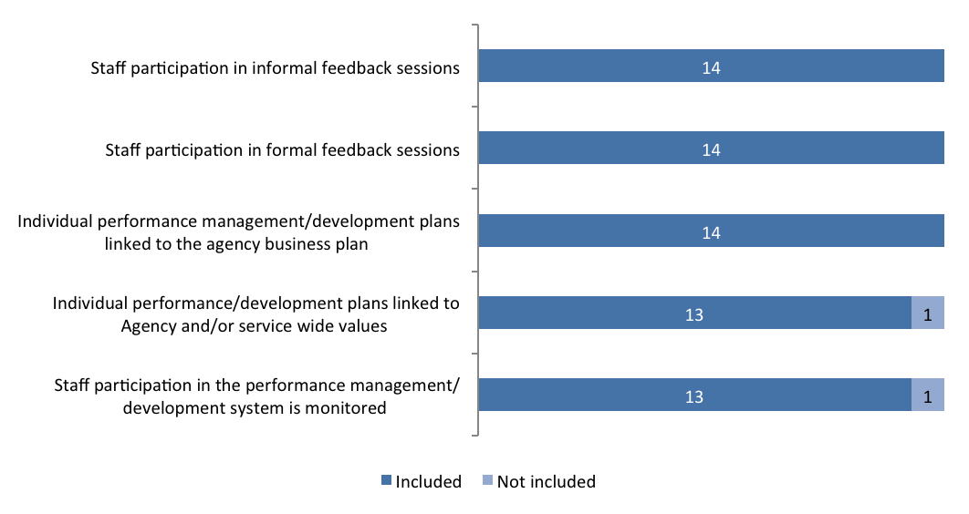

Performance Management System Elements – Tracking
 | Included |  | Not included
 | 2011/2012 | 2012/2013 | 2011/2012 | 2012/2013
Individual performance management/development plans linked to the agency business plan | 14 | 14 | 1 | 0
Staff participation in formal feedback sessions | 15 | 14 | 0 | 0
Staff participation in informal feedback sessions | 15 | 14 | 0 | 0
Staff participation in the performance management/development system is monitored | 12 | 13 | 3 | 1
Individual performance/development plans linked to Agency and/or service wide values | 12 | 13 | 3 | 1
Total | 15 | 14 | 15 | 14

Workforce Planning Activity
The Agencies were further asked to indicate the workforce planning activities undertaken by them during 2012/2013. All Agencies mention that they obtain information on their Agency’s demographics and characteristics. A high number (13) obtain information to evaluate the effectiveness of learning and development and identify the capabilities required to deliver services in future.
During 2012/2013, did your Agency undertake any of the following workforce planning activities?
Base: All respondents, n=14.
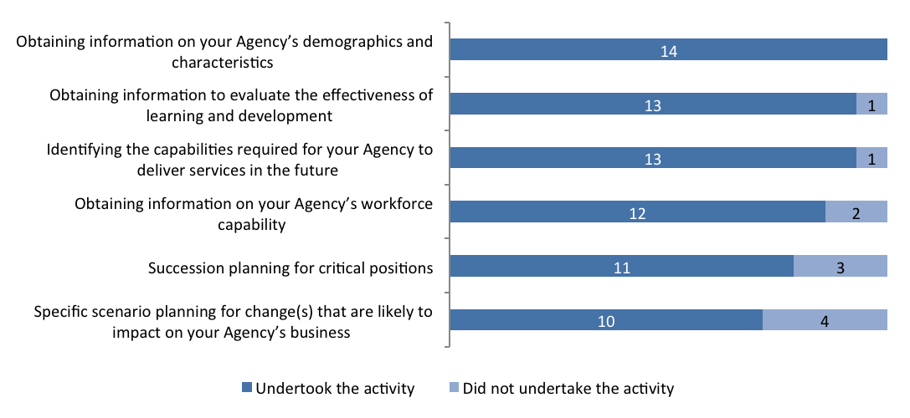

Workforce Planning Activity – Tracking
 | Undertook  the activity |  | Did not undertake  the activity
 | 2011/2012 | 2012/2013 | 2011/2012 | 2012/2013
Obtaining information on your Agency’s demographics and characteristics | 13 | 14 | 2 | 0
Identifying the capabilities required for your Agency to deliver services in the future | 13 | 13 | 2 | 1
Obtaining information to evaluate the effectiveness of learning and development | 9 | 13 | 6 | 1
Obtaining information on your Agency’s workforce capability | 8 | 12 | 7 | 2
Succession planning for critical positions | 8 | 11 | 7 | 3
Specific scenario planning for change(s) that are likely to impact on your Agency’s business | 8 | 10 | 7 | 4
Total | 15 | 14 | 15 | 14

Workforce Planning Challenges
Some of the major challenges indicated by Agencies include the difficulty to recruit people with the required skills (4), and loss of mature-aged employees (4). These were, however, considered major challenges by fewer than half of the Agencies reporting.
Of the challenges listed below, please choose one of the three options that best describes the challenge faced by your Agency in 2012/2013. Base: All respondents, n=14.
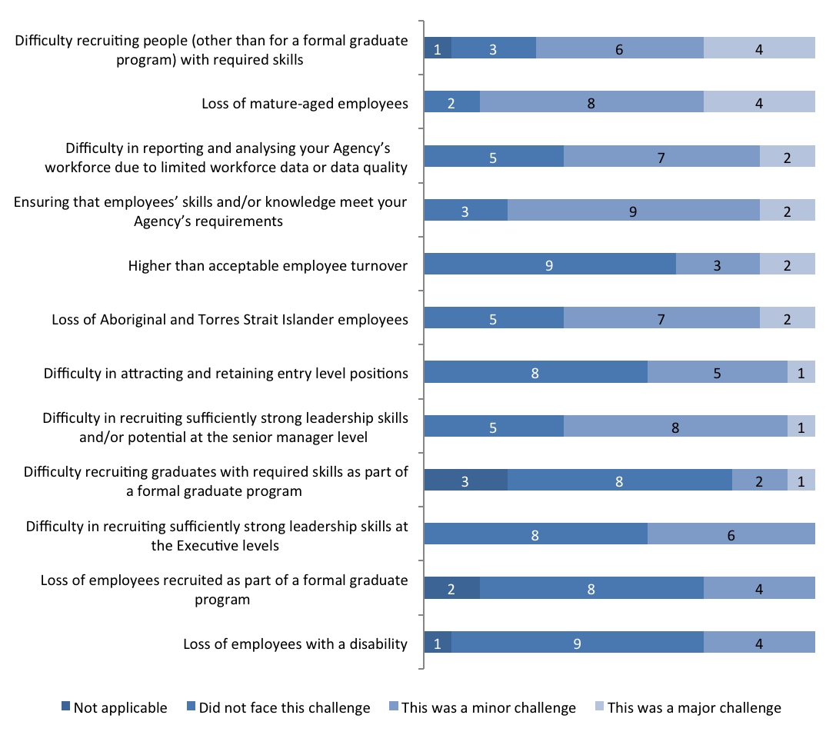

Workforce Planning Challenges – Tracking
 | Minor challenge |  |  | Major challenge
 | 2011/2012 | 2012/2013 | Difference | 2011/2012 | 2012/2013 | Difference
Difficulty in recruiting sufficiently strong leadership skills and/or potential at the senior manager level | 5 | 8 | 3 | 3 | 1 | -2
Difficulty recruiting graduates with required skills as part of a formal graduate program | 3 | 2 | -1 | 0 | 1 | 1
Ensuring that employees’ skills and/or knowledge meet your Agency’s requirements | 10 | 9 | -1 | 3 | 2 | -1
Higher than acceptable employee turnover | 8 | 3 | -5 | 2 | 2 | 0
Difficulty in attracting and retaining entry level positions | 3 | 5 | 2 | 1 | 1 | 0
Loss of employees with a disability | 5 | 4 | -1 | 0 | 0 | 0
Difficulty in reporting and analysing your Agency’s workforce due to limited workforce data or data quality | 7 | 7 | 0 | 4 | 2 | -2
Difficulty recruiting people (other than for a formal graduate program) with required skills | 6 | 6 | 0 | 7 | 4 | -3
Loss of mature-aged employees | 6 | 8 | 2 | 4 | 4 | 0
Loss of Aboriginal and Torres Strait Islander employees | 6 | 7 | 1 | 0 | 2 | 2
Difficulty in recruiting sufficiently strong leadership skills at the Executive levels | 7 | 6 | -1 | 1 | 0 | -1
Loss of employees recruited as part of a formal graduate program | 4 | 4 | 0 | 1 | 0 | -1
Total | 15 | 14 |  | 15 | 14

High Performers Identification Strategy
The most commonly used strategies to identify high performing individuals include participation in development opportunities and manager/supervisor identification which are used by all agencies (14). Performance management/development system (12) and Agency Head identification (12) are also frequently used.
What were the primary strategies used to identify high performing individuals?
Base: All respondents, n=14
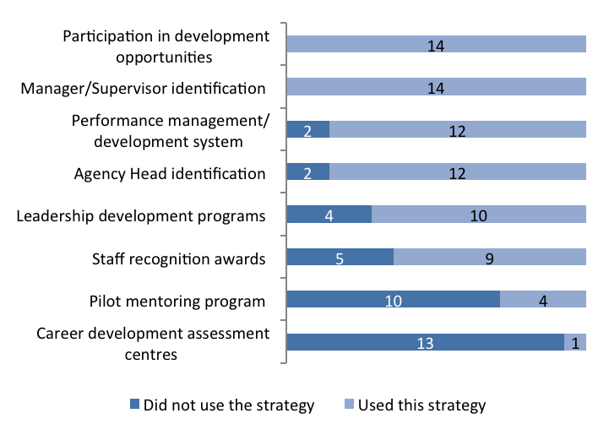
OTHER
Community of Practice Leadership and Strategy
(Commerce and Works)

Identify staff awards that are values based. Executive and Leader rounding in place across staff.
(Calvary Healthcare)

Auditor-General sends letters to staff for work well done.
(Auditor-General)

High Performers Identification Strategy – Tracking
 | Used this strategy |  | Did not use the strategy
 | 2011/2012 | 2012/2013 | 2011/2012 | 2012/2013
Manager/Supervisor identification | 12 | 14 | 3 | 0
Participation in development opportunities | 13 | 14 | 2 | 0
Agency Head identification | 9 | 12 | 6 | 2
Performance management/development system | 11 | 12 | 4 | 2
Leadership development programs | 12 | 10 | 3 | 4
Staff recognition awards | 10 | 9 | 5 | 5
Pilot mentoring program | 4 | 4 | 11 | 10
Career development assessment centres | 1 | 1 | 14 | 13
Total | 15 | 14 | 15 | 14

Most Utilised Benefits
Special employment arrangements, flexible work hours and commencement above base salary are the top three benefits most utilised by Agencies during 2012/2013 to specifically attract and retain people with critical skills.
Which of the following were the top three benefits most utilised by your Agency during 2012/2013 to specifically attract and retain people with critical skills?
Base: All respondents, 2011/2012; n=15, 2012/2013; n=14.
 | 2011/2012 |  | 2012/2013
Benefits | # of  Agencies | % of  Agencies | # of  Agencies | % of Agencies
Special Employment Arrangements (SEAs) | 9 | 60% | 11 | 79 %
Flexible work hours | 10 | 67% | 8 | 57 %
Commencement above base salary | 11 | 73% | 6 | 43 %
Provision of studies assistance | 3 | 20% | 4 | 29 %
Graduate programs | 5 | 33% | 3 | 21 %
Development opportunities (e.g. study awards, fellowships, secondments) | 3 | 20% | 3 | 21 %
Health and wellbeing programs | 0 | 0 % | 2 | 14 %
HR support case managers for trainees and apprentices | 1 | 7% | 1 | 7 %
Support for Transition to Retirement | 0 | 0 % | 1 | 7 %
Work placements/rotations | 1 | 7% | 0 | 0 %
Other | 2 | 13% | 3 | 21 %
Total | 15 | 100% | 14 | 100%

Targeted Initiatives to Retain Specific Groups
The following graph illustrates the breakdown of initiatives (targeted and not targeted) for each of the specific groups. A high number of Agencies indicate that they have targeted initiatives for professional employees (11) and Aboriginal and Torres Strait Islanders (11).
In 2012/2013, did your Agency employ any specific and targeted initiatives to attract and/or retain any of the following groups?
Base: All respondents, n=14.
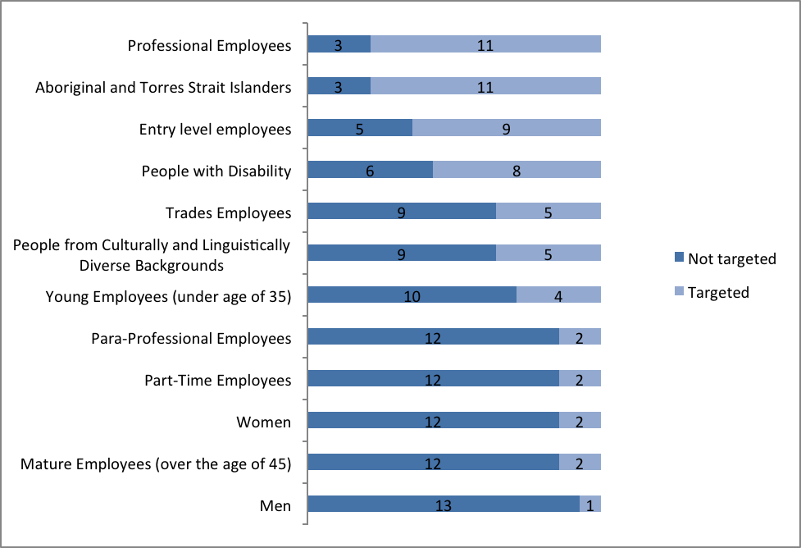

Targeted Initiatives to Retain Specific Groups –Tracking
 | Targeted |  | Not targeted
 | 2011/2012 | 2012/2013 | 2011/2012 | 2012/2013
Aboriginal and Torres Strait Islander people | 10 | 11 | 5 | 3
Professional Employees | 11 | 11 | 4 | 3
Entry level employees | 9 | 9 | 6 | 5
People with disability | 6 | 8 | 9 | 6
People from culturally and linguistically diverse backgrounds | 3 | 5 | 12 | 9
Trades Employees | 3 | 5 | 12 | 9
Young employees (under the age of 35) | 6 | 4 | 9 | 10
Mature employees (over the age of 45) | 2 | 2 | 13 | 12
Women | 3 | 2 | 12 | 12
Part-time employees | 1 | 2 | 14 | 12
Para-Professional Employees | 6 | 2 | 9 | 12
Men | 1 | 1 | 14 | 13
Total | 15 | 14 | 15 | 14

Breach Investigations
Please provide details on the number of investigations into suspected breaches of s9 of the PSMA during 2012/2013? Base: All respondents, n=14.
Number of suspected breach investigations finalised during 2012/2013
(All agencies combined)

125

Number of suspected breach investigations finalised during 2011/2012 = 99

Time Taken to Complete Investigations
Agencies were further asked about the time taken to complete the investigations. Most commonly, respondents mention that the investigations take anywhere between 2 months and 1 year.
Respondents were not aware of the time it took to complete the investigations for all breaches. Some respondents were not able to provide timeframes for each investigation and this accounts for the difference in the total number of suspected breaches noted above and the totals shown below on time taken to complete investigations.
Please provide the approximate timeframes the finalised in 2012/2013 breach investigations took to complete? Base: Respondents who mentioned that there was a breach of s9 of PSMA during 2011/2012; n=11, 2012/2013; n=10.
Timeframe | 2011/2012 | 2012/2013
<2 weeks | 1 | 1
2 weeks to <1 month | 17 | 13
1 month to <2 months | 18 | 19
2 months to <4 months | 27 | 22
4 months to <1 year | 28 | 58
1 year + | 2 | 7
Total | 93 | 120

Number of Alleged Breaches of s9 of PSMA
Of the investigations finalised during 2012/2013, please indicate the total number of employees alleged to have breached each subsection of s9 of the PSMA? (Please note that an individual investigation can be counted against more than one breach of s9 of the PSMA). Base: Respondents who mentioned that there was a breach of s9 of PSMA during 2011/2012; n=11, 2012/2013; n=10.
s9 of the PSMA Breach Category | 2011/2012 | 2012/2013
Exercise reasonable care and skill | 24 |  | 59
Treat members of the public and other public employees with courtesy and sensitivity to their rights, duties and aspirations | 41 |  | 52
Comply with the Act, the management standards and all other Territory laws | 21 |  | 36
Not harass a member of the public or another public employee, whether sexually or otherwise | 16 |  | 35
Comply with any lawful and reasonable direction given by a person having authority to give this direction | 25 |  | 32
Act with probity | 21 |  | 26
Not make improper use of the property of the Territory | 9 |  | 18
Not take, or seek to take, improper advantage of their position in order to obtain a benefit for the employee or any other person | 11 |  | 7
Act impartially | 0 |  | 4
If the employee has an interest, pecuniary or otherwise, that could conflict, or appear to conflict, with the proper performance of their duties –(i) disclose the interest to their supervisor; and (ii) take reasonable action to avoid the conflict as soon as possible after the relevant facts come to the employee’s notice | 1 |  | 4
Not disclose, without lawful authority –(i) any information acquired by him or her as a consequence of their employment; or (ii) any information acquired by him or her from any document to which he or she has access as a consequence of their employment | 2 |  | 4
Avoid waste and extravagance in the use of the property of the Territory | 2 |  | 4
Not take, or seek to take, improper advantage, for the benefit of the employee or any other person, of any information acquired, or any document to which the employee has access, as a consequence of their employment | 4 |  | 3
In dealing with members of the public, make all reasonable efforts to assist them to understand their entitlements under the laws of the Territory and to understand any requirements which they are obliged to satisfy under those laws | 0 |  | 1
Not unlawfully coerce a member of the public or another public employee | 0 |  | 1
Not make a comment that he or she is not authorised to make where the comment may be expected to be taken as an official comment | 0 |  | 0
Report to an appropriate authority – (i) any corrupt or fraudulent conduct in the public sector that comes to their attention; or (ii) any possible maladministration in the public sector that he or she has reason to suspect | 1 |  | 0

Total Number of Sanctions Applied for Completed Investigations
Agencies that mentioned that they have completed the investigations for breach were asked about the specific sanctions that were applied. Respondents mention that counseling was provided to employees in 42 cases and a written warning was issued in 35 cases. This is consistent with previous year’s findings.
Of the investigations finalised in 2012/2013, please indicate the total number of employees receiving each sanction?
Base: Respondents who mentioned that there was a breach of s9 of PSMA during 2011/2012; n=11, 2012/2013; n=10.
Completed Investigations – Sanction Applied | 2011/2012 | 2012/2013
Counseling of the employee | 29 | 42
First or final written warning | 25 | 35
Termination of employment | 12 | 16
Reduction in incremental point | 3 | 12
Transfer to other duties (at or below current salary) | 1 | 9
Complaint found, but no sanction applied | 3 | 5
Financial penalty | 2 | 5
A temporary or permanent reduction in classification/salary | 4 | 5
Written admonishment | 6 | 4
Deferral of increment | 0 | 1

Measures to Ensure Consistency
Agencies that mentioned there was a breach were further asked to indicate the measures to maintain consistency during the process of investigation. Use of Shared Services Centre was reported by nine out of ten Agencies and HR/Employee relations provides guidance and support to people who conduct investigations was reported by eight out of ten as was training an external panel to conduct investigations.
Did your Agency have any of the following measures in place during 2012/2013 to ensure the processes to investigate suspected breaches of s9 of the PSMA were consistent across the Agency?
Base: Respondents who mentioned that there was a breach of s9 of PSMA during 2012/2013, n=10.
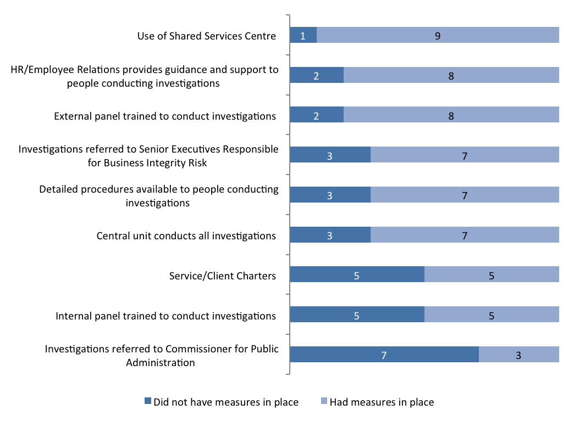

Measures to Ensure Consistency – Tracking
 | Had measures  in place |  | Did not have measures  in place
 | 2011/2012 | 2012/2013 |  | 2011/2012 | 2012/2013
Use of Shared Services Centre | 8 | 9 |  | 3 | 1
External panel trained to conduct investigations | 9 | 8 |  | 2 | 2
HR/Employee Relations provides guidance and support to people conducting investigations | 11 | 8 |  | 0 | 2
Central unit conducts all investigations | 7 | 7 |  | 4 | 3
Detailed procedures available to people conducting investigations | 8 | 7 |  | 3 | 3
Investigations referred to Senior Executives Responsible for Business Integrity Risk | 9 | 7 |  | 2 | 3
Internal panel trained to conduct investigations | 6 | 5 |  | 5 | 5
Service/Client Charters | 4 | 5 |  | 7 | 5
Investigations referred to Commissioner for Public Administration | 2 | 3 |  | 9 | 7

Base: Agencies who mentioned there was a breach, 2011/2012 n=11, 2012/2013 n=10

Measures to Ensure Sanctions are Imposed
The most common measures to ensure that sanctions are imposed include consulting the central HR and/or legal area when deciding the sanction and limiting the delegation for applying the sanctions.
Did your Agency have any of the following measures in place during 2012/2013 to ensure that sanctions imposed as a result of any determined breaches of s9 of the PSMA were applied appropriately and consistently across the Agency?
Base: Respondents who mentioned that there was a breach of s9 of PSMA during 2012/2013, n=10.
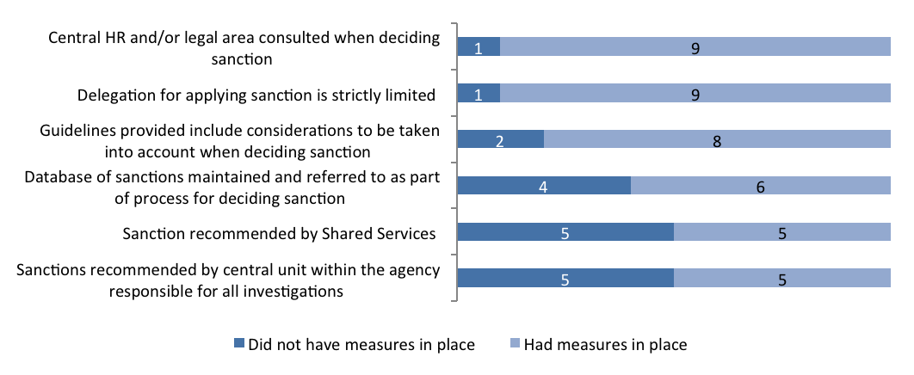

Measures to Ensure Sanctions are Imposed – Tracking
 | Had measures  in place |  | Did not have measures  in place
 | 2011/2012 | 2012/2013 | 2011/2012 | 2012/2013
Delegation for applying sanction is strictly limited | 10 | 9 | 1 | 1
Central HR and/or legal area consulted when deciding sanction | 10 | 9 | 1 | 1
Guidelines provided include considerations to be taken into account when deciding sanction | 6 | 8 | 5 | 2
Database of sanctions maintained and referred to as part of process for deciding sanction | 6 | 6 | 5 | 4
Sanctions recommended by central unit within the agency responsible for all investigations | 6 | 5 | 5 | 5
Sanction recommended by Shared Services | 6 | 5 | 5 | 5
Base: Agencies who mentioned there was a breach, 2011/2012 n=11, 2012/2013 n=10

Preventing Bullying and Harassment
Does your Agency have a formal reporting system for bullying and harassment?
Base: All respondents, n=14.
All the Agencies report that they have a formal reporting system for bullying and harassment.

14

Systems for Employees to Report Bullying and Harassment
All the Agencies report that they have a number of systems in place for employees to report bullying and harassment.
Does your Agency use any of the following systems for employees to report bullying and harassment? Select all that apply. Base: All respondents, 2011/2012; n=15, 2012/2013; n=14.
 | 2011/2012 |  | 2012/2013
Systems to Report Bullying and Harassment | Count | Percent | Count | Percent
Identified contact person(s) for reporting matters | 15 | 100% | 14 | 100 %
Procedures and policies in place to ensure appropriate confidentiality | 15 | 100% | 14 | 100 %
Awareness-raising with staff about bullying and harassment procedures and policies | 15 | 100% | 14 | 100 %
Option of additional support from an external provider  (e.g. EAP) | 15 | 100% | 14 | 100 %
Specialised training for contact staff | 14 | 93% | 14 | 100 %
Accessible and effective reporting system(s) | 14 | 93% | 13 | 93 %
Use of promotional material (e.g. posters, brochures) | 13 | 87% | 12 | 86 %
External investigator | 12 | 80% | 11 | 79 %
Other | 5 | 33% | 2 | 14 %
Total | 15 | 100% | 14 | 100 %

Employee Assistance Provider
Does your Agency have an Employee Assistance Provider?
Base: All respondents, n=14.
100%
All 14 Agencies have an Employee Assistance Provider.

Provider | # of mentions
PPC Worldwide | 10
Davidson Trahaire Corpsych | 4
IPS Worldwide. | 1
Converge | 1

Bullying and Harassment Reports
Regarding formal reports of bullying and harassment within your agency during 2012/2013 please complete the following.
Base: All respondents, n=14.
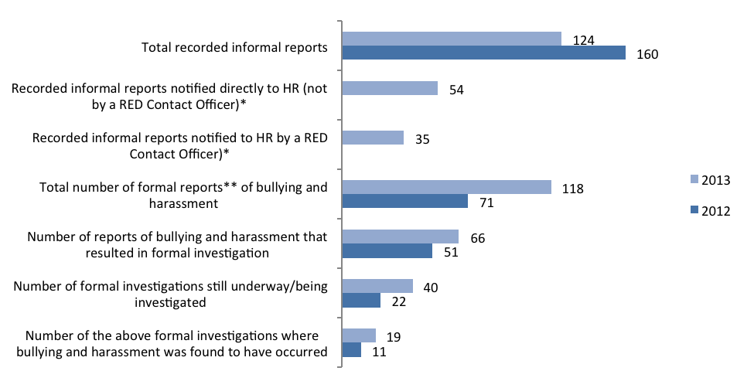
*These questions were not included in the 2012 Agency Survey.
**Please Note: Formal Reports include a report that is formally lodged and can include verbal referrals, incidents, complaints and any other matter that warrants further investigation

2.4 Managing Underperformance

Underperformance Investigations
Please provide details of the number of underperformance investigations finalised during 2012/2013.
Base: All respondents, n=14.
Number of investigations finalised during 2012/2013
40

Of those underperformance actions finalised, please indicate how often the following outcomes occurred:
Base: Respondents who provided the details of the number of investigations finalised in 2011/2012, n=5, 2012/2013, n=6.
 | 2011/2012 | 2012/2013
Underperformance action not finalised due to unavailability (e.g. resignation, long term leave, etc.) | 4 | 16
Satisfactory performance standard attained | 1 | 9
Development program instituted | 12 | 6
Termination of employment | 2 | 5
Assignment to other duties | 2 | 1
Reduction in classification | 0 | 1
No action taken | 0 | 3
Total | 21 | 41

Procedures for Managing Underperformance
The Agencies were further asked to indicate the number of procedures for managing underperformance. A total of eight Agencies indicate that they do not have any procedures for managing underperformance. Further, five Agencies indicate that the Agency managers are not adequately trained to manage underperforming staff. These numbers are down from previous findings.
Does your Agency have in place procedures for managing underperformance that supplement the ACTPS Enterprise Agreements?
Are your Agency managers adequately trained in managing underperforming staff? Did your Agency engage the Services of a provider from the ACTPS Administrative Review and Investigation Panel during the 2012/2013 reporting period?
Base: All respondents, 2011/2012; n=15, 2012/2013; n=14.
 | Yes |  | No
 | 2011/2012 | 2012/2013 | 2011/2012 | 2012/2013
Procedures for managing underperformance | 5 | 6 | 10 | 8
Agency managers are adequately trained in managing underperforming staff | 6 | 9 | 9 | 5
Engaged the Services of a provider from the ACTPS Administrative Review and Investigation Panel | 5 | 9 | 10 | 5
Total | 15 | 14 | 15 | 14

ACTPS Administrative Review and Investigations Panel Engagement
Please indicate the number of times your Agency engaged the Services of a provider from the ACTPS Administrative Review and Investigations Panel.
Base: Respondents who mentioned that they have an Administrative review and investigation penal, 2011/2012; n=5, 2012/2013; n=9.
 | Matters commenced but not finalised |  |  | Matters finalised
ACTPS Administrative Review and Investigations Panel Engagement | 2011/2012 |  | 2012/2013 | 2011/2012 | 2012/2013
Misconduct/Discipline (under ACTPS Enterprise Agreements) | 9 | 20 |  | 5 | 22
Appeals (under ACTPS Enterprise Agreements) | 1 | 5 |  | 3 | 10
Internal Reviews (under ACTPS Enterprise Agreements) | 1 | 1 |  | 1 | 1
Fraud investigations (under the ACTPS Integrity Policy) | 0 | 0 |  | 0 | 1
Other administrative review or investigation including complaints/grievances or public Interest Disclosure | 0 | 2 |  | 0 | 0

2.5 Respect, Equity and Diversity Framework

RED Framework Measure
How many of the following are there within your agency?
Base: All respondents, n=14.
RED Framework Measure | 2011/2012 | 2012/2013
Staff who have received RED training | 4471 | 3214
RED Contact Officers | 359 | 359
RED Contact Officers who have received RED training | 272 | 299
Managers/Supervisors who have received RED training | 2132 | 993
Executive Sponsor(s) | 14 | 15
Changes to Executive Sponsor(s) | N/A | 4
Current Executive Sponsor(s) who have received RED training | 12 | 13

Strategy
Which of the following did your Agency promote? Please select all that apply. Base: All respondents, 2011/2012; n=15, 2012/2013; n=14.
 | 2011/2012 |  | 2012/2013
 | Count | Percent | Count | Percent
Respect at Work Policy | 15 | 100% | 13 | 93 %
Open Door Policy | 15 | 100% | 14 | 100 %
Preventing Work Bullying Guidelines | 14 | 93% | 14 | 100 %
Total | 15 | 100% | 14 | 100 %

Tools to Promote RED Framework
A total of 13 Agencies include the information on bullying and harassment in the induction program and 12 Agencies use RED Resources.
Which of the following tools has your Agency used to promote the RED framework? Please select all that apply.
Base: All respondents, n=14.
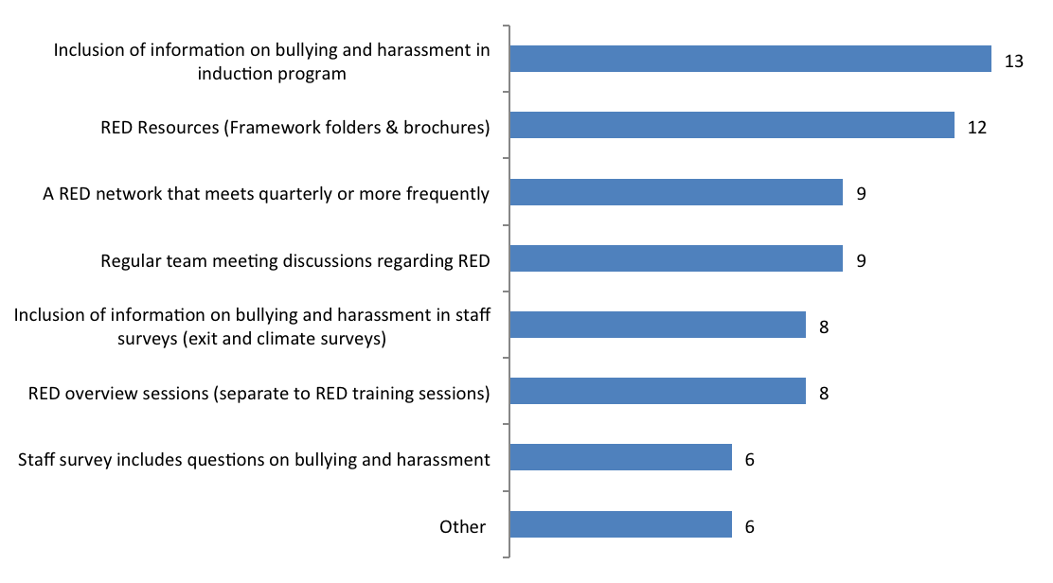

Tools to Promote RED Framework – Tracking
 | 2011/2012 | 2012/2013
Inclusion of information on bullying and harassment in induction program | 12 | 13
RED Resources (Framework folders & brochures) | 14 | 12
Regular team meeting discussions regarding RED | 9 | 9
A RED network that meets quarterly or more frequently | 7 | 9
RED overview sessions (separate to RED training sessions) | 8 | 8
Inclusion of information on bullying and harassment in staff surveys (exit and climate surveys) | 10 | 8
Staff survey includes questions on bullying and harassment | 4 | 6
Other | 6 | 6
Total | 15 | 14

Access to RED Folder and Other Resources
Do all managers and teams have access to a RED folder and other resources?
Base: All respondents, 2011/2012; n=15, 2012/2013; n=14.
 | 2011/2012 | 2012/2013
Have access to RED folder | 13 | 13
Do not have access to RED folder | 1 | 1
Unsure | 1 | 0
Total | 15 | 14

Method of Providing Staff Access to RED Resources
How has your Agency provided all staff access to your RED Contact Officer details? Please select all that apply.
Base: All respondents, 2011/2012; n=15, 2012/2013; n=14.
 | 2011/2012 |  | 2012/2013
 | Count | Percent | Count | Percent
Intranet | 13 | 87% | 11 | 79 %
Common areas/noticeboards | 9 | 60% | 9 | 64 %
Staff directory | 7 | 47% | 8 | 57 %
Website | 5 | 33% | 5 | 36 %
Agency switchboard | 2 | 13% | 1 | 7 %
Other | 8 | 53% | 6 | 43 %
Total | 15 | 100% | 14 | 100 %

Diversity Census Process
When asked if the Agency conducts a Diversity Census or “Update your Details” process to encourage the disclosure of diversity, five agencies each reported that they did conduct an Agency specific “Update your Details” process, conducted a different process or conducted none at all.
Did your Agency conduct a Diversity Census or ‘Update your Details’ process to encourage the disclosure of diversity? Please select all that apply.
Base: All respondents, n=14. (Multiple selections possible).
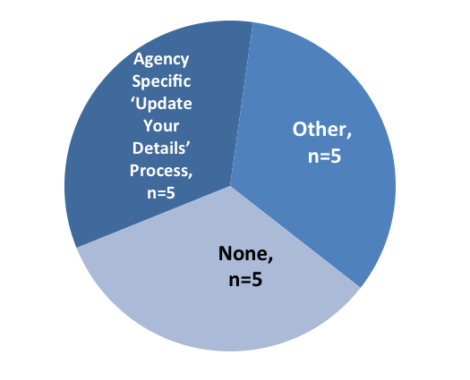
Those who said ‘other’:ACT Health is currently getting approval from the Director General to commence Diversity Census to be done annually.Conducted by mission on-site.Inclusion of requirement in induction process.Promoted Whole of Government Update your details program.Whole of Government Update your Details form promoted to all staff via email and whole of government message on 25 July 2012.

Review of Recruitment Process, HR Process and Forms
Has your Agency reviewed your recruitment process, HR processes and forms to ensure: Please select all that apply.
Base: All respondents, 2011/2012; n=15, 2012/2013; n=14.
 | 2011/2012 |  | 2012/2013
 | Count | Percent | Count | Percent
They are written in plain English | 12 | 80% | 11 | 79 %
Reasonable adjustments are made for people with disability for interview arrangements | 10 | 67% | 11 | 79 %
Reasonable adjustments are made for successful applicants | 9 | 60% | 10 | 71 %
Training for panel members on the inclusion of the needs of diverse applicants | 6 | 40% | 5 | 36 %
Roles and responsibilities are clearly defined in job descriptions | 14 | 93% | 12 | 86 %
No, my agency has not reviewed the recruitment process, HR processes and forms | 0 | 0% | 1 | 7 %
Total | 15 | 100% | 14

2.6 People with a Disability

Actions to Assist People with Disability
Did your Agency perform any of the following actions to promote the employment of People with Disability?
Base: All respondents, n=14.
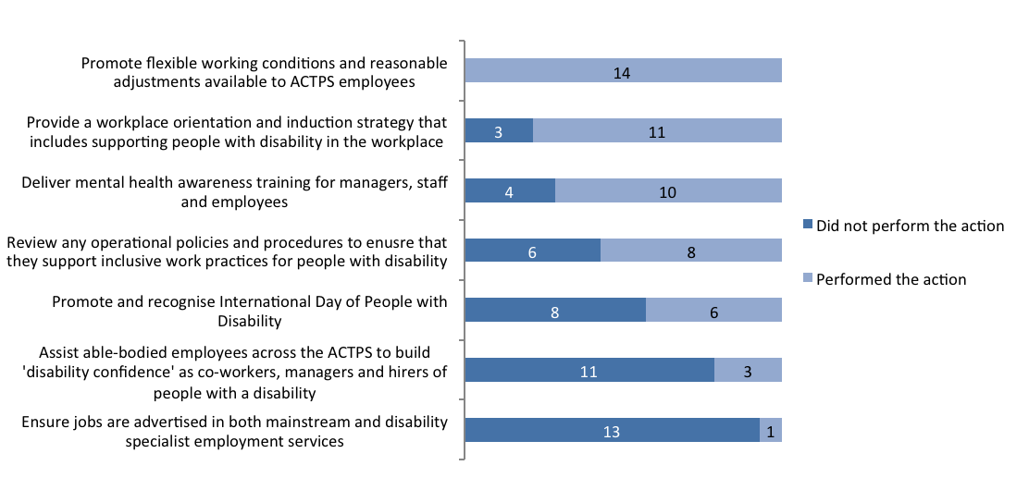

Actions to Assist People with Disability – Tracking
 | Performed the action |  |  | Did not perform the  action
 | 2011/2012 | 2012/2013 | 2011/2012 |  | 2012/2013
Promote flexible working conditions and reasonable adjustments available to ACTPS employees | 13 | 14 | 2 |  | 0
Review any operational policies and procedures to ensure that they support inclusive work practices for people with disability | 10 | 8 | 5 |  | 6
Promote and recognise International Day of People with Disability | 7 | 6 | 8 |  | 8
Assist able-bodied employees across the ACTPS to build ‘disability confidence’ as co-workers, managers and hirers of people with disability and provide practical ideas and tools to make a difference on the ground | 7 | 3 | 8 |  | 11
Provide a workplace orientation and induction strategy that includes supporting people with disability in the workplace | 7 | 11 | 8 |  | 3
Deliver mental health awareness training for managers, staff and employees | 6 | 10 | 9 |  | 4
Ensure jobs are advertised in both mainstream and disability specialist employment services | 3 | 1 | 12 |  | 13
Total | 15 | 14 | 15 |  | 14

Recruitment Strategies for People with Disability
Did your Agency use the any of the following strategies to attract people with disability to the ACT Public Service? If yes, how many? Base: All respondents, n=14.
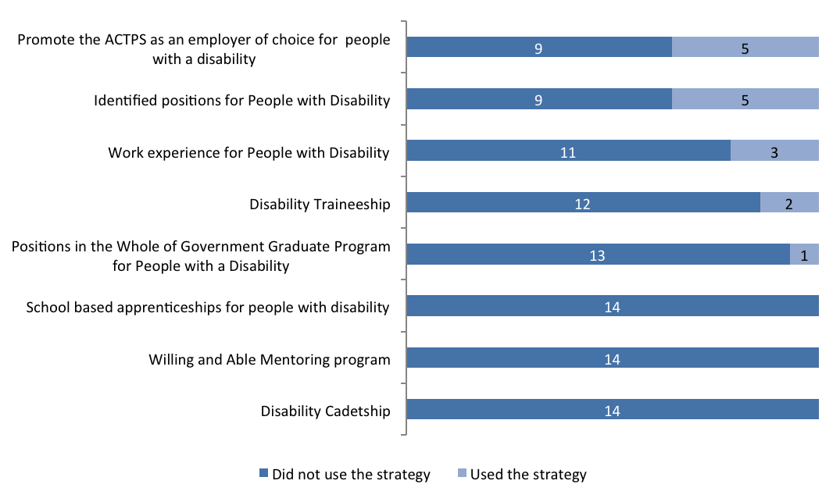

Recruitment Strategies for People with Disability – Tracking
 | Used the strategy |  | Did not use the strategy
 | 2011/2012 | 2012/2013 | 2011/2012 | 2012/2013
Identified positions for People with Disability | 5 | 5 | 10 | 9
Promote the ACTPS as an employer of choice for people with a disability | 2 | 5 | 13 | 9
Work experience for People with Disability | 3 | 3 | 12 | 11
Disability Traineeship | 6 | 2 | 9 | 12
Positions in the Whole of Government Graduate Program for People with a Disability | 1 | 1 | 14 | 13
Disability Cadetship | 0 | 0 | 15 | 14
Willing and Able Mentoring program | 0 | 0 | 15 | 14
School based apprenticeships for people with disability | 0 | 0 | 15 | 14
Total | 15 | 14 | 15 | 14

Retention Strategies for People with Disability
Does your Agency use any of the following strategies to retain employees with Disability in the ACT Public Service?
Base: All respondents, n=14.
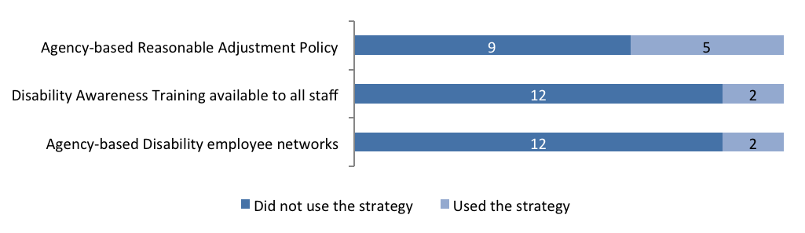

Retention Strategies for People with Disability – Tracking
 | Used the strategy |  | Did not use the strategy
 | 2011/2012 | 2012/2013 | 2011/2012 | 2012/2013
Agency-based Reasonable Adjustment Policy | 3 | 5 | 12 | 9
Agency-based Disability employee networks | 5 | 2 | 10 | 12
Disability Awareness Training available to all staff | 3 | 2 | 12 | 12
Total | 15 | 14 | 15 | 14

Reasonable Adjustment
Are the managers/supervisors within your Agency aware of the requirements to make reasonable adjustment(s) following disclosure of a disability status?
Base: All respondents, 2011/2012; n=15, 2012/2013; n=14.
 | 2011/2012 | 2012/2013
Aware of requirements | 9 | 7
Somewhat aware of requirements | 6 | 7
Total | 15 | 14

Applications to Employment Assistance Fund (EAF)
Were any applications for reasonable adjustment and/or financial assistance made to the Employment Assistance Fund (EAF) by your Agency in 2012/2013 (via the Job Access Fund)?
Base: All respondents, n=14.
No agencies made applications for reasonable assistance to Employment Assistance Fund.

0

Accessibility Audits (Timeline)
During the period did your Agency conduct an ‘accessibility audit(s)’ (in accordance with the ACTPS Employment Strategy for People with disability) to assess the level of accessibility to your premises for people with disability?
Base: All respondents2012/2013, n=14.
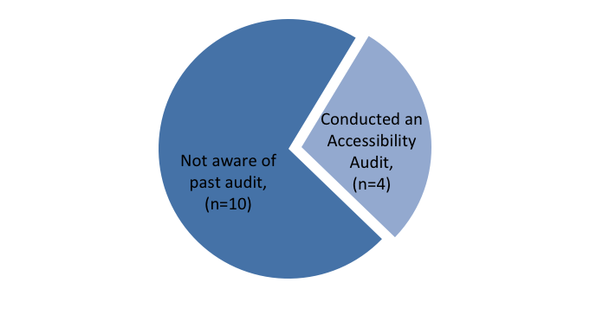
June
May
December
February

2004 | 2005 | 2006 | 2007 | 2008 | 2009 | 2010 | 2011 | 2012 | 2013
Director of Public Prosecutions |  |  |  |  |  | CIT |  | Commerce and Works | Health

Accessibility Audits (Timeline) – Reported in 2011/2012
During the period did your Agency conduct an ‘accessibility audit(s)’ (in accordance with the ACTPS Employment Strategy for People with disability) to assess the level of accessibility to your premises for people with disability? Base: All respondents2011/2012, n=15.
Not aware of past audit (n=8)
Conducted an Accessibility Audit (n=7)
July
May
Jan, Feb, March
Nov
Sept

2004 | 2005 | 2006 | 2007 | 2008 | 2009 | 2010 | 2011 | 2012
CIT |  |  | JACS | Assembly |  | CMCD |  | Treasury, EDD, TAMS

Disability Employment Network
Did your Agency work with a Disability Employment Network to place people identifying with a disability in employment within your Agency?
Base: All respondents, n=14.
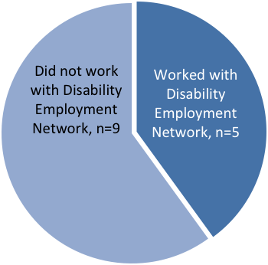
Agencies that worked with Disability Employment Network indicate that a total of 17 people were placed as follows: Seven ASO1, one contract ASO1; three ASO2, two contract ASO2; three contract GSO3; one CERT II in business – currently undergoing CERT III as an Administrative officer.

Which Disability Employment Service Provider/s did your Agency use?
Base: All respondents, n=14.
Service Providers | No. of Mentions
Advance Personnel | 5
Effective People | 1
LEAD Employment | 2
Nexus Human Services | 1
Vision Australia | 1
MAX Employment | 1

2.7 Aboriginal and Torres Strait Islander People

Strategies to attract Aboriginal and Torres Strait Islander People
Did your Agency use the any of the following strategies to attract Aboriginal and Torres Strait Islander people to the ACT Public Service? If yes, how many?
Base: All respondents, n=14.
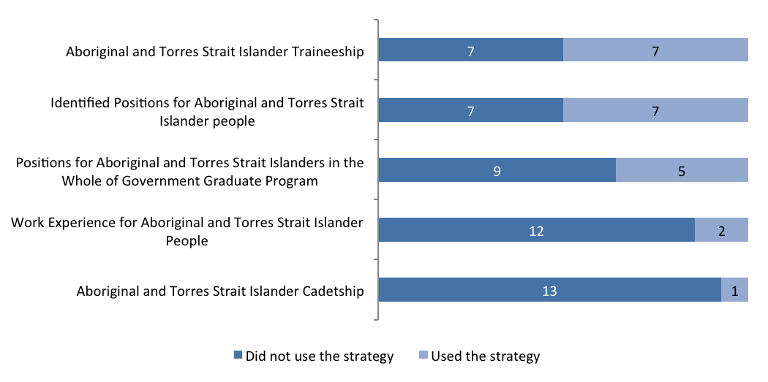

Strategies to attract Aboriginal and Torres Strait Islander People – Tracking
 | Used the strategy |  | Did not use the strategy
 | 2011/2012 | 2012/2013 | 2011/2012 | 2012/2013
Identified Positions for Aboriginal and Torres Strait Islander people | 9 | 7 | 6 | 7
Aboriginal and Torres Strait Islander Traineeship | 7 | 7 | 8 | 7
Positions for Aboriginal and Torres Strait Islanders in the Whole of Government Graduate Program | 3 | 5 | 12 | 9
Work Experience for Aboriginal and Torres Strait Islander People | 4 | 2 | 11 | 12
Aboriginal and Torres Strait Islander Cadetship | 0 | 1 | 15 | 13
Total | 15 | 14 | 15 | 14

Strategies to Retain Aboriginal and Torres Strait Islander People
Does your Agency use any of the following strategies to retain Aboriginal and Torres Strait Islander people in the ACT Public Service?
Base: All respondents, n=14.
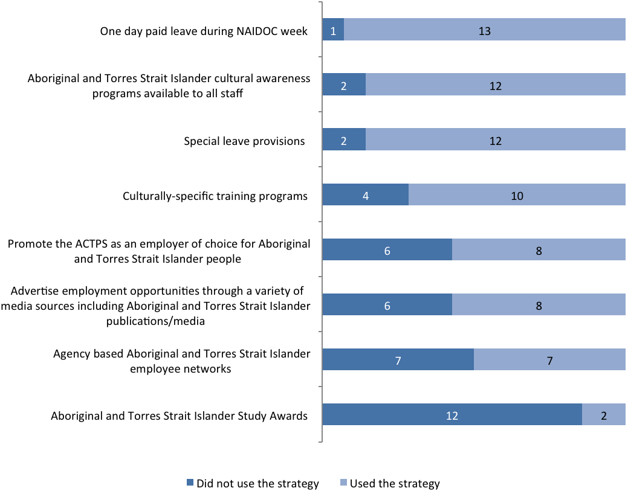

Strategies to Retain Aboriginal and Torres Strait Islander People – Tracking

 | Used the strategy |  |  | Did not use the  strategy
 | 2011/2012 | 2012/2013 | 2011/2012 |  | 2012/2013
Aboriginal and Torres Strait Islander Study Awards | 2 | 2 | 13 |  | 12
Agency based Aboriginal and Torres Strait Islander employee networks | 5 | 7 | 10 |  | 7
Advertise employment opportunities through a variety of media sources including Aboriginal and Torres Strait Islander publications/media | 6 | 8 | 9 |  | 6
Promote the ACTPS as an employer of choice for Aboriginal and Torres Strait Islander people | 6 | 8 | 9 |  | 6
Culturally-specific training programs | 9 | 10 | 6 |  | 4
Special leave provisions | 14 | 12 | 1 |  | 2
Aboriginal and Torres Strait Islander cultural awareness programs available to all staff | 9 | 12 | 6 |  | 2
One day paid leave during NAIDOC week | 14 | 13 | 1 |  | 1
Total | 15 | 14 | 15 |  | 14

Further Strategies for Aboriginal and Torres Strait Islander Employees
Does your Agency have any of the following in place for Aboriginal and Torres Strait Islander employees?
Base: All respondents, n=14.
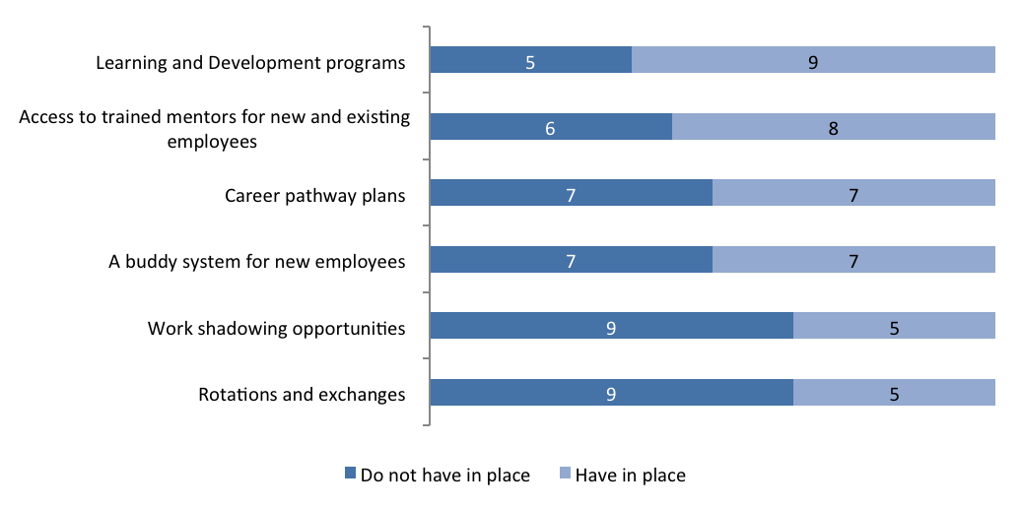

Further Strategies for Aboriginal and Torres Strait Islander Employees – Tracking
 | Have in place |  | Do not have in place
 | 2011/2012 | 2012/2013 |  | 2011/2012 | 2012/2013
Access to trained mentors for new and existing employees | 5 | 8 |  | 10 | 6
A buddy system for new employees | 6 | 7 |  | 9 | 7
Rotations and exchanges | 1 | 5 |  | 14 | 9
Work shadowing opportunities | 6 | 5 |  | 9 | 9
Learning and Development programs | 10 | 9 |  | 5 | 5
Career pathway plans | 6 | 7 |  | 9 | 7
Total | 15 | 14 |  | 15 | 14

Number of Aboriginal and Torres Strait Islander Liaison Officers
How many Aboriginal and Torres Strait Islander Liaison Officers were recruited in 2012/2013?
Base: All respondents, n=14.
Did you arrange for an Aboriginal Community member to be on the interview panel?
Base: Respondents who recruited Aboriginal and Torres Strait Islander Liaison Officers, n=4.
Of those who completed the survey, Five Agencies recruited a total of eight Aboriginal and Torres Strait Islander Liaison Officers. Further, four Agencies report they arranged for an Aboriginal Community member to be on the interview panel.

4

Aboriginal and Torres Strait Islander Recruitment Package
When your Agency is recruiting to Agency Liaison Officer roles, does your Agency develop a specific Aboriginal and Torres Strait Islander recruitment package that ensures that roles and responsibilities are clearly defined and position descriptions relevant?
Base: All respondents, n=14.
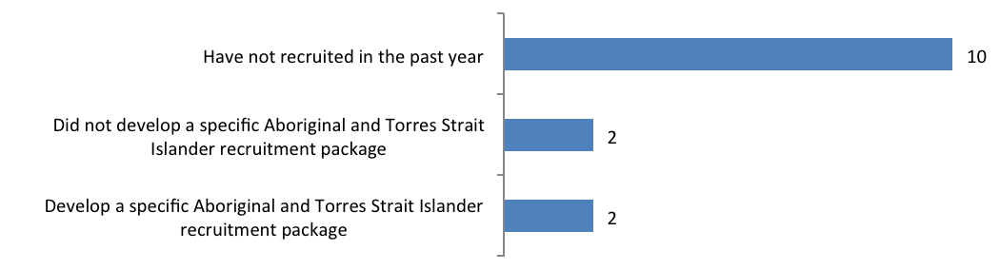

Aboriginal and Torres Strait Islander Recruitment Package – Tracking
 | 2011/2012 | 2012/2013
Develop a specific Aboriginal and Torres Strait Islander recruitment package | 3 | 2
Did not develop a specific Aboriginal and Torres Strait Islander recruitment package | 5 | 2
Have not recruited in the past year | 7 | 10
Total | 15 | 14

The Agencies were further asked if they ensure that a proportion of positions on management are allocated to Aboriginal and Torres Strait Islander employees. A high majority (13) of Agencies indicate that they do not do so while only one Agency reported that a proportion of positions on management development programs are allocated to Aboriginal and Torres Strait Islander employees.
Does your agency ensure a proportion of positions available on management development programs are allocated to Aboriginal and Torres Strait Islander employees, even if not all criteria for acceptance to a program are met?
Base: All respondents, 2011/2012; n=15, 2012/2013; n=14.
 | 2011/2012 |  | 2012/2013
 | Count | Percent | Count | Percent
Positions are allocated | 2 | 13% | 1 | 7 %
No positions are allocated | 13 | 87% | 13 | 93 %
Total | 15 | 100% | 14 | 100 %

2.8 Fraud and Risk

Formal Risk Assessment of Agency
Has a formal risk assessment of your Agency been undertaken in accordance with the Risk Management Standard and the ACTPS Integrity Policy (section 6.1)?
Base: All respondents, 2011/2012; n=15, 2012/2013; n=14.
 | 2011/2012 |  | 2012/2013
 | Count | Percent | Count | Percent
Undertook formal risk assessment | 14 | 93 % | 14 | 100 %
Did not undertake formal risk assessment | 1 | 7 % | 0 | 0 %
Total | 15 | 100% | 14 | 100 %

Plans to Review the Risk Assessment
Are there plans to review the risk assessment process within your Agency for this upcoming financial year?
Base: All respondents, 2011/2012; n=15, 2012/2013; n=14.
 | 2011/2012 |  | 2012/2013
 | Count | Percent | Count | Percent
Have plans to review the risk assessment process | 12 | 80 % | 12 | 86 %
Do not have plans to review risk assessment process | 3 | 20 % | 2 | 14 %
Total | 15 | 100 % | 14 | 100 %

Fraud and Corruption Prevention Plan
Does your Agency have a current Fraud and Corruption Prevention Plan?
Base: All respondents, n=14.
14
All the Agencies report that they have a current Fraud and Corruption
Prevention Plan.

Plans to review the Fraud and Corruption Plan
Are there plans to review the Fraud and Corruption Plan within your Agency for the next financial year?
Base: All respondents, 2011/2012; n=15, 2012/2013; n=14.
 | 2011/2012 |  | 2012/2013
 | Count | Percent | Count | Percent
Plans to review | 12 | 80% | 11 | 79 %
No plans to review | 3 | 20% | 3 | 21 %
Total | 15 | 100% | 14 | 100 %

Risk Category
Please use a scale of one to five to describe the following integrity risks within your Agency. Base: All respondents, n=14.
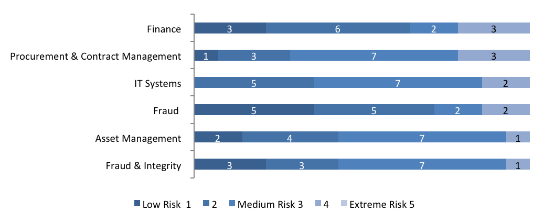

Risk Category – Tracking
 | Low risk 1 or 2 |  | Medium risk 3 |  |  | 4 or Extreme risk 5
 | 2011/2012 | 2012/2013 |  | 2011/2012 | 2012/2013 |  | 2011/2012 | 2012/2013
Fraud | 13 | 10 |  | 1 | 2 |  | 1 | 2
Finance | 11 | 9 |  | 2 | 2 |  | 2 | 3
Fraud & Integrity | 10 | 6 |  | 3 | 7 |  | 2 | 1
Asset Management | 13 | 6 |  | 1 | 7 |  | 1 | 1
IT Systems | 7 | 5 |  | 6 | 7 |  | 2 | 2
Procurement & Contract Management | 7 | 4 |  | 6 | 7 |  | 2 | 3

Occurrence of Risk Incidents
Overall, fraud and integrity risk is the most common risk category with Agencies reporting a total of 26 incidents of this type.
How many incidents occurred in the following risk categories within your Agency, in the period?
Base: All respondents, 2011/2012; n=15, 2012/2013; n=14.
 | Number of Incidents
Risk Category | 2011/2012 | 2012/2013
Fraud & Integrity | 16 | 26
Asset Management | 6 | 1
IT systems | 5 | 4
Finance | 4 | 5
Information/Record Management | 2 | 0
Procurement & Contract Management | 1 | 2
Fraud (client) | 1 | 0

Workforce Profile 2012-13
This report provides a holistic view of the ACT public sector to support robust workforce planning and management into the future. The report is a resource for the community, managers and employees within the ACT public sector to inform planning, policy development and decision-making.
The ACT public sector encompasses the employees of the nine directorates in the ACTPS that report to the Head of Service, as well as staff employed under the Public Sector Management Act 1994 (‘PSM Act’) in other ACT agencies. The data excludes contractors and staff of Territory Owned Corporations (‘TOCs’).
This workforce information has been published for the ACTPS based on the nine directorates and provides high-level time-series information over the past five years for the ACTPS. The nine directorates account for about 90 percent of the ACT public sector. The Workforce Profile provides a historical summary of indicators based on the ACTPS structure. This allows for time-series comparison and incorporates retrospective updates that help to remove time-lag in human resources data processing. ACT Shared Services, a division of the Commerce and Work Directorate, administers all but one percent of staff payroll across ACTPS directorates and provides the information for this report.
For reasons of administrative efficiency, historical information is based on employees administered by Shared Services. Historical figures may differ to figures from earlier publications however discrepancies will primarily be due to definitional change, including the structural movements within the ACT public sector, and to retrospective updates that reflect the time-lag in the processing of some human resource data. Similarly, some of the data definitions and treatment of data in directorate annual reports can differ.
The Workforce Profile includes indicators related to employee numbers, salaries, commencements and separations, age and length of service, leave usage and diversity. The profile provides workforce statistics based on information from ACTPS payroll systems as at the final pay of June 2013 (‘June 2013’) and indicators that apply to the period over the 2012-13 financial year (‘FY’). Workforce indicators are based on paid staff and exclude employees on leave without pay, board members, contractors and employees on secondment to other jurisdictions. These are point in time indicators and do not adjust for seasonal fluctuation, such as demand for casual teachers and back pay. Directorates and employee cohorts with small numbers are susceptible to fluctuation.

  - ACT public sector – ACT Public Service and other ACT public sector Agencies
The ACT public sector includes the nine directorates of the ACTPS as well as other ACT government agencies (see Table 1).

Table 1: ACT public sector - ACT Public Service and other ACT public sector agencies
ACT Public Service Agencies |  ACT Public Service  |  ACT public sector
Chief Minister and Treasury Directorate  Long Service Leave Authority  Independent Competition and Regulatory Commission |  ACT Public Service  |  ACT public sector
Commerce and Works Directorate  Shared Services |  ACT Public Service  |  ACT public sector
Community Services Directorate  Cultural Facilities Corporation |  ACT Public Service  |  ACT public sector
Economic Development Directorate  Exhibition Park Corporation  Land Development Agency  Gambling and Racing Commission |  ACT Public Service  |  ACT public sector
Education and Training Directorate |  ACT Public Service  |  ACT public sector
Environment and Sustainable Development Directorate |  ACT Public Service  |  ACT public sector
Health Directorate |  ACT Public Service  |  ACT public sector
Justice and Community Safety Directorate |  ACT Public Service  |  ACT public sector
Territory and Municipal Services Directorate  ACTION |  ACT Public Service  |  ACT public sector
ACT public sector Agencies |  |  ACT public sector
Auditor-General's Office |  |  ACT public sector
Director of Public Prosecutions |  |  ACT public sector
Calvary Health Care (Public) |  |  ACT public sector
Canberra Institute of Technology |  |  ACT public sector
Office of the Legislative Assembly |  |  ACT public sector

ACT public sector – Workforce Summary
As at June 2013, the ACT public sector was represented by a full-time equivalent (‘FTE’) workforce of 19,793.3 (up from 19,344.4 as at June 2012), and headcount of 22,671 (up from 21,955 as at June 2012). Headcount for permanent officers, full-time and part-time, was 16,579 or 75.5 percent of all employees.
As a proportion of the ACT public sector, the health and education portfolios represent 34.2 percent and 29.3 percent of employees, respectively, or a combined 63.5 percent, based on FTE as at June 2013. Growth particularly in health has been observed in recent years and is expected to continue with higher demand, consistent with national trends.
As at June 2013, Aboriginal & Torres Strait Islanders were represented by a headcount of 258 (up from 224 as at June 2012), or 1.1 percent of all employees. Employees with culturally and linguistically diverse backgrounds were represented by a headcount of 3,399 (up from 2,847 as at June 2012) or 15.0 percent of all employees. People with a disability, were represented by a headcount of 408 (up from 375 compared to June 2012), or 1.8 percent of all employees. For comparison, representation in the ACT population is approximately 16 percent for people with disability and 1.4 percent for Aboriginal and Torres Strait Islanders.

Table 2 provides a summary of the ACT public sector as at June 2012 and June 2013 (or financial years 2011-12 and 2012-13, as noted).

Table 2: ACT public sector – Workforce Summary (2011-12 and 2012-13)
 | June 2012 |  | June 2013
Full-time equivalent (FTE) | 19,344.4 |  | 19,793.3
Headcount | 21,955 |  | 22,671
Proportion of ACT population | 5.9% |  | 6.0%
Permanent | 16,579 | 75.5% | 18,197 | 80.3%
Temporary and casual | 5,376 | 24.5% | 4,474 | 19.7%
Full-time* | 70.4% |  | 70.5%
Part-time* | 22.8% |  | 22.4%
Executives (headcount)* | 187 | 1.0% | 197 | 1.0%
Age (average, incl. casuals)* | 42.6 |  | 42.4
Length of service (average, excl. casuals)* | 8.4 |  | 8.4
Salary (full-time, average)* | $77,099 |  | $80,012
Gender pay gap* | 3.0% |  | 2.9%
Separation rate (permanent officers, 2011-12 and 2012-13)* | 8.5% |  | 6.8%
Personal leave (average in days, 2011-12 and 2012-13)* | 11.4 |  | 10.7
Female | 14,339 | 65.3% | 14,849 | 65.5%
Culturally and linguistically diverse | 2,847 | 13.0% | 3,399 | 15.0%
Aboriginal and Torres Strait Islanders | 224 | 1.0% | 258 | 1.1%
People with disability | 375 | 1.7% | 408 | 1.8%
*Indicates data based on the nine directorates of the ACTPS.

ACT Public Service – Workforce Summary
The ACTPS consists of nine directorates that report to the Head of Service (see Table 1), and together represent approximately 90 percent of the ACT public sector. As at June 2013, FTE was 17,848.5 (up from 17,196.1 as at June 2012) and headcount was 20,017 (up from 19,493 as at June 2012). As a proportion of ACT population, end of financial year data from June 2009 to June 2013, shows an increase from 4.4 percent to 4.7 percent based on FTE, and 5.0 percent to 5.3 percent based on headcount. The proportions do not encompass other public sector agencies of the ACT public sector nor regional population neighbouring the ACT.
Averages over the period from 2008-09 to 2012-13, and June 2009 to June 2013, provide some trend information. Average FTE (over each financial year) experienced an average year-on-year increase of 4.2 percent. Executive staff numbers as a proportion of total FTE and headcount at the end of each financial year have remained steady at 1.1 percent and 1.0 percent, respectively. ACTPS employment modes also show minor variation over the five year period. On average, permanent staff at the end of each financial year represented 78.3 percent of total headcount.
Full-time salaries from June 2009 to June 2013, have experienced an average year-on-year increase of 3.6 percent, based on the average as at the end of each financial year. Gender pay gap during this time has had minimal variation between 2.2 percent and 3.0 percent, comparing well to other jurisdictions. Females continue to represent over 60 percent of the workforce by FTE and by headcount. The composition of staff superannuation schemes includes 56.2 percent with a fund of choice, based on headcount as at June 2013 (up from 52.3 percent as at June 2012).
Of total appointments to permanent positions, approximately 34.7 percent were recruited from outside the organisation during 2012-13 (down on previous years) with the complement of 63.3 percent being appointments of internal staff, including temporary employees to permanent positions. The separation rate of permanent staff was 6.8 percent (down from 8.5 percent in 2011-12) and is the lowest it has been for the past five years.
The average age and length of service of ACTPS employees has remained virtually unchanged and was
42.4 years and 8.4 years, respectively as at June 2013. As at June 2013, the generational mix since June 2009 has changed, with generation Y as a proportion of total headcount increasing by approximately
10 percentage points to 26.9 percent, and conversely baby boomers decreasing by approximately
10 percentage points to 34.6 percent of all employees.
From 2008-09 to 2011-12, the usage of annual leave has remained virtually unchanged at an average of 18.6 days per person. Over the same period, personal leave usage has increased from 10.9 days per person to 11.1 days person, or equivalent to a 4.5 percent and 4.7 percent absence rate, respectively.
Table 2a, 2b and 2c provides an overview of ACTPS aggregate indicators, based on the one-ACTPS organisation, for the five year period 2008-09 to 2012-13. All data tables should be read in conjunction with definitions and limitations found in the introduction, and explanatory footnotes. Information is based on paid staff, as at the end of each financial year or over the financial year (FY), as noted.

Table 2a: ACTPS employee numbers (2008-09 to 2012-13)
 | 2008-09 | 2009-10 | 2010-11 | 2011-12 | 2012-13
Full-Time Equivalent (FTE)
FTE (end FY) | 15513.9 | 15857.7 | 16509.6 | 17196.1 | 17848.5
Proportion of ACT population | 4.4% | 4.4% | 4.5% | 4.6% | 4.7%
FTE (average, during FY) | 14930.9 | 15648.0 | 15970.6 | 16676.7 | 17329.2
Increase year-on-year | 5.9% | 4.8% | 2.1% | 4.4% | 3.9%
Headcount
Headcount (end FY) | 17495 | 17917 | 18599 | 19331 | 20017
Proportion of ACT population | 5.0% | 5.0% | 5.1% | 5.2% | 5.3%
Headcount  (average, during FY) | 16847.2 | 17643.6 | 18014.9 | 18818.0 | 19440.7
Increase year-on-year | 5.1% | 4.7% | 2.1% | 4.5% | 3.3%
Executives (end FY)
FTE | 169.5 | 175.4 | 183.6 | 186.0 | 196.7
Proportion of workforce | 1.1% | 1.1% | 1.1% | 1.1% | 1.1%
Headcount | 172 | 178 | 185 | 187 | 197
Proportion of workforce | 1.0% | 1.0% | 1.0% | 1.0% | 1.0%
Employment modes (proportions of workforce, based on headcount, end FY)
Permanent | 78.7% | 79.3% | 78.2% | 77.9% | 77.6%
Temporary | 13.4% | 12.9% | 14.5% | 15.3% | 15.3%
Casual | 8.0% | 7.7% | 7.3% | 6.8% | 7.1%
Full-time | 70.3% | 70.3% | 70.2% | 70.4% | 70.5%
Part-time | 21.7% | 22.0% | 22.5% | 22.8% | 22.4%

Table 2b: ACTPS workforce characteristics (2008-09 to 2012-13)
 | 2008-09 | 2009-10 | 2010-11 | 2011-12 | 2012-13
Remuneration (base salaries)
Full-time (average) | $70,086 | $71,730 | $73,832 | $77,099 | $80,012
Increase year-on-year | 4.6% | 2.3% | 2.9% | 4.4% | 3.7%
Full-time (median) | $65,886 | $67,470 | $69,153 | $71,578 | 74082
Part-time | $62,398 | $64,152 | $ 65,893 | $69,043 | 71970
Part-time load (average) | 0.70 | 0.70 | 0.69 | 0.69 | 0.69
Gender pay gap | 2.9% | 2.4% | 2.2% | 3.0% | 2.9%
Commencements and separations (permanent staff)
External appointments as a proportion of total appointments | Not avail. | 38.8% | 40.9% | 40.9% | 34.7%
Separation rate | 7.4% | 7.6% | 9.8% | 8.5% | 6.8%
Age and length of service (average in years, end FY)
Age (includes casuals) | 42.5 | 42.7 | 42.7 | 42.6 | 42.4
Length of service (excludes casuals) | 8.3 | 8.5 | 8.4 | 8.4 | 8.4
Generations (proportions of workforce, based on headcount, end FY)
Generation Y | 16.6% | 18.5% | 21.2% | 24.0% | 26.9%
Generation X | 35.8% | 36.4% | 36.4% | 37.0% | 37.4%
Baby boomers | 44.9% | 42.8% | 40.5% | 37.6% | 34.6%
Pre-baby boomers | 2.8% | 2.3% | 1.9% | 1.4% | 1.1%
Leave usage
Annual leave (average in days) | 18.7 | 18.8 | 18.8 | 18.4 | 18.3
Personal leave (average in days) | 10.9 | 11.4 | 11.4 | 11.1 | 10.7
Personal leave absence rate | 4.5% | 4.7% | 4.8% | 4.7% | 4.4%

Table 2c: ACTPS diversity (2008-09 to 2012-13)
 | 2008-09 | 2009-10 | 2010-11 | 2011-12 | 2012-13
Aboriginal and Torres Strait Islanders
FTE | 140.4 | 139.4 | 175.2 | 186.0 | 216.7
Headcount | 154 | 153 | 193 | 202 | 238
Proportion of workforce | 0.9% | 0.9% | 1.0% | 1.0% | 1.2%
Culturally and linguistically diverse
FTE | 1986.8 | 2128.4 | 2264.4 | 2408.3 | 2936.6
Proportion of workforce | 12.6% | 13.2% | 13.4% | 13.8% | 16.1%
Headcount | 2211 | 2363 | 2495 | 2663 | 3218
People with disability
FTE | 251.6 | 273.6 | 306.5 | 305.0 | 345.1
Headcount | 286 | 306 | 351 | 343 | 384
Proportion of workforce | 1.6% | 1.7% | 1.9% | 1.8% | 1.9%
Females
Proportion of workforce - FTE | 63.1% | 63.4% | 63.1% | 62.7% | 62.7%
Proportion of workforce – headcount | 65.2% | 65.5% | 65.0% | 64.7% | 64.8%

Table 3: ACTPS FTE and headcount by employment modes (June 2013)
Employment mode | FTE | Headcount | FTE as proportion of headcount
Permanent full-time | 11721.0 | 11766 | 99.6%
Permanent part-time | 2651.6 | 3777 | 70.2%
Temporary full-time | 2317.6 | 2348 | 98.7%
Temporary part-time | 443.2 | 705 | 62.9%
Casual | 715.0 | 1421 | 50.3%
Total | 17848.5 | 20017 | 89.2%

Figure 1: FTE by employment mode (June 2013)

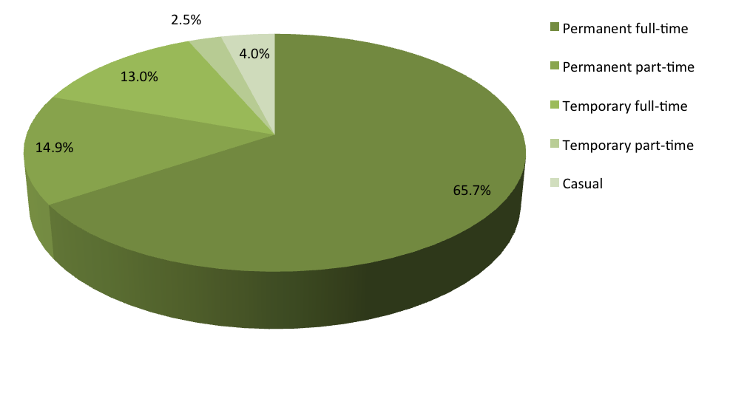

Table 4: ACTPS FTE and headcount by classification group (June 2012 and June 2013)
Classification group | FTE |  | Headcount
 | June 2012 | June 2013 | June 2012 | June 2013
Administrative Officers | 4130.3 | 4280.4 | 4737 | 4895
Ambulance Officers | 189.4 | 203.8 | 201 | 216
Bus Operators | 575.9 | 597.3 | 648 | 674
Correctional Officers | 159.5 | 163.0 | 169 | 173
Dentists/Dental Officers | 10.9 | 13.5 | 14 | 17
Disability Officers | 237.6 | 251.4 | 262 | 283
Executive Officers | 186.0 | 196.7 | 187 | 197
Fire and Rescue Officers | 334.4 | 347.5 | 336 | 349
General Service Officers & Equivalent | 977.3 | 1027.8 | 1060 | 1103
Health Assistants | 42.8 | 56.1 | 47 | 64
Health Professional Officers | 1126.9 | 1182.7 | 1286 | 1333
Information Technology Officers | 147.5 | 163.5 | 151 | 166
Judicial Officers | 10.7 | 10.0 | 12 | 15
Legal Officers | 75.7 | 89.5 | 83 | 95
Legal Support | 13.9 | 15.8 | 15 | 16
Linen Production & Maintenance | 63.9 | 57.2 | 67 | 60
Medical Officers | 666.3 | 742.5 | 739 | 814
Nursing and Midwifery | 2154.8 | 2218.7 | 2579 | 2626
Professional Officers | 113.8 | 114.4 | 124 | 132
Prosecutors | 34.9 | 37.6 | 41 | 38
Rangers | 39.2 | 35.6 | 41 | 38
School Leaders | 717.7 | 740.3 | 734 | 753
Senior Officers | 1953.7 | 2042.2 | 2022 | 2113
Statutory Office Holders | 11.0 | 12.8 | 12 | 14
Teachers | 2865.3 | 2893.0 | 3367 | 3433
Technical Officers | 272.6 | 276.2 | 310 | 319
Trainees and Apprentices | 42.6 | 40.0 | 43 | 40
Transport Officers (incl. trainer/assessors) | 41.4 | 39.1 | 44 | 41
Total | 17196.1 | 17848.5 | 19331 | 20017

Table 5: FTE by agency (June 2012 and June 2013)
Directorate | June 2012 | June 2013 | Percentage change (%)
Chief Minister and Treasury  339.2 | 279.1 | -17.7%
Long Service Leave Authority | 10.0 | 12.0 | 20.0%
Independent Competition and Regulatory Commission | 9.2 | 8.0 | -13.0%
Commerce and Works | 911.6 | 1048.1 | 15.0%
Community Services | 1221.5 | 1219.0 | -0.2%
Economic Development | 214.8 | 208.3 | -3.0%
Exhibition Park Corporation | 13.9 | 13.9 | 0%
Gambling and Racing Commission | 29.3 | 27.6 | -5.8%
Land Development Agency | 85.5 | 89.2 | 4.3%
Education and Training | 4927.8 | 5027.1 | 2.0%
Environment and Sustainable Development | 466.8 | 452.3 | -3.1%
Health | 5416.0 | 5749.1 | 6.1%
Justice and Community Safety | 1748.2 | 1820.6 | 4.1%
Territory and Municipal Services | 1825.6 | 1894.3 | 3.8%
Total | 17196.1 | 17848.5 | 3.8%

Table 6: FTE by agency and employment mode (June 2013)
Directorate | Permanent | Temporary | Casual | Total
Chief Minister and Treasury | 201.4 | 77.6 | 0.0 | 279.1
Long Service Leave Authority | 10.0 | 2.0 | 0.0 | 12.0
Independent Competition and Regulatory Commission | 5.0 | 3.0 | 0.0 | 8.0
Commerce and Works | 830.8 | 215.1 | 2.2 | 1048.1
Community Services | 1044.7 | 127.2 | 47.1 | 1219.0
Economic Development | 184.1 | 19.7 | 4.5 | 208.3
Exhibition Park Corporation | 11.7 | 2.0 | 0.3 | 13.9
Gambling and Racing Commission | 25.0 | 2.6 | 0.0 | 27.6
Land Development Agency | 81.2 | 8.0 | 0.0 | 89.2
Education and Training | 3993.4 | 663.1 | 370.6 | 5027.1
Environment and Sustainable Development | 380.6 | 70.8 | 0.9 | 452.3
Health | 4354.8 | 1194.4 | 199.8 | 5749.1
Justice and Community Safety | 1600.0 | 202.5 | 18.1 | 1820.6
Territory and Municipal Services | 1650.0 | 172.8 | 71.4 | 1894.3
Total | 14372.7 | 2760.9 | 715.0 | 17848.5

Figure 2: FTE by agency and employment mode (June 2013)
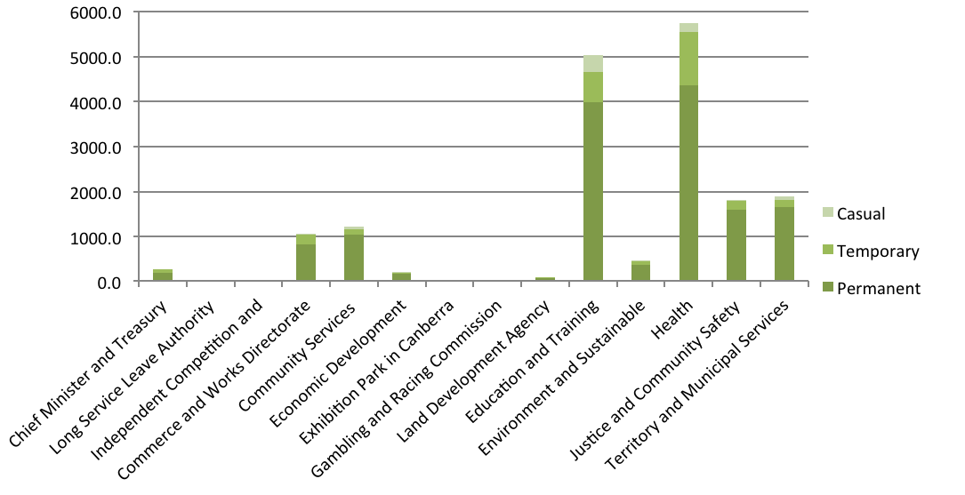

Table 7: Headcount by agency and employment mode (June 2013)
Directorates | Permanent | Temporary | Casual |  | Total
Chief Minister and Treasury | 210 | 82 | 0 |  | 292
Long Service Leave Authority | 10 | 2 | 0 |  | 12
Independent Competition and Regulatory Commission | 5 | 3 | 0 |  | 8
Commerce and Works Directorate | 852 | 221 | 4 |  | 1077
Community Services | 1114 | 138 | 68 |  | 1320
Economic Development | 188 | 20 | 9 |  | 217
Exhibition Park Corporation | 12 | 2 | 1 |  | 15
Gambling and Racing Commission | 26 | 3 | 0 |  | 29
Land Development Agency | 86 | 8 | 0 |  | 94
Education and Training | 4377 | 801 | 819 |  | 5997
Environment and Sustainable Development | 399 | 77 | 2 |  | 478
Health | 4857 | 1307 | 376 |  | 6540
Justice and Community Safety | 1644 | 211 | 45 |  | 1900
Territory and Municipal Services | 1763 | 178 | 97 |  | 2038
Total | 15543 | 3053 | 1421 |  | 20017

Table 8: Headcount by classification group and agency (June 2013)
Classification group | CMTD | CWD | CSD | EDD | ETD | ESDD | HD | JACSD | TAMS | Total
Administrative Officers | 138 | 481 | 471 | 129 | 1495 | 212 | 940 | 662 | 367 | 4895
Ambulance Officers | - | - | - | - | - | - | - | 216 | - | 216
Bus Operators | - | - | - | - | - | - | - | - | 674 | 674
Correctional Officers | - | - | - | - | - | - | - | 173 | - | 173
Dental | - | - | - | - | - | - | 17 | - | - | 17
Disability Officers | - | - | 281 | - | 2 | - | - | - | - | 283
Executive Officers | 30 | 20 | 22 | 19 | 14 | 12 | 22 | 39 | 19 | 197
Fire and Rescue Officers | - | - | - | - | - | - | - | 349 | - | 349
General Service Officers & Equivalent | - | - | 4 | 10 | 117 | 18 | 472 | 19 | 463 | 1103
Govt Advisors | - | - | - | - | - | - | - | - | - | 0
Health Assistant | - | - | - | - | - | - | 64 | - | - | 64
Health Professional Officers | - | - | 301 | - | 4 | - | 1015 | 13 | - | 1333
Information Technology Officer | - | 138 | - | - | 25 | 1 | 2 | - | - | 166
Judicial Officers | - | - | - | - | - | - | - | 15 | - | 15
Legal Officers | - | - | 1 | - | - | 2 | 1 | 91 | - | 95
Legal Support | - | - | - | - | - | - | - | 16 | - | 16
Linen Production & Maintenance | - | - | - | - | - | - | - | - | 60 | 60
Medical Officer | - | - | - | - | - | - | 814 | - | - | 814
Nursing and Midwifery | - | - | - | - | - | - | 2626 | - | - | 2626
Professional Officers | - | 13 | 7 | 5 | 22 | 20 | 12 | 7 | 46 | 132
Prosecutors | - | - | - | - | - | - | - | 38 | - | 38
Rangers | - | - | - | 4 | - | - | - | - | 34 | 38
School Leaders | - | - | - | - | 753 | - | - | - | - | 753
Senior Officers | 144 | 421 | 221 | 179 | 132 | 186 | 373 | 238 | 219 | 2113
Statutory Office Holders | - | - | - | - | - | 1 | - | 13 | - | 14
Teachers | - | - | - | - | 3432 | - | 1 | - | - | 3433
Technical Officers | - | - | 10 | 7 | - | 26 | 177 | 8 | 91 | 319
Trainees and Apprentices | - | 4 | 2 | 2 | 1 | - | 4 | 3 | 24 | 40
Transport Officers (incl. trainer/assessors) | - | - | - | - | - | - | - | - | 41 | 41
Totals | 312 | 1077 | 1320 | 355 | 5997 | 478 | 6540 | 1900 | 2038 | 20017

CMTD Chief Minister and Treasury Directorate (inclusive of Long Service Leave Authority, Independent Competition and Regulatory Commission).
CSD Community Services Directorate.
CWD Commerce and Works Directorate (inclusive of Shared Services).
EDD Economic Development Directorate (inclusive of Land Development Agency, Exhibition Park Corporation, Gambling and Racing Commission).
ESDD Environment and Sustainable Development Directorate.
ETD Education and Training Directorate.
HD Health Directorate.
JACSD Justice and Community Safety Directorate (inclusive of Director of Public Prosecutions).
TAMSD Territory and Municipal Services Directorate (inclusive of ACTION)

Table 9: FTE and headcount by agency and division (June 2013)
Directorate | Division/agency | FTE | Headcount
Chief Minister & Treasury Directorate | Corporate Management and Strategic Finance | 19.6 | 20
Chief Minister & Treasury Directorate | Culture and Communications | 40.7 | 43
Chief Minister & Treasury Directorate | Default Insurance Fund | 2.0 | 2
Chief Minister & Treasury Directorate | Workforce Capability and Governance Division | 87.7 | 92
Chief Minister & Treasury Directorate | Independent Competition and Regulatory Commission | 8.0 | 8
Chief Minister & Treasury Directorate | Investment & Economics | 35.5 | 38
Chief Minister & Treasury Directorate | Office of the Director-General | 4.0 | 4
Chief Minister & Treasury Directorate | Office of the Under Treasurer | 6.0 | 6
Chief Minister & Treasury Directorate | Policy | 37.1 | 39
Chief Minister & Treasury Directorate | Finance & Budget | 46.5 | 48
Sub- total |  | 287.1 | 300
Long Service Leave Authority - Total |  | 12.0 | 12
Total |  | 299.1 | 312

Directorate | Division/agency | FTE | Headcount
Commerce and Works Directorate | ACT Insurance Authority | 13.6 | 15
Commerce and Works Directorate | Business Services | 74.3 | 76
Commerce and Works Directorate | Executive | 6.0 | 6
Commerce and Works Directorate | Finance and Finance and Budget | 127.2 | 132
Commerce and Works Directorate | Human Resources | 205.0 | 216
Commerce and Works Directorate | Information and Communication Technology | 419.7 | 424
Commerce and Works Directorate | Procurement | 128.7 | 132
Commerce and Works Directorate | Revenue Management | 73.6 | 76
Total |  | 1048.1 | 1077

Machinery of Government (MOG) changes in November 2012 included the merging of the former Treasury Directorate with Chief Minister and Cabinet. This change resulted in injury management staff of Shared Services transferring to the Workforce Capability and Governance Division.

Directorate | Division/agency | FTE | Headcount
Community Services Directorate | Child, Youth & Family Support | 389.9 | 424
Community Services Directorate | Disability ACT | 335.1 | 371
Community Services Directorate | Housing & Community Services | 219.1 | 224
Community Services Directorate | Office of the Director-General | 8.0 | 8
Community Services Directorate | Policy and Organisational Services | 161.2 | 170
Community Services Directorate | Therapy ACT | 105.8 | 123
Total |  | 1219.0 | 1320

Directorate | Division/agency | FTE | Headcount
Economic Development Directorate | Capital Metro | 2.0 | 2
Economic Development Directorate | Economic Development, Policy and Governance | 61.8 | 64
Economic Development Directorate | Land Strategy and Finance | 26.6 | 27
Economic Development Directorate | Office of the Director-General | 9.0 | 9
Economic Development Directorate | Office of the Coordinator General | 1.0 | 1
Economic Development Directorate | Tourism, Events & Sport | 107.9 | 114
Sub- total |  | 208.3 | 217
Land Development Agency | Land Development | 52.1 | 55
 | Land Strategy and Finance | 33.4 | 35
Gambling and Racing Commission |  | 27.6 | 29
Exhibition Park Corporation |  | 13.9 | 15
Total |  | 335.3 | 351

Directorate | Division/agency | FTE | Headcount
Education and Training Directorate | Casuals | 364.0 | 804
Education and Training Directorate | Executive Director of Corporate Services | 105.2 | 112
Education and Training Directorate | Office for Schools | 4182.3 | 4669
Education and Training Directorate | Office of the Director-General | 3.0 | 3
Education and Training Directorate | Office of the Deputy Director-General | 2.0 | 2
Education and Training Directorate | Strategy & Coordination | 41.4 | 44
Education and Training Directorate | Learning, Teaching and Student Engagement | 233.3 | 264
Education and Training Directorate | Teacher Quality Institute | 8.8 | 10
Education and Training Directorate | Tertiary Education and Performance | 86.9 | 89
Total |  | 5027.1 | 5997

Directorate | Division/agency | FTE | Headcount
Environment & Sustainable Development Directorate | City Planning | 48.9 | 51
Environment & Sustainable Development Directorate | Corporate | 41.1 | 43
Environment & Sustainable Development Directorate | Office of the Director-General | 15.3 | 17
Environment & Sustainable Development Directorate | Planning Delivery | 73.5 | 79
Environment & Sustainable Development Directorate | Policy | 73.9 | 78
Environment & Sustainable Development Directorate | Regulation and Services | 199.7 | 210
Total |  | 452.3 | 478

Directorate | Division/agency | FTE | Headcount
Health Directorate | Canberra Hospital and Health Services | 4626.5 | 5326
Health Directorate | Director-Generals Reports | 300.6 | 320
Health Directorate | Strategy and Corporate | 808.4 | 877
Health Directorate | Special Purpose Account | 13.6 | 17
Total |  | 5749.1 | 6540

Directorate | Division/agency | FTE | Headcount
Justice & Community Safety Directorate | ACT Government Solicitor | 84.6 | 88
Justice & Community Safety Directorate | Corporate | 60.9 | 63
Justice & Community Safety Directorate | Corrective Services | 302.9 | 320
Justice & Community Safety Directorate | Director of Public Prosecutions | 73.1 | 75
Justice & Community Safety Directorate | Electoral Commission | 6.4 | 7
Justice & Community Safety Directorate | Emergency Services | 649.3 | 665
Justice & Community Safety Directorate | Human Rights Commission | 20.3 | 22
Justice & Community Safety Directorate | Law Courts & Tribunal | 152.0 | 165
Justice & Community Safety Directorate | Legislation, Policy & Programs | 45.0 | 47
Justice & Community Safety Directorate | Office of the Director-General | 6.9 | 7
Justice & Community Safety Directorate | Office of Regulatory Services | 208.7 | 217
Justice & Community Safety Directorate | Parliamentary Counsel’s Office | 22.9 | 28
Justice & Community Safety Directorate | Public Advocate of the ACT | 14.4 | 16
Justice & Community Safety Directorate | Public Trustee for the ACT | 38.8 | 41
Justice & Community Safety Directorate | Security Emergency Management | 14.0 | 14
Justice & Community Safety Directorate | Strategic Finance | 12.0 | 12
Justice & Community Safety Directorate | Transport & Infrastructure | 92.7 | 93
Justice & Community Safety Directorate | Victim Support ACT | 15.9 | 20
Total |  | 1820.6 | 1900

Directorate | Division/agency | FTE | Headcount
Territory & Municipal Services Directorate | Business Enterprises Division | 191.6 | 199
Territory & Municipal Services Directorate | Directorate Services Division | 216.9 | 225
Territory & Municipal Services Directorate | Canberra Connect | 101.4 | 106
Territory & Municipal Services Directorate | Corporate (incl. Executive) | 72.5 | 76
Territory & Municipal Services Directorate | Operations | 43.0 | 43
Territory & Municipal Services Directorate | Office of the Director-General | 5.0 | 5
Territory & Municipal Services Directorate | Parks & City Services Division | 546.6 | 578
Territory & Municipal Services Directorate | Roads & Public Transport | 102.6 | 103
Sub-total |  | 1062.3 | 1110
ACTION |  | 831.6 | 928
Total |  | 1894.3 | 2038

Remuneration

Figure 3: Headcount by superannuation scheme (June 2013)
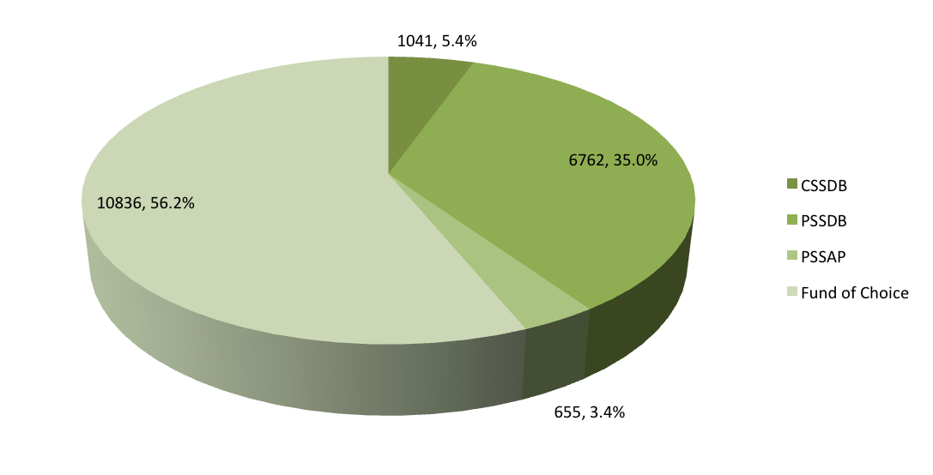

Notes from Figure 3:
CSSDB – Commonwealth Superannuation Scheme - Defined Benefit
PSSDB – Public Sector Superannuation - Defined Benefit
PSSAP – Public Sector Superannuation – Accumulation Plan
Fund of Choice

Figure 4: Salary profile by gender (June 2013)
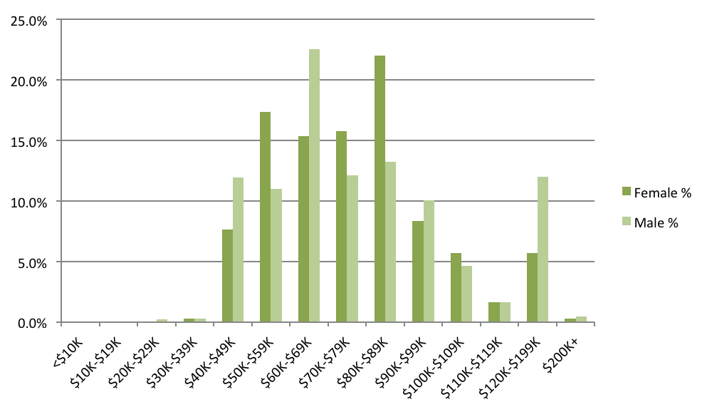

Table 10: Full-time employee salaries by generation and gender (June 2013)
(full-time employees, average per annum)
Generation | Female | Male | Aggregate
Generation Y | $70,620 | $68,231 | $69,826
Generation X | $83,973 | $83,765 | $83,874
Baby Boomers | $85,427 | $84,811 | $85,159
Pre-Baby Boomers | $80,785 | $85,412 | $83,792
Salary (average) | $79,711 | $80,388 | $80,012

Table 11: Full-time employee salaries by length of service and gender (June 2013)
(full-time employees, average per annum)
Length of service |  |  | Female |  |  |  |  | Male |  |  |  |  | Aggregate
Less than 5 years |  |  | $71,961 |  |  |  |  | $74,825 |  |  |  |  | $73,128
5 to 9 years |  |  | $82,840 |  |  |  |  | $81,624 |  |  |  |  | $82,332
10 to 19 years |  |  | $88,341 |  |  |  |  | $87,116 |  |  |  |  | $87,849
20 years or more |  |  | $91,857 |  |  |  |  | $87,490 |  |  |  |  | $89,702
Salary (average) |  |  | $79,711 |  |  |  |  | $80,388 |  |  |  |  | $80,012

Table 12: Part-time employee salaries by generation and gender (June 2013)
(average per annum)
Generation | Female |  |  |  |  | Male |  |  |  |  |  | Aggregate
Generation | Salary (average) |  |  | Part-time load (average) |  | Salary (average) |  |  | Part-time load (average) |  |  | Salary (average) |  | Part-time load (average)
Generation Y | $66,803 |  |  | 0.68 |  | $57,264 |  |  | 0.72 |  |  | $65,243 |  | 0.68
Generation X | $75,017 |  |  | 0.67 |  | $74,258 |  |  | 0.70 |  |  | $74,926 |  | 0.68
Baby Boomers | $69,874 |  |  | 0.72 |  | $76,602 |  |  | 0.71 |  |  | $71,070 |  | 0.71
Pre-Baby Boomers | $78,778 |  |  | 0.60 |  | $77,795 |  |  | 0.63 |  |  | $78,427 |  | 0.61
Salary (average) | $71,927 |  |  | 0.69 |  | $72,214 |  |  | 0.71 |  |  | $71,970 |  | 0.69

Table 13: Part-time employee salaries by length of service and gender (June 2013)
(part-time employees)
Length of service | Female |  | Male |  | Aggregate
Length of service | Salary (average) | Part-time load (average) | Salary (average) | Part-time load (average) | Salary (average) | Part-time load (average)
Less than 5 years | $67,202 | 0.68 | $67,687 | 0.69 | $67,297 | 0.68
5 to 9 years | $70,910 | 0.70 | $73,975 | 0.73 | $71,293 | 0.70
10 to 19 years | $79,260 | 0.68 | $82,582 | 0.71 | $79,638 | 0.68
20 years or more | $78,064 | 0.71 | $77,585 | 0.73 | $78,009 | 0.71
Salary (average) | $71,927 | 0.69 | $72,214 | 0.71 | $71,970 | 0.69

The ACT Government supports the principles of pay equity across the ACTPS through the establishment of common terms and conditions in enterprise agreements - including standard salaries within classifications. These common terms and conditions also promote consistency and mobility within the ACTPS.
The gender pay gap assists with the review of gender pay equity within the ACTPS, by assessing average earnings of male and female employees to determine if a difference exists. Factors that contribute to gender pay gap include gender workforce participation rates and length of service.
A positive pay gap indicates average earnings of females are less than average earnings of males, and conversely, a negative pay gap indicates the opposite.

Table 14: Gender pay gap in the ACTPS, ACT and Australia (June 2013)
Workforce | Gender pay gap
ACTPS | 2.9%
ACT | 14.8%
Australia | 17.5%

Figure 5: Gender pay gap by age cohort (June 2013)
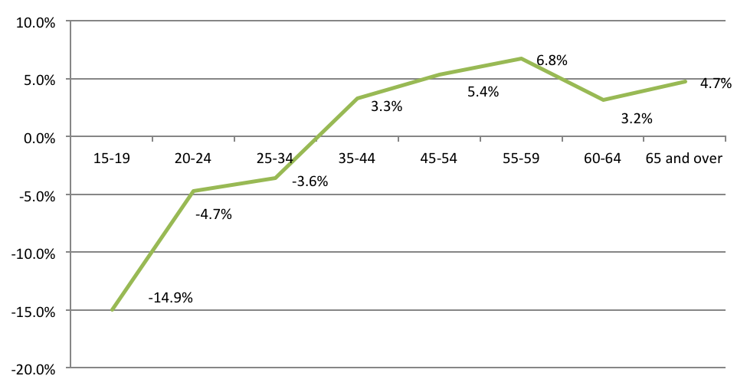

The proportion of female employees and their average earnings affects the gender pay gap by classification.

Table 15: Gender pay gap by classification group (June 2013)
Classification group | Salary |  | Proportion female | Gender pay gap | Female earnings  (average, per dollar of male earnings)
Classification group | Average | Median | Proportion female | Gender pay gap | Female earnings  (average, per dollar of male earnings)
Administrative Officers | $62,813 | $60,056 | 75.9% | 5.6% | $0.94
Ambulance Officers | $75,561 | $79,990 | 35.6% | 2.8% | $0.97
Bus Operators | $63,875 | $64,224 | 10.2% | 0.5% | $1.00
Correctional Officers | $64,002 | $63,245 | 21.4% | 3.1% | $0.97
Dentists/Dental Officers | $114,316 | $121,853 | 76.5% | -7.0% | $1.07
Disability Officers | $48,873 | $44,915 | 51.2% | -2.0% | $1.02
Executive Officers | $184,003 | $164,832 | 42.7% | -5.0% | $1.05
Fire and Rescue Officers | $72,337 | $69,563 | 2.0% | 4.4% | $0.96
General Service Officers & Equivalent | $49,091 | $44,739 | 22.6% | 10.1% | $0.90
Health Assistants | $52,063 | $55,674 | 90.6% | -8.1% | $1.08
Health Professional Officers | $84,088 | $83,648 | 79.1% | 2.1% | $0.98
Information Technology Officers | $71,187 | $72,341 | 15.7% | -4.1% | $1.04
Legal Officers | $107,565 | $113,833 | 61.1% | 10.7% | $0.89
Legal Support | $57,462 | $59,108 | 75.0% | -11.3% | $1.11
Linen Production & Maintenance | $49,096 | $39,770 | 58.3% | 12.4% | $0.88
Medical Officers | $119,881 | $109,118 | 47.1% | 13.5% | $0.86
Nursing and Midwifery | $74,050 | $74,082 | 89.8% | -2.5% | $1.02
Professional Officers | $78,619 | $75,168 | 66.7% | 8.3% | $0.92
Prosecutors | $98,867 | $91,650 | 60.5% | 14.7% | $0.85
Rangers | $60,730 | $62,277 | 23.7% | -4.8% | $1.05
School Leaders | $110,091 | $102,311 | 72.2% | 2.8% | $0.97
Senior Officers | $107,996 | $98,770 | 51.9% | 1.6% | $0.98

Statutory Office Holders | $222,200 | $201,687 | 46.7% | -5.5% | $1.06
Teachers | $79,292 | $88,637 | 77.6% | 0.5% | $0.99
Technical Officers | $63,618 | $61,152 | 49.9% | 15.6% | $0.84
Trainees and Apprentices | $33,298 | $34,019 | 27.5% | -17.5% | $1.17
Transport Officers  (incl. trainer/assessors) | $83,582 | $83,856 | 9.8% | 2.5% | $0.97
ACTPS averages | $78,053 | $74,082 | 64.8% | 2.9% | $0.97

Time-to-hire and separation rates

Table 16: Time-to-hire (2012-13)
Directorate | Time-to-hire  (average, work days)
Directorate | Panel selection  (excl. processing by Shared Services & Gazettal) | Time-to-hire  (incl. Processing by Shared Services & Gazettal)
Chief Minister and Treasury | 33.4 | 50.9
Community Services | 44.2 | 61.6
Commerce and Works | 33.1 | 49.5
Economic Development | 28.8 | 45.0
Education and Training | 31.3 | 47.6
Environment and Sustainable Development | 30.7 | 47.1
Health | 37.6 | 54.7
Justice and Community Safety | 38.0 | 54.8
Territory and Municipal Services | 41.5 | 60.4
Time-to-hire | 32.7 | 50.3

Table 17: Separation rates by classification group (2012-13)
Classification group |  | Separation rate | Average permanent officer headcount
Administrative Officers |  | 7.4% | 3552
Ambulance Officers |  | 3.0% | 202
Bus Operators |  | 6.2% | 602
Correctional Officers |  | 5.7% | 141
Dentists/Dental Officers |  | 17.8% | 11
Disability Officers |  | 7.8% | 232
Executive Officers |  | 0.0% | 23
Fire and Rescue Officers |  | 1.1% | 350
General Service Officers & Equivalent |  | 8.5% | 846
Health Assistants |  | 10.0% | 40
Health Professional Officers |  | 8.1% | 1085
Information Technology Officers |  | 6.9% | 130
Judicial Officers |  | 9.1% | 11
Legal Officers |  | 9.0% | 78
Legal Support |  | 0.0% | 9
Linen Production & Maintenance |  | 4.8% | 62
Medical Officers |  | 5.3% | 245
Nursing and Midwifery |  | 7.7% | 2154
Professional Officers |  | 7.1% | 99
Prosecutors |  | 27.3% | 29
Rangers |  | 9.2% | 33
School Leaders |  | 4.7% | 722
Senior Officers |  | 6.1% | 1872
Statutory Office Holders |  | 0.0% | 2
Teachers |  | 6.3% | 2491
Technical Officers |  | 4.1% | 245
Trainees and Apprentices |  | 44.1% | 14
Transport Officers (incl. Trainer/Assessors) |  | 6.9% | 44
Separation rate and average headcount |  | 6.8% | 15331

Table 18: Separation rates by agency (2012-13)
Directorate | Separation rate
Chief Minister and Treasury | 10.9%
Commerce and Works Directorate | 6.3%
Long Service Leave Authority | 10.2%
Community Services | 7.5%
Economic Development | 11.8%
Land Development Agency | 6.9%
Education and Training | 6.0%
Environment and Sustainable Development | 8.6%
Health | 7.6%
Justice and Community Safety | 5.1%
Territory and Municipal Services | 6.7%
ACTPS Separation rate | 6.8%

Table 19: Separation rates by generation (2012-13)
Generation | Female | Male | Total
Generation Y | 7.6% | 8.1% | 7.8%
Generation X | 4.1% | 4.1% | 4.1%
Baby Boomers | 8.9% | 8.1% | 8.6%
Pre-Baby Boomers | 32.9% | 15.5% | 25.3%
Separation rate | 7.0% | 6.5% | 6.8%

Age and Length of Service

Table 20: Definition of generations
Generation |  | Definition
Generation Y |  | Born from 1980 and onwards
Generation X |  | Born 1965 to 1979 inclusive
Baby Boomers |  | Born 1946 to 1964 inclusive
Pre-Baby Boomers |  | Born prior to 1946

Table 21: Headcount by generation and gender (June 2013)
Generation | Female |  | Male | Total
Generation Y | 3711 |  | 1674 | 5385
Generation X | 4758 |  | 2731 | 7489
Baby Boomers | 4393 |  | 2529 | 6922
Pre-Baby Boomers | 117 |  | 104 | 221
Total | 12979 |  | 7038 | 20017

Figure 6: Generation and gender as a proportion of headcount (June 2013)
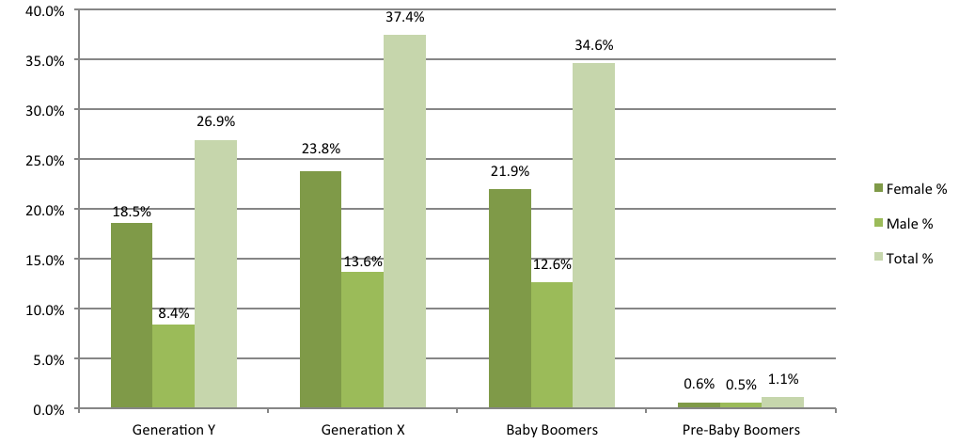

Table 22: Age and length of service by agency and gender (June 2013)
Directorate | Age (average) |  |  | Length of service (average)
Directorate | Female | Male | Aggregate | Female | Male | Aggregate
Chief Minister and Treasury | 39.3 | 42.3 | 40.5 | 6.4 | 7.6 | 6.9
Long Service Leave Authority | 47.6 | 42.0 | 45.3 | 7.3 | 7.4 | 7.4
Commerce and Works | 39.5 | 41.4 | 40.5 | 8.5 | 7.9 | 8.2
Community Services | 41.7 | 43.2 | 42.2 | 7.3 | 7.9 | 7.5
Economic Development | 38.9 | 43.2 | 41.0 | 8.4 | 8.6 | 8.5
Land Development Agency | 39.7 | 46.3 | 43.2 | 7.2 | 10.3 | 8.9
Education and Training | 43.4 | 43.0 | 43.3 | 9.4 | 9.4 | 9.4
Environment and Sustainable Development | 40.0 | 43.9 | 41.8 | 7.4 | 9.0 | 8.1
Health | 41.5 | 40.6 | 41.3 | 7.6 | 6.5 | 7.4
Justice and Community Safety | 39.7 | 43.4 | 41.8 | 7.1 | 10.5 | 9.1
Territory and Municipal Services | 44.1 | 46.2 | 45.7 | 8.3 | 10.1 | 9.6
Age (average) | 42.0 | 43.2 | 42.4 | 8.2 | 8.7 | 8.4

Figure 7: Age distribution by gender (June 2013)
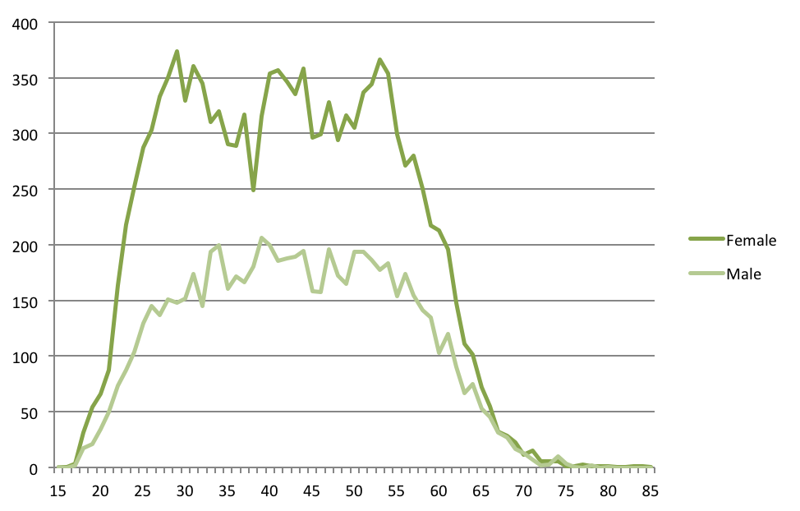
Headcount
Age

Table 23: Age and length of service by classification group and gender
(June 2013)
Classification group | Age (average) |  |  | Length of service (average)
Classification group | Female | Male | Aggregate | Female | Male | Aggregate
Administrative Officers | 41.8 | 39.3 | 41.2 | 7.1 | 6.5 | 6.9
Ambulance Officers | 36.9 | 40.4 | 39.2 | 7.3 | 8.0 | 7.7
Bus Operators | 44.9 | 48.6 | 48.2 | 7.1 | 9.9 | 9.6
Correctional Officers | 40.9 | 43.5 | 42.9 | 6.4 | 6.9 | 6.8
Dentists/Dental Officers | 39.5 | 43.5 | 40.5 | 8.8 | 5.5 | 8.0
Disability Officers | 45.8 | 44.1 | 45.0 | 8.6 | 8.1 | 8.4
Executive Officers | 49.8 | 50.1 | 50.0 | 12.2 | 11.4 | 11.8
Fire and Rescue Officers | 38.6 | 43.6 | 43.5 | 10.9 | 16.0 | 15.9
General Service Officers & Eq. | 44.9 | 45.0 | 45.0 | 9.6 | 9.0 | 9.2
Health Assistant | 37.1 | 27.0 | 36.2 | 5.9 | 1.3 | 5.5
Health Professional Officers | 39.5 | 41.5 | 39.9 | 6.9 | 6.9 | 6.9
Information Technology Officers | 38.1 | 35.2 | 35.7 | 6.3 | 5.7 | 5.8
Judicial Officers | 54.0 | 62.7 | 59.8 | 10.7 | 14.6 | 12.9
Legal Officers | 35.3 | 43.9 | 38.7 | 5.7 | 8.9 | 6.9
Legal Support | 30.8 | 26.0 | 29.6 | 2.1 | 0.7 | 1.7
Linen Production & Maintenance | 51.0 | 47.2 | 49.4 | 12.5 | 12.3 | 12.4
Medical Officers | 35.8 | 39.9 | 38.0 | 3.2 | 4.7 | 4.0
Nursing and Midwifery | 42.6 | 40.1 | 42.4 | 8.3 | 6.2 | 8.1
Professional Officers | 41.3 | 41.0 | 41.2 | 5.9 | 7.0 | 6.3
Prosecutors | 31.1 | 39.0 | 34.2 | 3.5 | 5.4 | 4.2
Rangers | 37.1 | 41.6 | 40.5 | 6.4 | 8.7 | 8.1
School Leaders | 46.1 | 44.9 | 45.8 | 15.6 | 15.7 | 15.6
Senior Officers | 44.4 | 46.8 | 45.6 | 10.0 | 10.3 | 10.2
Statutory Office Holders | 58.6 | 56.1 | 57.3 | 6.7 | 16.2 | 11.8
Teacher | 41.5 | 41.8 | 41.6 | 8.8 | 8.3 | 8.7
Technical Officers | 43.4 | 45.2 | 44.3 | 8.7 | 10.4 | 9.6
Trainees and Apprentices | 26.6 | 21.8 | 23.2 | 1.8 | 1.8 | 1.8
Transport Officers  (incl. trainer/ assessors) | 44.8 | 51.8 | 51.1 | 13.1 | 18.0 | 17.5
Age and length of service | 42.2 | 43.3 | 42.6 | 8.2 | 8.7 | 8.4

Leave

Table 24: Annual leave usage by classification group and gender (2012-13)
Classification group | Annual leave usage  (average, days per person)
 | Female |  | Male |  |  | Aggregate
Administrative Officers | 15.7 |  | 16.9 |  |  | 16.0
Ambulance Officers | 32.6 |  | 39.2 |  |  | 36.9
Bus Operators | 17.4 |  | 17.5 |  |  | 17.5
Correctional Officers | 28.1 |  | 27.8 |  |  | 27.9
Dentists/Dental Officers | 12.3 |  | 10.6 |  |  | 11.9
Disability Officers | 21.2 |  | 18.3 |  |  | 19.8
Executives | 21.5 |  | 17.2 |  |  | 18.9
Fire and Rescue Officers | 29.4 |  | 32.6 |  |  | 32.5
General Service Officers and Equivalent | 16.9 |  | 18.1 |  |  | 17.8
Health Assistants | 17.1 |  | 32.9 |  |  | 18.0
Health Professional Officers | 16.4 |  | 16.0 |  |  | 16.3
Information Technology Officers | 19.4 |  | 16.0 |  |  | 16.5
Judicial Officers | 15.4 |  | 9.4 |  |  | 12.1
Legal Officers | 17.9 |  | 21.3 |  |  | 19.2
Legal Support | 11.2 |  | 6.2 |  |  | 10.3
Linen Production and Maintenance Officers | 20.7 |  | 18.3 |  |  | 19.7
Medical Officers | 14.1 |  | 15.8 |  |  | 15.1
Nursing and Midwifery | 22.6 |  | 23.0 |  |  | 22.6
Professional Officers | 17.2 |  | 17.3 |  |  | 17.2
Prosecutors | 17.1 |  | 20.8 |  |  | 18.7
Rangers | 14.4 |  | 21.8 |  |  | 20.0
School Leaders | 19.6 |  | 19.4 |  |  | 19.6
Senior Officers | 18.6 |  | 19.0 |  |  | 18.8
Statutory Office Holders | 11.0 |  | 24.7 |  |  | 18.1
Teachers | 16.4 |  | 16.4 |  |  | 16.4
Technical Officers | 17.2 |  | 17.7 |  |  | 17.4
Trainees and Apprentices | 17.9 |  | 11.6 |  |  | 13.3
Transport Officers (incl. trainer/assessors) | 23.1 |  | 18.2 |  |  | 18.7
ACTPS annual leave usage | 17.9 |  | 19.3 |  |  | 18.3

Table 25: Annual leave usage by agency and gender (2012-13)
Directorate |  | Annual leave usage  (average, days per person)
 |  | Female |  | Male | Aggregate
Chief Minister and Treasury |  | 17.8 |  | 18.8 | 18.2
Long Service Leave Authority |  | 24.5 |  | 21.7 | 23.5
Independent Competition and Regulatory Commission |  | 1.2 |  | 2.6 | 1.9
Commerce and Works Directorate |  | 17.9 |  | 17.4 | 17.6
Community Services |  | 18.9 |  | 18.6 | 18.8
Economic Development |  | 20.0 |  | 16.8 | 18.4
Exhibition Park Corporation |  | 15.4 |  | 17.7 | 16.4
Gambling and Racing Commission |  | 17.3 |  | 19.0 | 18.2
Land Development Agency |  | 17.3 |  | 18.0 | 17.6
Education and Training |  | 15.7 |  | 16.3 | 15.8
Environment and Sustainable Development |  | 18.9 |  | 18.6 | 18.7
Health |  | 19.1 |  | 17.4 | 18.7
Justice and Community Safety |  | 19.6 |  | 26.4 | 23.5
Territory and Municipal Services |  | 18.5 |  | 19.8 | 19.3
ACTPS annual leave usage |  | 17.9 |  | 19.3 | 18.3

Table 26: Personal leave usage and absence rate by classification group (2012-13)
Classification group | Personal leave usage  (average, days per person)
 | Female | Male | Aggregate | Absence rate
Administrative Officers | 11.6 | 11.1 | 11.5 | 4.8%
Ambulance Officers | 12.2 | 13.5 | 13.0 | 5.3%
Bus Operators | 19.4 | 14.2 | 14.7 | 5.8%
Correctional Officers | 18.7 | 13.9 | 15.0 | 5.8%
Dentists/Dental Officers | 7.9 | 5.3 | 7.3 | 3.4%
Disability Officers | 14.0 | 17.3 | 15.6 | 6.6%
Executives | 7.6 | 6.6 | 7.0 | 2.7%
Fire and Rescue Officers | 7.3 | 12.1 | 12.0 | 4.4%
General Service Officers and Equivalent | 14.1 | 12.4 | 12.7 | 5.1%
Health Assistants | 13.9 | 20.5 | 14.3 | 6.1%
Health Professional Officers | 9.6 | 8.3 | 9.4 | 4.1%
Information Technology Officers | 10.9 | 10.0 | 10.2 | 3.9%
Judicial Officers | 6.9 | 0.7 | 3.5 | 1.4%
Legal Officers | 8.5 | 7.3 | 8.1 | 3.3%
Legal Support | 11.9 | 3.7 | 10.3 | 4.1%
Linen Production and Maintenance Officers | 12.2 | 12.0 | 12.1 | 4.8%
Medical Officers | 5.1 | 3.8 | 4.4 | 1.7%
Nursing and Midwifery | 12.8 | 12.6 | 12.8 | 5.6%
Professional Officers | 9.6 | 7.6 | 9.0 | 3.8%
Prosecutors | 12.1 | 8.9 | 10.7 | 4.2%
Rangers | 13.5 | 18.1 | 17.0 | 6.9%
School Leaders | 10.7 | 9.3 | 10.3 | 4.0%
Senior Officers | 11.4 | 9.2 | 10.3 | 4.0%
Statutory Office Holders | 5.1 | 4.1 | 4.6 | 1.9%
Teachers | 9.0 | 8.3 | 8.8 | 3.7%
Technical Officers | 13.6 | 10.2 | 11.8 | 4.9%
Trainees and Apprentices | 14.1 | 10.0 | 11.1 | 4.3%
Transport Officers (incl. trainer/assessors) | 6.2 | 11.2 | 10.8 | 4.1%
Personal leave usage and absence rate | 11.0 | 10.1 | 10.7 | 4.4%

Table 27: Personal leave usage and absence rate by agency (2012-13)
Directorate | Personal leave usage  (average, days per person)
Directorate | Female | Male | Aggregate | Absence rate
Chief Minister and Treasury | 12.3 | 7.9 | 10.5 | 4.2%
Long Service Leave Authority | 9.3 | 28.7 | 16.4 | 6.3%
Independent Competition and Regulatory Commission | 3.7 | 0.4 | 2.1 | 4.7%
Commerce and Works Directorate | 12.7 | 9.8 | 11.1 | 4.3%
Community Services | 12.9 | 13.1 | 12.9 | 5.3%
Economic Development | 9.4 | 6.9 | 8.2 | 3.2%
Exhibition Park Corporation | 9.6 | 3.5 | 6.8 | 2.7%
Gambling and Racing Commission | 13.6 | 14.1 | 13.9 | 5.6%
Land Development Agency | 12.0 | 7.5 | 9.7 | 3.1%
Education and Training | 8.8 | 8.7 | 8.8 | 3.8%
Environment and Sustainable Development | 12.0 | 11.8 | 12.0 | 4.9%
Health | 11.7 | 9.1 | 11.1 | 4.7%
Justice and Community Safety | 12.0 | 11.5 | 11.7 | 4.5%
Territory and Municipal Services | 13.6 | 11.1 | 12.0 | 4.8%
Average Personal Leave Usage | 11.0 | 10.1 | 10.7 | 4.4%

Diversity

Table 28: Diversity in the ACTPS (June 2013)
 | ACTPS | Females | Culturally and linguistically diverse | People with disability | Aboriginal and Torres Strait Islanders
FTE | 17848.5 | 11198.3 | 2936.6 | 345.1 | 216.7
Headcount | 20017 | 12979 | 3218 | 384 | 238
Employment status (headcount)
Permanent Full-time | 11766 | 6785 | 1767 | 231 | 157
Permanent Part-time | 3777 | 3225 | 534 | 81 | 27
Temporary Full-time | 2348 | 1371 | 605 | 39 | 37
Temporary Part-time | 705 | 582 | 88 | 14 | 9
Casual | 1421 | 1016 | 224 | 19 | 8
Generation
Pre-Baby Boomers | 221 | 117 | 30 | 8 | 1
Baby Boomers | 6922 | 4393 | 990 | 145 | 53
Generation X | 7489 | 4758 | 1388 | 136 | 72
Generation Y | 5385 | 3711 | 810 | 95 | 112
Length of service
Less than 5 years | 9336 | 5998 | 1848 | 195 | 165
5 to 9 years | 4998 | 3353 | 705 | 83 | 45
10 to 19 years | 3457 | 2337 | 426 | 51 | 21
20 years or more | 2226 | 1291 | 239 | 55 | 7

Table 28: Diversity in the ACTPS (June 2013) (cont’d)
 | ACTPS | Females | Culturally and linguistically diverse | People with disability | Aboriginal and Torres Strait Islanders
Separation rate | 6.8% | 5.5% | 3.7% | 6.3% | 10.8%
Annual leave (average days per person during 2011-12) | 18.3 | 17.9 | 0.7 | 0.7 | 0.7
Personal leave usage  (average, days) | 10.7 | 11.0 | 0.4 | 0.6 | 0.6
Personal leave absence rate  (average) | 4.4% | 4.7% | 4.0% | 6.1% | 5.4%
Salary
Average | $78,053 | $77,235 | $75,867 | $74,554 | $70,137
Median | $74,082 | $74,082 | $71,031 | $71,031 | $65,221

Table 29: Diversity by classification group (June 2013)
Classification group | Females | Culturally and linguistically diverse | People with disability | Aboriginal and Torres Strait Islanders
Administrative Officers | 75.7% | 14.2% | 2.5% | 2.1%
Ambulance Officers | 35.6% | 2.3% | 0.5% | 0.9%
Bus Operators | 10.2% | 39.2% | 0.3% | 1.0%
Correctional Officers | 21.4% | 9.2% | 1.7% | 0.0%
Dentists/Dental Officers | 76.5% | 52.9% | 0.0% | 5.9%
Disability Officers | 51.2% | 18.4% | 3.2% | 0.0%
Executive Officers | 43.1% | 6.6% | 2.0% | 0.0%
Fire and Rescue Officers | 2.0% | 1.4% | 0.3% | 0.6%
General Service Officers & Equivalent | 22.2% | 19.0% | 3.7% | 1.2%
Health Assistants | 90.6% | 18.8% | 3.1% | 1.6%
Health Professional Officers | 79.1% | 15.8% | 1.9% | 1.4%
Information Technology Officers | 15.7% | 19.9% | 1.8% | 1.2%
Judicial Officers | 33.3% | 0.0% | 0.0% | 0.0%
Legal Officers | 61.1% | 12.6% | 2.1% | 0.0%
Legal Support | 75.0% | 31.3% | 0.0% | 0.0%
Linen Production & Maintenance | 58.3% | 3.3% | 1.7% | 0.0%
Medical Officers | 47.1% | 31.4% | 1.4% | 0.4%
Nursing and Midwifery | 89.8% | 23.7% | 1.7% | 0.6%
Professional Officers | 68.9% | 17.4% | 3.0% | 0.8%
Prosecutors | 60.5% | 7.9% | 0.0% | 5.3%
Rangers | 23.7% | 5.3% | 2.6% | 5.3%
School Leaders | 72.2% | 7.2% | 1.9% | 0.8%
Senior Officers | 51.6% | 13.6% | 2.2% | 1.1%
Statutory Office Holders | 42.9% | 0.0% | 0.0% | 0.0%
Teachers | 77.6% | 10.0% | 1.0% | 0.8%
Technical Officers | 51.4% | 21.0% | 1.6% | 0.0%
Trainees and Apprentices | 27.5% | 2.5% | 12.5% | 22.5%
Transport Officers (incl. trainer/assessors) | 9.8% | 39.0% | 0.0% | 0.0%
ACTPS diversity | 64.8% | 16.1% | 1.9% | 1.2%

Table 30: Diversity by agency (June 2013)
Directorate | Females | Culturally and linguistically diverse | People with disability | Aboriginal and Torres Strait Islanders
Chief Minister and Treasury | 58.9% | 14.0% | 4.1% | 0.7%
Long Service Leave Authority | 58.3% | 33.3% | 0.0% | 0.0%
Independent Competition and Regulatory Commission | 37.5% | 12.5% | 12.5% | 0.0%
Commerce and Works Directorate | 47.1% | 20.4% | 2.8% | 1.1%
Community Services | 67.1% | 15.0% | 2.8% | 3.0%
Economic Development | 51.6% | 6.5% | 2.3% | 1.4%
Exhibition Park Corporation | 46.7% | 0.0% | 0.0% | 0.0%
Gambling and Racing Commission | 44.8% | 3.4% | 0.0% | 3.4%
Land Development Agency | 46.8% | 10.6% | 3.2% | 2.1%
Education and Training | 77.9% | 10.1% | 1.2% | 1.0%
Environment and Sustainable Development | 54.6% | 16.1% | 2.9% | 1.5%
Health | 75.9% | 22.1% | 1.9% | 1.0%
Justice and Community Safety | 42.3% | 8.9% | 1.7% | 1.3%
Territory and Municipal Services | 26.0% | 21.1% | 2.5% | 1.2%
ACTPS Total | 64.8% | 16.1% | 1.9% | 1.2%

Table 31: Cultural Facilities Corporation (June 2013)
Agency | Cultural Facilities Corporation
FTE | 81.9
FTE – permanent | 36.9
FTE – temporary | 17.8
FTE – casual | 27.2
Headcount | 131
Headcount – permanent | 41
Headcount – temporary | 21
Headcount - casual | 69
Age (average) | 40.6
Length of service (average, years) | 5.0
Separation rate | 12.2%
Diversity (FTE, headcount):
Aboriginal and Torres Strait Islanders  People with disability | 0.33,1  2.0, 2
Culturally & linguistically diverse | 5.3, 6
Female | 44.0, 78

Summary of ACT public sector Agencies external to the ACT Public Service

Table 32: Summary of ACT public sector agencies external to the ACT Public Service (June 2013)
Agency | Auditor-General’s Office |  | Calvary Healthcare (Public) |  | Canberra Institute of Technology |  | Office of the Legislative Assembly
FTE | 39.3 |  | 1013.5 |  | 766.9 |  | 43.2
FTE - permanent | 32.3 |  | 789.8 |  | 489.8 |  | 36.3
FTE - temporary | 7.0 |  | 158.1 |  | 139.4 |  | 4.0
FTE - casual | - |  | 65.6 |  | 137.8 |  | 2.9
Headcount - Total | 41 |  | 1423 |  | 994 |  | 65
Headcount - permanent | 34 |  | 898 |  | 520 |  | 43
Headcount – Temporary | 7 |  | 215 |  | 160 |  | 9
Headcount – Casual | - |  | 310 |  | 314 |  | 13
Age (average) | 37.9 |  | 41.5 |  | 46.8 |  | 50.0
Length of service (average, years) | 5.9 |  | 5.5 |  | 9.4 |  | 6.0
Separation rate | 9.4% |  | 11.0% |  | 7.9% |  | 16.3%
Diversity
by FTE and Headcount (HC)  NA = Not Available | FTE | HC | FTE | HC | FTE | HC | FTE | HC
Aboriginal and Torres Strait Islanders | Nil |  | NA |  | 14.1 | 19 | Nil
People with disability | 1.0 | 1 | NA |  | 13.4 | 21 | Nil
Culturally & linguistically diverse | 15.9 | 16 | NA |  | 123.4 | 159 | Nil
Female | 16.4 | 18 | 979.5 | 1133 | 452.3 | 609 | NA | 40

Table 33: Divisions of ACT public sector agencies external to the ACT Public Service (June 2013)
Agency | Division | FTE | Headcount
Calvary Health Care (Public) | Allied Health | 109.5 | 165
 | Administration, Finance and Executives | 48.6 | 63
 | Medical Officers | 64.8 | 86
 | Nursing | 614.6 | 843
 | Support Staff | 175.9 | 266
Total |  | 1013.5 | 1423

Agency | Division | FTE | Headcount
Canberra Institute of Technology | Administrative Officers, Professional Officers and Executives | 266.1 | 295
 | General Service Officers and Technical Officers | 49.5 | 59
 | VET Teachers and Teacher Managers | 451.3 | 640
Total |  | 766.9 | 994

Statutory Officer Holders
During 2012-13, there were 16 paid full-time Statutory Office Holders in the ACT, employed under the appointment provisions of the relevant legislation and whose salaries are determined by the ACT Remuneration Tribunal:
- Auditor-General;
- General President, ACT Civil and Administrative Tribunal;
- Appeals President, ACT Civil and Administrative Tribunal;
- Director of Public Prosecutions;
- Electoral Commissioner;
- Chief Planning Executive, ACT Planning and Land Authority;
- Chief Executive Officer, Land Development Agency;
- Commissioner for the Environment;
- Clerk, Legislative Assembly;
- Chief Executive Officer, Legal Aid Commission (ACT);
- Assistant Executive Officer, Legal Aid Commission (ACT);
- Human Rights Commissioner;
- Children and Young People Commissioner;
- Disability and Community Services Commissioner;
- Discrimination Commissioner;
- Health Services Commissioner;
- Public Advocate;
- Victims of Crime Commissioner.

Appendix 1 - Abbreviations Used in This Report
ABS  ACT | Australian Bureau of Statistics  Australian Capital Territory
ACTPS | Australian Capital Territory Public Service
ACTION | ACTION Buses
ASO | Administrative Services Officer
CFC | Cultural Facilities Corporation
CIT | Canberra Institute of Technology
CMCD | Chief Minister and Treasury Directorate
CSD | Community Services Directorate
ESDD | Environment and Sustainable Development Directorate
FTE | Full-time Equivalent
HD  HR | Health Directorate  Human Resources
JACSD | Justice and Community Safety Directorate
TAMSD | Territory and Municipal Services Directorate
TD | Treasury Directorate
VET | Vocational Education & Training

Current Administration Arrangements:
HD | Health Directorate
CMTD | Chief Minister and Treasury Directorate
ETD | Education and Training Directorate
CSD | Community Services Directorate
CWD | Commerce and Works Directorate
EDD | Economic Development Directorate
ESDD | Environment and Sustainable Development Directorate
JCSD | Justice and Community Safety Directorate
TMSD | Territory and Municipal Services Directorate

Other:
AA | Administration Arrangement
ACTPS | ACT Public Service
CIT | Canberra Institute of Technology
Commissioner | Commissioner for Public Administration
SERBIR | Senior Executive Responsible for Business Integrity and Risk

Legislation:
FOI Act | Freedom of Information Act 1989
FM Act | Financial Management Act 1996
FW Act | Fair Work Act 2009 (Cwlth)
HR Act | Human Rights Act 2004
PID Act | Public Interest Disclosure Act 2012
PSM Act | Public Sector Management Act 1994
SRC Act | Safety, Rehabilitation and Compensation Act 1988 (Cwlth)
Standards | Public Sector Management Standards 2006
WR Act | Workplace Relations Act 1996 (Cwlth)

Appendix 2 - Definitions
ACT Public Service (ACTPS)
The ACTPS comprises nine Directorates (refer to Table 1 for details) that report to the Head of Service as constituted by the Administrative Arrangements 2011 (No 3).
ACT public sector
The ACT public sector encompasses the employees of the nine Directorates that report to the Head of Service, as well as staff employed under the Public Sector Management (PSM) Act 1994 in other ACT Government agencies.
Appointments
Appointments refer to the recruitment of people as permanent officers. Recruits can be people external to the organisation, or people already working internal to the organisation as temporary or casual employees.
Employees
Employees include permanent officers, temporary and casual employees.
Employees – casual
Casual employees are those engaged on an ad hoc hourly or daily basis with no ongoing tenure of employment. This category of employment can also be referred to as non-ongoing and usually consists of an employment arrangement which is not considered systematic, continuous or permanent.
Employees – full-time
Full-time employees can be either permanent or temporary who work full-time hours in accordance with their provisions.
Employees – part-time
Employees either permanent or temporary, who work less than full-time hours.
General Service Officers (GSOs)
Examples include tradespeople, gardeners, drivers and labourers.
Generations
Generation | Definition
Pre-Baby Boomers | Born prior to 1946
Baby Boomers | Born 1946 to 1964 inclusive
Generation X | Born 1965 to 1979 inclusive
Generation Y | Born from 1980 and onwards

Gender pay gap
Gender pay gap is equal to one minus female weekly ordinary time earnings, divide by male weekly ordinary time earnings, multiplied by 100. Annual salary represents the salary increment point, pro-rated for part-time employees, and does not include allowances or other pay components.
The methodology used to determine employee salary averages and the associated gender pay gap in this year’s report has been revised to remove causes of some minor statistical anomalies. The result of this change may cause some variation from previously published figures. The data in this report excludes remuneration of executives unless noted differently.
Headcount and FTE
This report is based on paid employees. Paid headcount for all employees includes employees on paid leave or with back pay, as at the end of the financial year. Headcount and FTE are standard measures of staff numbers. Headcount considers each employee as one regardless of whether they are full-time or part-time. In contrast, FTE represents total employee numbers based on equivalent full-time hours worked. For example, an employee working standard full-time hours attracts an FTE of 1.0 whereas an employee working half the standard full-time hours attracts an FTE of 0.5. The total FTE in this example would be 1.5 whereas the headcount would be two. Average FTE and average headcount are based on the 26 pay periods in each financial year. The average over time removes seasonality that can be experienced at a point in time, particularly with temporary and casual employees, and for this reason it is used to calculate year-on-year percentage increases.
Leave
Staff can access annual leave and personal leave entitlements. Annual leave is often referred to as recreational leave. Personal leave can be taken in instances of personal illness or injury, for bereavement, or when caring for a dependent due to illness or injury. Leave can experience a time-lag in processing.
Entitlements can be found in the relevant section of enterprise and collective agreements, see the website for details: http://www.sharedservices.act.gov.au/docs/agreements/
Median
The median of a set of data values is the middle value of the data set when it has been arranged in ascending order. It is the point at which 50 percent of the data set has a greater value and 50 percent of the data has a smaller value.
Officer - permanent
Permanent officers can be full-time or part-time, who have been appointed to an office or as an unattached officer under the Public Sector Management Act 1994.
Payroll system administrators - discrete sources of workforce data
ACTPS Shared Services (CHRIS21), Calvary Public Hospital, Cultural Facilities Corporation, Exhibition Park Corporation and the Office of the Legislative Assembly.
Separation rate
The separation rate is determined by dividing the total number of permanent separations by the average permanent headcount, over the financial year, for the ACTPS, and excludes transfers between Directorates. Previous years have been based on average headcount of all staff, including casuals and temporary employees, which deflates the result. The new calculation is consistent with other jurisdictions including the Australian Public Service.
Territory-owned Corporations (TOCS)
Government enterprises (known as Territory-owned Corporations) under the Territory-owned Corporations Act 1990 (TOCS), are separate entities to the ACTPS and other ACT public sector agencies and are not included in this report. As at June 2012, TOCS are ACTEW Corporation Limited and ACTTAB Limited.
Workforce average
Note that the calculation of a workforce average is based on the total available data for ACTPS Directorates only. The ACTPS average is a weighted mean of groups that have varying numbers of employees and it is not a simple average of the figures for groups shown.

Workforce information throughout this report is presented as available from the CHRIS21 payroll system and data for independent agencies may be aggregated with that of a relevant directorate.
The health portfolio includes the Health Directorate and Calvary Health Care (Public). The education portfolio includes the Education Directorate and Canberra Institute of the Technology (CIT).
Based on Australian Bureau of Statistics (ABS) survey - Disability, Ageing and Carers, Australia, 2009.
Based on the ABS Australian Demographic Statistics 2011 Census Edition - Preliminary.
Percentage based on most recent available ACT population data, December 2011, sourced from the Australian Bureau of Statistics (ABS), Australian Demographic Statistics 2011 Census Edition – Preliminary.
ACT estimated resident population, sourced from the Australian Bureau of Statistics (3101.0 - Australian Demographic Statistics, Dec 2012) is used to calculate employee numbers (FTE and headcount) as a proportion of population.
Ibid.
External appointments as a proportion of total appointments provide an indication of external recruits versus internal employees, appointed to permanent positions. 2008-09 data is not available.
Leave data tends to endure a processing lag time, affecting 2012-13 data. Earlier years have been retrospectively updated to address processing time lag.
FTE as a proportion of headcount provides an indicator of utilisation within each employment mode.
The reduction in FTE for the Chief Minister and Treasury Directorate is a result of the machinery of government changes in November 2012 and the merging of elements of the former Treasury Directorate with Chief Minister and Cabinet Directorate. The transfer of Shared Services and other smaller elements of the former Treasury Directorate to the newly created Commerce and Works Directorate accounts for the majority of this reduction.
The Capital Metro Agency was part of the Economic Development Directorate as of 30 June 2013. As of 1 July 2013 The Capital Metro Agency is a standalone Directorate.
For information on superannuation schemes, see australia.gov.au. Superannuation data excludes ACTION staff paid through the Aurion payroll system.
Remuneration reflects base salary increment points, excludes superannuation and allowances.
The gender pay gap methodology used within this section is similar to the methodology used by the Western Australian Government’s Department of Commerce. Gender pay gap is equal to one minus {female weekly ordinary time earnings divide by male weekly ordinary time earnings} multiplied by 100.
ACT and national indicators are based on a calculation, using full-time adult ordinary time earnings published by the ABS, Commonwealth Government, Average Weekly Earnings - States & Territories: Trend - ABS 6302 average weekly earnings trend estimates, May 2013.
Data inclusive of all employees and based on headcount.
Time-to-hire information available for clients of Shared Services and in the format shown and excludes ACTION. Health Directorate has a separate online application system.
A total of 2285 vacancies were advertised during 2011-12. CIT and Auditor General’s Office is not separated from the overall time-to-hire statistic due to system limitation.
Average permanent officer headcount is an average of paid headcount based on the 26 pay periods during 2012-13, to the nearest whole number.
Separation rates available in the form shown and represent permanent separations as a percentage of average permanent headcount. Executives are on temporary contract and are excluded. Directorates with relatively few employees are susceptible to misleading fluctuation.
TAMS separation rate is inclusive of ACTION bus operators and transport officers.
The calculation of average age includes casuals. Note the average age for casuals is higher than for other employment types and this affects the average age of classifications with a high proportion of casuals, such as Teachers and nurses. Length of service in this report excludes casuals. The average length of service calculation does not differentiate between periods of leave with or without pay.
Leave experiences processing lag time which affects 2012-13 data. Leave accrual methods can vary according to occupation and employment mode.
Personal leave can be taken in instances of personal illness or injury, for bereavement, or when caring for a dependent due to illness or injury. The absence rate is calculated by dividing the total number of hours absent by the total number of available work hours.
The ACTPS continues to encourage voluntary disclosure by employees. Diversity percentages are based on total ACTPS headcount which assumes that all respondents do not identify as one or more of the diversity groups, which is likely to result in under-reporting of the actual proportion of diversity groups in the ACTPS. Diversity statistics are also provided in Annual Reports and monitored through the ACTPS Respect, Equity and Diversity Framework. Workforce data in this section has been presented in a way that protects the identity of individual employees.
Salary averages here are inclusive of part-time and casual employees.
Cultural Facilities Corporation (CFC) has common reporting lines to Community Services Directorate (CSD). CFC reports to the Minister, CFC Board and/or CSD Director-General, as required.

